PE Funding

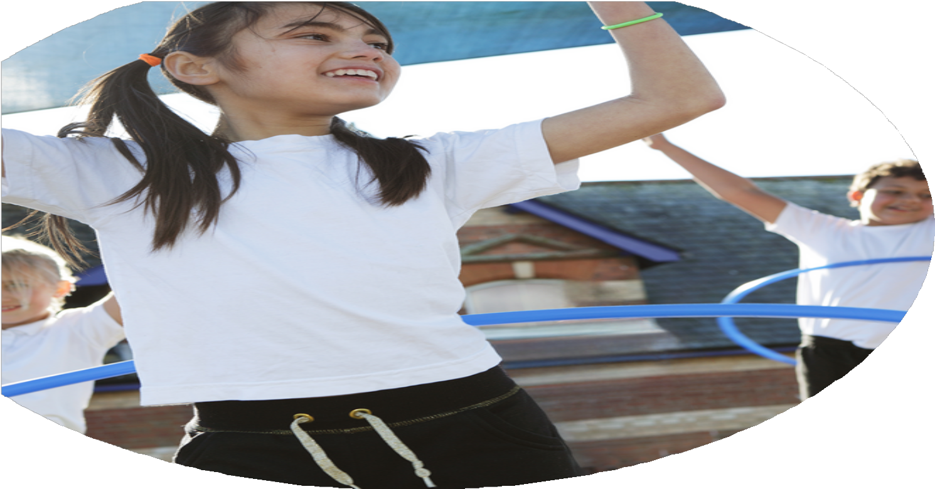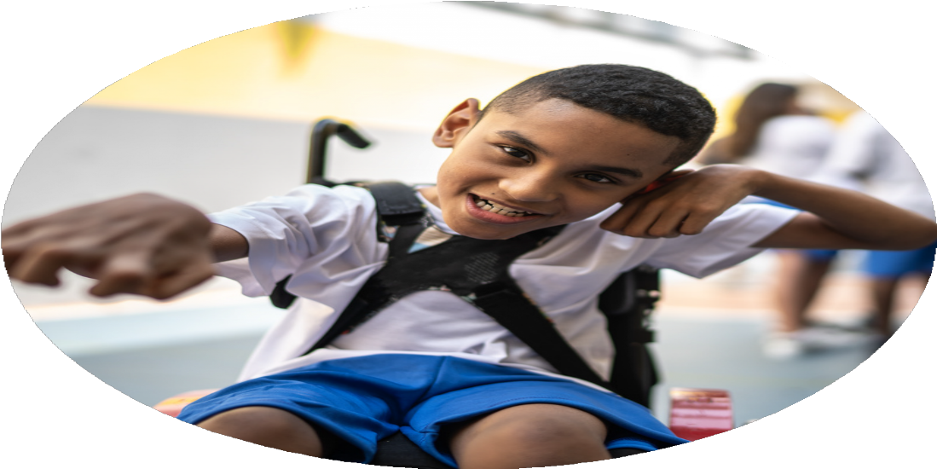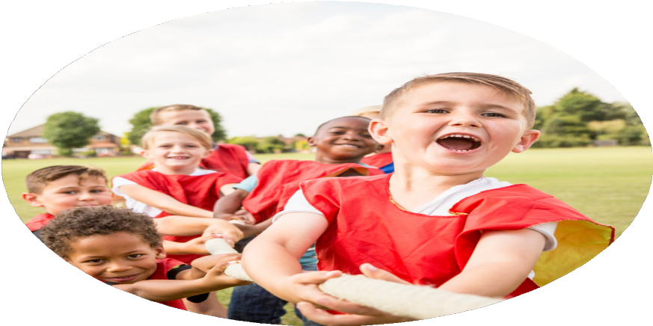

Evaluation Form

**Commissioned by**

**Created by**

Images courtesy of Youth Sport Trust

**PE Funding Evaluation Form**

 It is intended that this template should be used as preparation for the completion of the statutory digital reporting tool being introduced this academic year. You can upload data (including swimming) from this template onto this platform once it becomes accessible.

 Before you decide how you are going to use the funding for this academic year you should reflect and evaluate the impact of your use of the funding in 2023/24.

 All spending of the funding must conform with the terms outlined in the Conditions of Grant document.  The template is a working document that you can amend/update during the year.

 Based on your evaluation of last year’s funding you should decide what you intend to do this academic year, how you will do it, and what impact you expect it to have.

It is important that the funding is used effectively and based on your school’s needs.

 You must use the funding to make additional and sustainable improvements to the PE and sport in your school.  You must develop and add to the PESSPA activities that your school already offers.

*Summative digital reporting from June 2025 will continue to include swimming and water safety information therefore funding can be used to provide top-up lessons where necessary to ensure pupils meet national curriculum swimming requirements.*

* Some evidence of rushing clubs for competitions which meant children were not fully prepared.
* Quality rather than quantity approach to the running of sports clubs.

-Positive feedback from children indicated that OPAL playtimes have had a positive effect on children’s physical and mental wellbeing.

-Questionnaires indicated that teachers felt more confident teaching PE after CPD was provided by PNE.

-Pupil feedback indicated they were pleased with the variety of opportunities through extra-curricular clubs and competitions at school.

-Introduced and implemented OPAL play scheme during playtimes.

-Implemented CPD through PNE coaches.

-Increased PE opportunities and the awareness of sporting events for children in all year groups throughout the year through an increase in extra-curricular sports clubs, sports competitions and sports week.

-Began implementing cross-curricular orienteering into PE lessons.

- South Ribble School Games opportunities provided children with a vast range of opportunities in a variety of sports.

-Invested in Primary PE Planning Scheme to support the teaching of PE lessons.

-Children in Year 4, 5 and 6 were able to improve their swimming and water safety skills through swimming lessons.

What are your plans for 2024/25?

Intent

How are you going to action and achieve these plans?

Implementation

* To continue with SoW provided by Primary Planning PE.
* CPD for teachers from PNE coaches delivering PE sessions in sports with lesser sport-specific knowledge.
* Develop teacher’s ability to adapt PE lessons to best support children with SEND through CPD.
* Raise the profile of PE within school through celebrating PE and Sport through a National Sports Week Whole School Festival.
* Provide opportunities for all children to represent the school in inter school competitions.
* Provide opportunities for all children to represent the school in competitions and performances both inside and outside of school.
* Introduce lunchtime sport sessions/activities for children.
* Incorporate OPAL play scheme into playtimes with new activities and equipment.
* Ensure maximum uptake of our extracurricular clubs to engage as many pupils in extracurricular clubs.
* Year 4/5 classes attend 10 weeks of swimming sessions. Top up swimming sessions for Year 6 children.
* Continue to invest in scheme of works to provide teachers with lesson plans to up level children’s PE skills
* Up level teacher’s PE subject knowledge in sports they feel less confident through gathering feedback through questionnaires.
* South Ribble Sports Team will provide CPD for teachers to support them in adapting PE lessons to effectively support SEND learners.
* Collaborate with Priory Academy and Hutton Grammar School to offer children more sporting opportunities in a variety of different sports during sports week.
* Invest in South Ribble School Games to support in providing children with opportunities to compete in competitive sport.
* Invest in new equipment and training to effectively roll out the OPAL play scheme to increase children’s physical activity during playtimes.
* Invest in cross-curricular orienteering scheme to allow children the opportunity to participate in orienteering and increase active cross-curricular lessons.
* Ask teachers to help support the running of extra-curricular activities.

What impact/intended impact/sustainability are you

expecting?

How will you know? What **evidence** do you have or

expect to have?

* Children across all age groups get opportunities to participate in a variety of sports through multiple ways such as extra-curricular activities, sports week, competitions etc.
* Children across multiple age groups get opportunities to competitively participate in a variety of sports.
* Investment in OPAL play scheme will increase children’s activity minutes.
* CPD for teachers will increase teacher’s subject knowledge and ideas of how to effectively teach PE for all children.
* Through all the sporting opportunities provided for the children will intend to inspire children to continue with sports in their futures.

What **impact/sustainability** have you seen?

What **evidence** do you have?