Whitefield Primary School

SEN Information Report 2026/27

Whitefield Primary School – SEN Information Report 2026/27

1. Key Contacts
SENCO: Mr Chris Ginty
SEND Governor: Sarah Sells
Address: Whitefield Primary School, Oaklands Drive, Penwortham, Preston, PR1 0RH
Email: admin@whitefield-pri.lancs.sch.uk senco@whitefield-pri.lancs.sch.uk
Telephone: 01772 744449

2. The Kinds of SEND We Provide For
Whitefield Primary School is a mainstream setting supporting all four areas of the SEND Code of Practice (2015): Communication & Interaction; Cognition & Learning; Social, Emotional & Mental Health (SEMH); Sensory/Physical needs. We provide early intervention, adaptive teaching, targeted interventions and access to specialist services.

3. How We Identify SEND
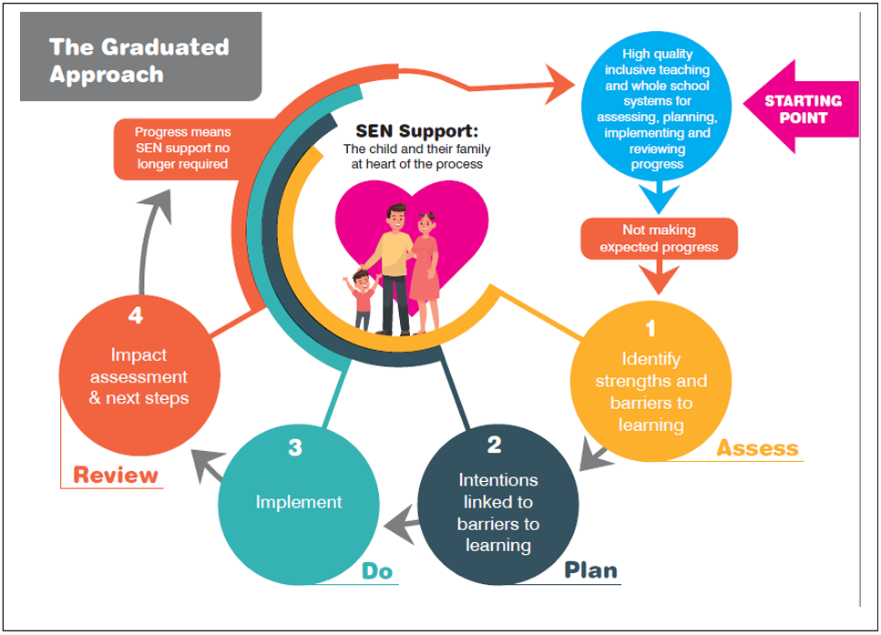
We identify SEND through assessments, observations, behaviour and attendance data, pupil discussions, parental concerns and external professional advice. Pupils may be placed on a monitoring list before SEND Support is confirmed. We follow the Assess–Plan–Do–Review (APDR) cycle for all SEND Support pupils.

4. Consulting with Children
Pupils help shape their support through discussions, visuals, feedback tools and participation in APDR reviews. For EHCPs, we use person‑centred tools to ensure pupil voice is central.

5. Consulting with Parents/Carers
Parents are partners in the process. We offer termly SEND reviews, parent evenings, open‑door access and Annual Reviews for pupils with EHCPs. Parent views inform all SEND decisions.

6. Curriculum and Teaching
All pupils receive high‑quality adaptive teaching. Strategies include scaffolding, chunking tasks, multisensory learning and targeted support. Specialist assessments support curriculum planning. TAs are deployed based on expertise (e.g., speech & language, ASD support, precision teaching).

7. Accessibility of the Environment
The school is fully accessible: ground‑floor layout, accessible toilets and changing facilities, adapted outdoor areas and risk assessments ensuring every pupil accesses all areas. Reasonable adjustments follow the Equality Act (2010).

8. Allocation of Resources
Resources are allocated based on need, provision mapping and consultation with teachers, parents and external professionals. Pupils with EHCPs receive provision outlined in their plans. All support is regularly reviewed for impact.

9. Monitoring Progress and Communication
Progress is reviewed termly through APDR cycles, SENCO monitoring, data analysis and intervention evaluations. Parents receive regular updates through meetings, reports and informal communication.

10. Staff Training
Training includes autism support, SEMH and trauma‑informed approaches, speech and language strategies, dyslexia awareness, behaviour support, adaptive teaching and de‑escalation.

11. Specialist Services Available
We work with Educational Psychologists, Specialist Teacher services, NHS Speech & Language Therapists, Occupational Therapists, CAMHS, Child Action North West, School Nursing, Social Care and other relevant agencies.

12. Preparing for Transitions
Transitions include structured programmes, enhanced visits, photo books, SENCO‑to‑SENCO handovers and Annual Review transition planning. Year 6 pupils receive additional support for secondary transfer.

13. Inclusion in Activities and Trips
Activities, after‑school clubs, trips and residentials are offered to all pupils. Risk assessments consider individual SEND needs and ensure appropriate support is available.

14. Supporting Wellbeing
We support wellbeing through the pastoral manager, emotional literacy interventions, health care plans, anti‑bullying measures, attendance monitoring and early help referrals. SEMH needs are supported through targeted strategies.

15. Evaluating Effectiveness
Provision is evaluated through APDR reviews, SEND Governor monitoring, data analysis, pupil/parent feedback, provision maps and staff consultations. SEND is part of the school’s self‑evaluation cycle.

16. Working with External Agencies
We liaise with SENDO, EPs, SaLT, CAMHS, medical professionals, social care, advisory teachers and voluntary organisations. Parental consent is sought for all referrals.

17. Complaints Procedures
Parents should first speak to class teachers, then the SENCO or Headteacher. Unresolved issues should follow the school’s Complaints Policy and may be raised with the Chair of Governors.

18. Support Services for Parents
Lancashire SENDIASS provides impartial advice for families. Website:
https://www.lancashire.gov.uk/children-education-families/special-educational-needs-and-disabilities/help-for-parents-and-carers/

19. Local Offer
Lancashire’s Local Offer outlines SEND support services across the county. Website: https://www.lancashire.gov.uk/send

20. Review Date
Reviewed: January 2026 | Next Review: January 2027 | SENCO Responsible: Mr Chris Ginty

