

**Marking & Feedback Policy**

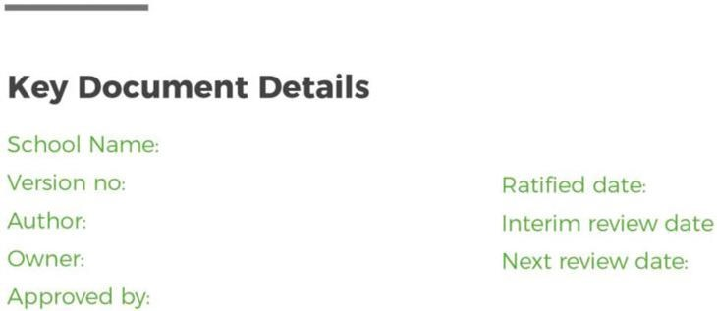

Whitelands Academy 2

F Forder

F Forder Edwards

18/12/20

24

18/12/2025

18/12/2025

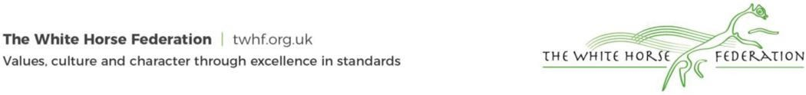

# Statement of intent

Feedback is information provided to the student, allowing them to understand how they can move their learning forward to result in rapid progress. Through research based on Teacher Toolkit, Sec-ed and the EEF we do not promote written feedback in books. This is, however, used in some subject areas. We rely on live feedback to support students actively during tasks and the lesson itself.

The scheduled review date December 2025

# How will students receive feedback?

Students will receive regular feedback through a number of different methods:

# Assessment feedback

Students will sit two assessments annually according to the assessment calendar. Feedback will be given as a percentage in line with White Horse Federation policy.

Following assessments, students will receive a feedback lesson, where feedback is provided to the class and common learning errors or misconceptions are challenged and refined.

These assessments will then be reported through Individual School Monitoring reports that will get sent home twice per year. Included in this will also be an effort grade.

Marks for KS4 GCSE mocks will be recorded at the question level to allow question level analysis to take place. Teachers will then provide class feedback. The question level analysis will be used to inform curriculum planning, interventions and bespoke support for relevant students.

# Whole class feedback

Following each task, teachers will discuss the answers. Students are to reflect on their own answers and improve learning using a green pen.

Teachers may use the following teaching methods to understand where students within the class are making learning errors and correct them in front of the whole class so that students have a clear understanding of why it is an error and how it can be improved.

1. Tracking not watching – teachers circulate looking for errors or mis-conceptions to be challenged and corrected.
2. Show call – teachers show student’s work under the visualiser to model to the class what makes a brilliant answer and how to improve answers.
3. Cold call – teachers ask students to answer questions

# Individual verbal feedback

During ‘Tracking not watching’ teachers will speak to individual students about their work and their learning.

# Peer feedback

There may be tasks where students assess their partners’ work and provide feedback with guidance from their teacher, particularly with multi choice or short answer questions.

# Quiz feedback

Students will receive immediate understanding from recall quizzes at the beginning of lessons and home learning on which questions they could correctly answer and which they could not.

# How do we expect students to use their feedback?

Students are expected to engage with each type of feedback by reflecting on how the feedback relates to their own learning. Students are then expected to improve their answer using green pen. Time is given in class to make the corrections required.