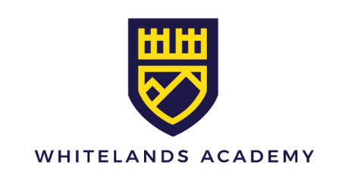
Year 10 Mocks June 2026

 | Friday 12th June 2026 | Monday 15th June 2026 | Tuesday 16th June 2026 | Wednesday 17th June 2026 | Thursday 18th June 2026 | Friday 19th June 2026 | Monday 22nd June 2026 | Tuesday 23rd June 2026 | Wednesday 24th June 2026 | Thursday 25th June 2026 | Friday 26th June 2026
Session 1  08:00  Till  11:00 |  |  |  |  | Drama NEA | Year 11 Leavers | Maths Calculator Paper  Foundation & Higher  X hr X mins | Physics Paper  Combined Science  1 hr 15 mins  Separate Science  1 hr 45 mins | Maths  Non – Calculator Paper  Foundation & Higher  X hr X mins | Spanish & French  Listening & Reading Paper  SF 1 hr 30 Mins  SH 2 hrs | English Language Paper 2  1 hr 45 mins
Session 2  11:20  Till  13:20 |  |  |  |  | Drama NEA | Year 11 Leavers | Chemistry Paper  Combined Science  1 hr 15 mins  Separate Science  1 hr 45 mins | Food  Preparation & Nutrition  1 hr 45 mins | Design & Technology  2 hrs |  | Biology Paper  Combined Science  1 hr 15 mins  Separate Science  1 hr 45 mins
Session 3  14:00  Till  End of exam | History Paper  1 hr | Business Paper  X hr X mins | English Literature Paper 2  45 mins | Geography Paper  1 hr | Drama NEA | Year 11 Leavers | Religious Studies Paper  1 hr 45 mins | Drama Paper  1 hr (Section A Only) | Creative Imedia  1 Hour 30 mins | Computer Science Paper  X hr X mins | PE Paper 1  1 hr

Notes
- Students are expected to arrive at school between 08:00 and 08:15
- Session 3 on days highlighted in green will finish after the end of the ordinary school day. This is exactly as would occur in the summer examination series. Students must have made their own arrangements to travel home.
- Students may not leave the examination hall till the exam time is completed.
- Students not in an examination will attend a lesson where they can revise, they must have material with them for this
- Practical preparation sessions take place before half term on the following dates:
  - Art:
  - Drama:
  - Food:
  - Students in these sessions will be out of ordinary lessons all day, break and lunch as usual.
- We want students to become completely comfortable and confident with the examination routines, and after great success last year now wish to further refine these for our new cohort. We will be seeking feedback on the process to further inform our next set of mock examinations in February 2026 and the Summer series.

