How is school helping my child to become a successful reader?
Reading Reconsidered

At William de Yaxley, we recognise that there are many different strands that children need to become proficient with in order to become a skilled, fluent reader. This is best illustrated by Hollis Scarborough’s Reading Rope. All of the strands are necessary in order for children to become skilled readers. If a child has difficulties in one of the strands, it will make reading with fluency and understanding more difficult. For example, a child who is still decoding words will be using most of their working memory on this task rather than understanding what they are reading.
William de Yaxley has a whole school Reading Canon. These are carefully selected, high quality texts that are used to develop the children’s reading. In order to teach reading, we use techniques developed by Doug Lemov. These focus on reading quality texts to increase fluency and comprehension.
Being able to read quickly and fluently unlocks comprehension of written texts. Anything that occupies our attention limits our ability to think. If we have to spend too much time thinking about how to decode the words on the page, we will have a reduced capacity to consider the meaning of those words. In order to optimize reading fluency, all children read aloud in whole class reading lessons, using carefully chosen extracts from the Reading Canon book. All children read the text as secondary readers, (following along), while the primary reader (selected in advance by the teacher) is reading aloud in order to maximise the amount of reading done by each child in every lesson.
In the first phase of reading an extract, there will be a focus on four aspects, which you can read more about here:

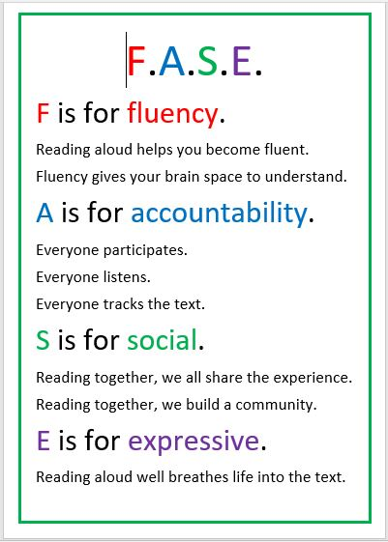
In the second phase of reading, the focus of the learning then moves to comprehension. This does not mean simply answering comprehension questions. It involves discussion of the extract, led by a carefully-selected over-arching question. For example, when reading Private Peaceful in Year 6, a question could be How do the characters change? In Year 3, reading Casting the Gods Adrift, it could be Father’s feelings are different to the feeling of the boys. How might that effect what happens next?

The children are guided through looking for evidence in the text that helps them to contribute to the discussion and enable them to answer the question. As they do so, they will highlight key words and phrases that help them answer the question as well as annotate the text to show they have understood what the evidence is telling them.

Reading is more than lifting the words from the page. Children need a rich vocabulary and background knowledge to help them understand the words they are reading. Our Reading Canon has been carefully selected to ensure all children develop a broad and deep vocabulary and background knowledge to develop their reading comprehension. We also read in other curriculum areas to further develop this.
Across the school, specific reading techniques are used to ensure that all children join in with reading aloud. These include repeated reading and close reading sections of text. Additional scaffolding may be required for children who need it. For example, the teacher informs the child in advance which part they will be expected to read, and children may pre-read the text with an adult ahead of the whole class lesson. Teachers plan in advance which child reads which part of the text in order to challenge more fluent readers or to ensure those extra practice for those wo need it. Teachers also carefully select vocabulary from the text to teach explicitly in order to improve fluency and understanding.
We run our reading lessons in this way in order to expose all children to high-quality literature and develop their fluency and prosody, to increase their vocabulary breadth and depth and to build high-quality reading miles.

