William de Yaxley C of E Academy



SEND Policy/Information Report 2025/26

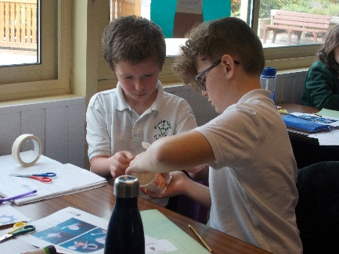
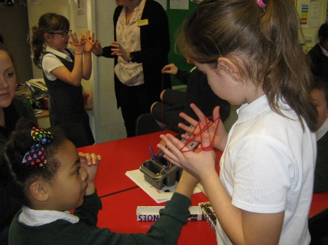

Introduction

This policy complies with the statutory requirement laid out in the SEND Code of Practice 0-25 (2015) Chapter 6 and has been written with reference to the following guidance and documents:

- Equality Act 2010: advice for schools (DfE February 2013)
- SEND Code of Practice 025 (2015)
- Schools SEN Information Report Regulations (2014)
- Statutory Guidance on Supporting pupils at school with medical conditions (April 2014)
- The National Curriculum in England Key Stage 1 & 2 framework document (September 2013)
- Safeguarding Policy
- Accessibility Plan
- Teachers Standards 2012
The Special Educational Needs and Disability Co-ordinator (SENDCo) is Tracey Phillips. Tracey works closely with the Head teacher and Governor responsible for Special Educational Needs and Disability. Together they ensure that the SEND policy works within the SEN Code of Practice (2015) and the Local Education Authority inclusion policies. Contact details: tphillips@williamdeyaxley.cambs.sch.uk

This policy was developed in consultation with the SENDCo, school staff and SEN Governors. It was shared with your stakeholders, including parents and families and it reflects guidance from the SEND Code of Practice 2015.

AIM

At William de Yaxley CE Academy we believe that all children have an equal right to a broad, balanced and well taught curriculum in order to fully access education. This will enable children to make accelerated and sustained progress. We aim to identify children who require special educational provision, provision that is ‘additional to and different from’ that provided within the differentiated curriculum.
In our school, the role of the Special Educational Needs and Disability Coordinator (SENDCo) includes:
- Managing the day to day operation of the school’s SEND policy
- Co-ordinating the provision for and manage the responses to children’s needs
- Providing support and advice to colleagues
- Overseeing the records of all pupils with SEND
- Acting as a link between parents and school
- Acting as the link with external agencies and other support agencies
- Monitoring and evaluating the SEND provision and reporting to the Head Teacher, SEND LINC Governor and the full Governing Body.
- Managing a range of resources to ensure appropriate provision can be made for children with SEND.

All our staff have responsibility for pupils with SEND.

Teaching staff are aware of their responsibilities towards pupils with SEND, with our Teaching Assistants playing a key role in the support of pupils.

The ‘School Information Regulations’ require schools to provide information on Special Educational Needs and Disabilities.

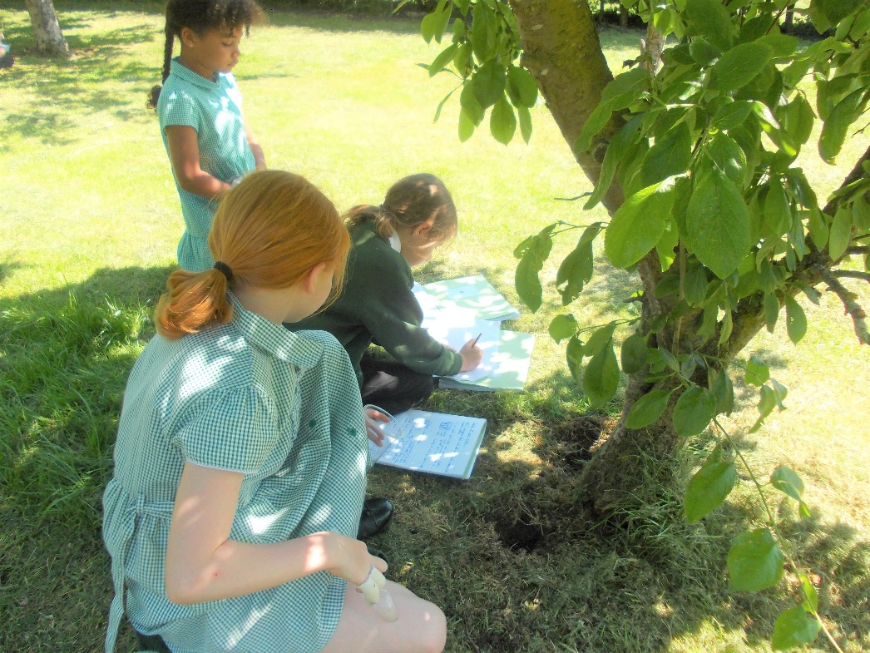

FAQ:
Below are frequently asked questions by parents who have concerns about their child’s
SEND

How does William de Yaxley CE Academy know if children need extra help and what should I do if I think my child may have special educational needs?

All pupils are assessed as they progress through the school, so that we can build upon their prior learning. Children may be considered to have a learning difficulty if:

- They have significantly greater difficulty in learning than the majority of children of a similar age.
- They have a disability which prevents or hinders them from making use of the educational facilities that are provided for other children of the same age.

We recognise that pupil’s needs should be identified and met as early as possible. The SENDCo works closely with the teaching staff using our school tracking data as an early identification indicator. Intervention is triggered where pupils:

- Make little or no progress
- Demonstrate difficulty in developing literacy or numeracy skills
- Show persistent social, emotional and mental health issues which are not affected by behaviour management strategies
- Have sensory or physical impairment and make little progress despite the provision of specialist equipment
- Experience communication and/or interaction problems and make limited or no progress despite accessing a differentiated curriculum

The Class Teacher is the first point of contact for parents / carers who think their child has additional needs. They would also inform parents / carers at the earliest opportunity to alert them of any concerns. Following this, the Class Teacher may liaise with the Special Educational Needs and Disability Co-ordinator (SENDCo) for further advice and guidance. A meeting may then be arranged with parents/carers if it is felt supplementary assessments or investigations are required. An intervention might be put into place that is different from, or in addition to, those provided as part of the school’s usual work practice.

How will William de Yaxley CE Academy staff support my child?

At William de Yaxley CE Academy we offer many different forms of additional provision. This can include: additional in-class support, additional out-of-class support, one to one support, flexible groupings (including small group work), access to specific resources, mentoring and access to a range of outside agencies.
Additional provision is overseen by the school’s SENDCO and is designed and implemented by the teachers, supported by our teaching assistants.
For many children, targets will be connected to learning and will often be specifically to do with literacy and numeracy. For other children, they may be to do with social interaction, communicating with children and adults, emotional difficulties, overcoming physical issues (e.g. problems with fine motor control). Additional provision depends on the needs of the child.
The Class Teacher plans for all of the pupils in her/his class and adapts tasks and activities accordingly to suit the pupil’s individual needs. The Class Teacher is also responsible for the assessment of each child’s progress.
Children are taught as a whole class, as groups, or sometimes individually by both the Class Teacher and Teaching Assistants.
Pupil Progress meetings/Data Driven Discussions are held with the Head Teacher and members of the Senior Leadership Team (SLT) at the beginning of each term to discuss the progress of pupils. The shared discussions will highlight what further support or intervention may be needed to increase progress and narrow or close the gap between the identified child and his/her peers in order to meet end of year targets.
A formal review is held once a year if a child has an Education Health Care Plan to discuss the child’s progress, their current areas of special needs and any additional, newly identified needs.
The additional needs are met through intervention groups and progress is monitored and recorded by class teachers in consultation with SENDCo and SLT. Examples of intervention groups are: Fine Motor Skills, Co-ordination, Memory, Speech and Language programmes, Nurture groups, Catch-up and Keep – up groups, closing the gap approaches. Where necessary, a pupil centred plan outlining targets and strategies planned for your child’s intervention groups will be created and shared with the child, parents and carers. Your child’s view is valued and is an important part of the process.
If your child needs expert support from an outside agency such as Occupational Therapy or a Community Paediatrician, or the Speech and Language Therapy Service, Specialist teaching team or Younited a referral will be made with your consent.

The Governors of William de Yaxley CE Academy are responsible for the overseeing of all procedures in school and regularly spend time in school.

How will the curriculum be matched to my child’s needs?

All children have an entitlement to a broad and balanced curriculum. At William de Yaxley CE Academy, pupils benefit from a range of teaching and learning styles, a carefully
Adapted/scaffolded curriculum, with clear learning objectives, a range of differentiated learning materials and assessment procedures that emphasise pupils’ strengths and achievements. Observation and assessment are used to inform the pupils’ next stage of learning. A broad range of extra-curricular activities, including residential visits, clubs, access to IT etc. enrich learning experiences at William de Yaxley CE Academy.
We recognise that our pupils make progress in many ways, not only through academic achievement. We teach using approaches that develop confidence, resilience and independence across our curriculum. The children are exposed to a variety of opportunities where they can apply these skills throughout the whole school.

How will I know how my child is doing and how will you help me to support my child’s learning?

A child with Special Educational Needs and/or Disabilities will have an Individual Pupil Profile along with a needs based plan in the form of an Assess Plan Do Review (APDR) or SEN support plan. These set out targets that are currently being worked on and outline the additional provision in place for her/ him. The content of the plan is discussed with the child’s parents or carers and the child. Parents’ Evenings are held twice a year to discuss your child’s progress with class teachers. Assessment data is shared at these meetings. At the end of each year you will receive a written report outlining progress made over the year and targets set for the following year.

What support will there be for my child’s overall well-being?

Your child’s well-being and emotional health is as important as their academic progress. Teachers plan for the holistic development of each child in his/her class, using their detailed knowledge of each individual to promote confidence and raise self-esteem. The school offers a variety of pastoral support for pupils who are encountering emotional difficulties, including:
- Teachers, Teaching Assistants and lunchtime staff who are readily available to discuss issues and concerns
- Additional, small group and individual support programmes eg. Nurture group, Mental Health First Aider, Mentorship plus access to qualified therapists via the Ormiston Families network
- If a pupil has a medical need then a detailed Health Care Plan is compiled with support from the NHS professional involved with the child, in consultation with parents/carers.
- Teaching Assistants and lunchtime staff are trained in first aid. In agreement with parents/carers, medicines are administered in school only where a signed medical consent form is in place. This is to ensure the safety of both child and staff member.
We pride ourselves on how we promote children’s well-being and emotional health at William de Yaxley CE Academy.

What specialist services and expertise are available at, or accessed by, the school?

Senior leaders, teachers and teaching assistants are skilled in meeting the individual learning, emotional, behavioural and social needs of our children.
The school accesses a range of specialist services including:
  - Speech and Language Therapist
  - Occupational Therapist
  - Educational Psychologists
  - Educational Welfare Officer
  - Vision and Hearing Support
  - Social Care
  - Family Support Worker
  - Community Paediatricians
  - Specialist Teaching Team
  - School Nurse
  - Younited

What training is provided for staff supporting children with SEND receive?

Different members of staff have received training related to SEND, including sessions on:
- Autism awareness
- Social Communication Difficulties
- Speech and Language
- Dyslexia
- Occupational Therapy and strategies to use within the classroom
- Social Emotional and Mental Health Needs
- First Aid
Staff Development is ongoing.

How will my child be included in activities outside the classroom including school trips?

At William de Yaxley CE Academy we make every effort to ensure that all our extra-curricular activities are adapted for children’s specific needs.
We are delighted by the number of pupils with Special Educational Needs and Disabilities who participate fully in school trips, residential visits, extra-curricular clubs, musical activities, sports teams and school committees. As a fully inclusive school, all children are offered the opportunity to participate in the whole school curriculum and off-site activities. The extent to which each child participates, and the levels of support received, will vary between children. We aim adapt all activities and expectations to enable all children to participate at their entry level and ability to do so.

How accessible is the school environment?

All areas of William de Yaxley CE Academy are accessible via ramps (portable and fixed). The buildings are light, classrooms have plenty of access, doors are wide and the site is both safe and secure. Individual access or PEEP arrangements are made where appropriate.

How will the school prepare and support my child when joining William de Yaxley CE Academy or transferring to a new school?

Parents and children are welcome to look around our school, see our provision and discuss how the needs of their child would be met at William de Yaxley CE Academy. Year 2 children planning to join our school as Year 3s are provided with a suite of transition visits across the summer term. Visits to support children transferring from other schools at any point in Key Stage 2 are also arranged providing the child with the opportunity to tour the buildings, meet their new Class Teacher, class mates and discuss any anxieties they may have about their move.

Transition to secondary school can be a worrying time for both parents and the child. At William de Yaxley CE Academy we arrange additional transition visits and talk at length to Secondary teachers/receiving schools about pupils’ Special Educational Needs and Disabilities. We ensure that all paperwork is shared to the Secondary school and that they are made aware of any special requirements, both educational and pastoral.

How is the decision made about how much support my child will receive?

On a daily basis the Class Teacher determines the level of support for individual children within the class. When children whose SEND circumstances or health requirements indicate that additional support may be required, discussions are held between the Class Teacher and senior leaders to determine what this may be. Typically, this support continues to be provided from within the class but may be targeted at specific times of the day. If evidence (over pre-specified timescales and pre-determined processes) suggests that a higher level of support or funding may be beneficial, this will be agreed by senior leaders and applications for assessment by and/or involvement with outside agencies may be made in consultation with parents.

How will I be involved in discussions about and planning for my child’s education?

All parents are encouraged to contribute to their child’s education. This may be through:

- Discussions with the Class Teacher
- EHCP Annual reviews
- Informal meetings with teaching staff and/or SENDCo
- Parent consultation evenings
- Discussions with other professionals
- Secondary and KS1 Parents transition meetings
- Questionnaires
- Achievement and Celebration assemblies

Who can I contact for further information or if I have any issues or concerns?

The first point of contact for anything related to your child’s education is the Class Teacher. We use Class DOJO to regularly communicate with parents and carers, or an appointment can be made for a mutually convenient time via the School Office. Please telephone the school office (01733 240323) to make an appointment. We encourage parents not to wait for the next formal opportunity to meet, but to contact us as the need arises. We will always endeavour to work with parents and carers to solve any problems or address any concerns. However, should you feel that despite meeting with members of staff, your concerns have not been fully addressed you can follow the procedures outlined in our school complaints policy, which is on our school website under policies. All local authorities working with their partners must publish information about how children and young people 0 – 25yrs, who have special educational needs and /or disabilities (SEND) are supported in their area. This is known as the local offer and it is part of the SEND reforms under the Children and Families Act 2014.

Cambridgeshire local offer
If you need help to find information, you can contact the Families and Childcare by Telephone on 0345 045 1360. Email local.offer@cambridgeshire.gov.uk
Or visit their website –
https://info.cambridgeshire.gov.uk/kb5/cambridgeshire/directory/family.page?camfamilychannel=0
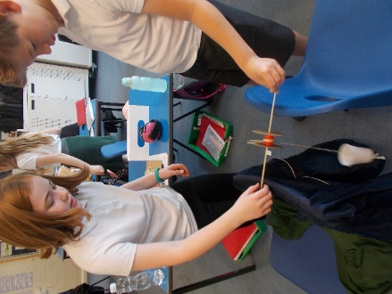
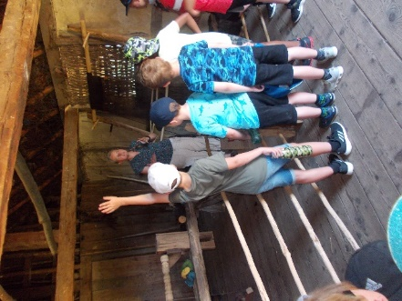

OBJECTIVES
- To identify and provide for pupils who have special educational needs and additional needs
- To work within the guidance provided in the SEND Code of Practice, 2015
- To operate a ‘whole pupil, whole school’ approach to the management and provision of support for special educational needs
- To provide training, support and advice for all staff working with special educational needs pupils
- Create an environment that meets the special educational needs of each child in order for them to achieve their individual learning potential
- To work closely with parents, carers and external agencies to meet the needs of pupils

IDENTIFYING SPECIAL EDUCATIONAL NEEDS

There are four broad areas of need and these categories are detailed in the SEND Code of Practice (2015) as:
- Communication and Interaction
- Cognition and Learning
- Social, emotional and mental health difficulties
- Sensory and/or physical needs
The purpose of identification is to decide what action the school needs to take in order for the needs of the pupil to be met.
At William de Yaxley we identify the needs of pupils by considering the needs of the whole child which will include not just the special educational needs of the child or young person.
The following may impact on progress and attainment but are not SEN:

Disability (the CoP outlines the ‘reasonable adjustment’ duty for all settings and schools provided under current Disability Equality legislation – these alone do not constitute SEN)

- Attendance and Punctuality
- Health and Welfare
- EAL
- Being in receipt of Pupil Premium Grant
- Being a Looked After Child
- Being a child of a Serviceman/woman

(NB - behavioural needs are dealt with under the schools ‘Behaviour Policy’ unless they are linked to SEND)

Pupil progress is rigorously monitored by class teachers and the leadership team to identify and address gaps in learning or barriers to learning.
Pupil progress data is collected, analysed and tracked half termly throughout the year, thereby highlighting those children who may need additional investigation to determine if they have a special education need.
Slow progress and low attainment do not necessarily mean that a child has special educational needs and should not automatically lead to a child being reported as such. Equally it should not be assumed that attainment in line with chronological age means there is no learning difficulty or disability.

Class teachers are accountable and responsible for the progress and development of all children in their class. Children may also have access to TA support or specialist support staff at times.

However, additional intervention and support cannot compensate for a lack of good quality teaching.

Children’s need’s will be met largely through quality first teaching and in class individualised differentiated provision. It is the class teacher’s responsibility to tailor provision to meet the individual needs within their class.

When identifying those children with SEND, the SENDCO and teacher will consider the collective information gathered about pupil progress, alongside national data and expectations of progress. For higher levels of need the SENCDO and teachers will use effective tools, assessment materials and specialised assessment from the Specialist Teaching Team or external agencies such as Educational Psychologists and Community Paediatricians.

A GRADUATED APPROACH TO SEND SUPPORT

There will be a graduated response to identification of SEND allowing actions and objectives to be revised and revisited. The Assess, Plan, Do, Review model will be implemented to ensure that the child’s needs are met. A child’s needs may invariably change, highlighting the need for this graduated response.

ASSESS
A thorough assessment of the needs of an individual pupil is carried out drawing information from a wide range of sources, sometimes including external agencies, as well as the views of the parents.

PLAN
Where it is decided to provide a pupil with additional support (following a thorough assessment) the parents, teacher, SENDCo and any other agencies involved agree the adjustments, interventions and support to be put in place. A plan is written providing details of support which is reviewed, maintaining a clear collaboration between school staff, the child and the child’s family and professionals.

DO
The class teacher remains responsible for working with the pupil on a daily basis. Where interventions involve group or one-to-one teaching away from the main class, they still retain responsibility for the pupil. The class teacher works closely with teaching assistants and specialist staff to plan and assess the impact of support and interventions and how they can be linked to classroom teaching.

REVIEW
The effectiveness of support and interventions and their impact on pupil progress will be reviewed and adapted regularly.

Involving Specialists

Where a pupil continues to make less than expected progress, despite targeted, evidence based support and interventions that are matched to the pupil’s area of need, the school will consult with specialists from outside agencies. We may involve specialists at any point including early identification of special educational needs and we will always request specialist advice where pupils continue to make little or no progress or where they work substantially below age related expectations.
Where assessment indicates that support from specialist services is required, we endeavour to ensure that children receive this as quickly as possible through the Cambridgeshire Local Offer. More information about the local offer can be found by following this link to the Cambridgeshire Local Authority website:

http://www.cambridgeshire.gov.uk/info/20136/special_educational_needs_and_disabilities /532/age_5_-_16/2
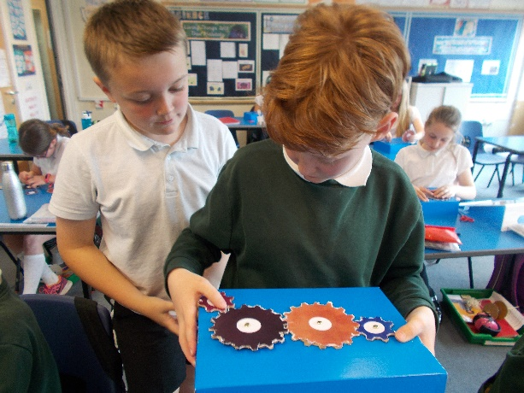

REQUESTING AN EARLY HELP ASSESSMENT:
Through the Cambridgeshire County Council the school can request the help of Specialist Teachers from the SEND specialist services. In addition to the support provided by Cambridgeshire County Council the school can also request support from:

- The Diocese of Ely Multi Academy Trust
- Educational psychologists (NHS)
- Speech and language therapists (NHS)
- Occupational therapists / Physiotherapists (NHS)
- Child and Adolescent Mental Health Services (CAMHS)
- School Nursing Team
- Family Support Workers (Locality Team)
- SEN and Disability Information, Advice and Support Service (SENDIASS)

All requests for support are made by the SENDCO, Miss Tracey Phillips in consultation with parents/carers.

REQUESTING AN EDUCATIONAL HEALTH AND CARE PLAN ASSESSMENT

- If a pupil demonstrates significant cause for concern the school can request an Education, Health and Care Plan from the Local Authority (LA). This is a request for additional support above and beyond the provision already made by the school. The school will submit detailed information about the child’s progress over time including references to any additional support the child has already received. The evidence submitted by the school will include:

- Previous support plans and targets for the pupil
- Records of reviews and their outcomes
- Records of the child’s health and medical history where appropriate
- Progress in the literacy and numeracy national curriculum
- Education and other assessments, for example from a specialist teacher or educational psychologist
- Views of the parents and pupils
- The parents of any child who is referred for statutory assessment will be kept fully informed of the progress of the referral. Children with an EHCP will have their progress reviewed each term in addition to the statutory annual review. When this coincides with transfer to secondary school, the SENDCo from the secondary school will be informed of the outcome of the review.

SUPPORTING FAMILIES AND PUPILS

Partnership plays a key role in enabling children and young people with special educational needs to achieve their potential. We value the information, knowledge and experience parents contribute to gain an overall view of a child’s needs. All parents of children with special educational needs are treated as partners and given support to play an active and valued role in their child’s education. Parental concerns about a child’s progress are taken seriously and dealt with sensitively. At all stages of the special needs process, the school aims to keep parents informed and involved. We take account of the wishes, feelings and knowledge of parents and have regular meetings each term to share information and review progress. We inform the parents of any outside intervention, and share the process of decision-making by providing clear information relating to the education of their child. Wherever possible the voice of the child in any decision making will also be evident.

Parents can always contact the SENCO through a school email address which is Office@williamdeyaxley.cambs.sch.uk or Admin@williamdeyaxley.cambs.sch.uk

Children and young people with special educational needs often have a unique knowledge of their own needs and their views about what sort of help they would like. They are encouraged, where appropriate, to contribute to the assessment of their needs, the review and transition process.
Access arrangements are made for all pupils with special educational needs to ensure that they can take a full and active role in the life of the school. Adaptations are made to teaching and learning methods and additional equipment can be provided if needed. We set clear targets for pupils and take all necessary measures to enable these to be met. If necessary, adjustments can be made to tests and examinations so that pupils with special educational needs have the opportunity to perform to the best of their ability. Wherever possible, we do not withdraw children from the classroom situation. There are times though, when to maximise learning, we ask the children to work in small groups, or in a one-to-one situation outside the classroom.

Transition

Transition, at key points throughout the school is managed effectively to minimise disruption and reduce anxiety. Communication between staff plays a critical role in ensuring that class teachers have a full and in depth understanding of a child’s needs well before they enter a new class. When a child with special educational needs makes a transition into another school (such as at the end of Key Stage 2) then this is carefully managed to ensure as smooth a transition as possible. Transition visits and meetings will take place between both settings to ensure that the child and their family have opportunities to experience their new setting in advance of transfer.

Supporting Pupils with Medical Needs and Disabilities

We recognise that pupils at school with disabilities and medical conditions should be properly supported so that they have full access to education, including school trips and physical education. Some children with medical conditions may be disabled and where this is the case the school will comply with its duties under the Equality Act 2010. We are a fully accessible site. We have an electrical accessibility door between the main building and the playground, a dedicated space for physio therapy and a spacious disabled toilet. Some pupils may also have special educational needs (SEN) and may have an Education, Health and Care Plan (EHCP) which brings together details of health and social care needs as well as special educational provision.

Children with medical needs are supported in accordance with our ‘Supporting Pupils with Medical Conditions Policy.’ This policy is available on the school website www.williamdeyaxley.cambs.sch.uk

Evaluation and Review

The SENDCo meets regularly with class teachers, pupils and parents to monitor the implementation of this policy and the impact of SEND support. Progress is monitored and tracked on a regular basis. Reviews are carried out on a termly basis.

The Head Teacher submits termly reports to the Governing Body which gives details of outcomes for pupils with SEND.
The Governing Body challenges the school and its members to secure necessary provision for any pupil identified as having special educational needs or a disability. They ask probing questions to ensure all teachers are aware of the importance of providing for these children and ensure that funds and resources are used effectively. Children with special educational needs are admitted to the school in line with the school’s agreed Admissions Policy.

Training and Resources

If the SENDCo identifies teachers or teaching assistants who require additional support in order to meet the requirements of this policy, then individual specific training is provided. If a child is identified as having a specific need and teachers or teaching assistants would benefit from further specific training this is identified and provided. This may involve all the staff or just the relevant personnel at the time. All members of personnel who come into contact with a child who has specific needs will receive relevant training; this includes office staff, catering staff and midday supervisors.

Roles and Responsibilities

Parents are expected to work in partnership with the school to share important information and support the implementation of pupil targets, and EHCPs.
All pupils, including those identified as having a SEND need, are expected to work hard, to achieve their targets and share important information about their learning with parents and teachers.

The Governing Body are responsible for ensuring the school has a qualified teacher designated as SENDCo; monitoring the implementation of this policy and the quality of the school’s SEND provision; allocating adequate resources to support identified pupils and monitoring the delivery of pupils support/ECHPs (admitting pupils identified with SEND in line with the school Admission Policy).

Teachers are responsible for identifying special educational needs, adapting their teaching and learning methods to meet the needs of pupils, implementing pupil support and EHCPs, assessing and reporting on the progress of pupils, communicating effectively with pupils, parents and the SENDCo, raising concerns about individual pupils

The SENDCo has day-to-day responsibility for the operation of SEND policy and coordination of specific provision made to support individual pupils with SEND, including those who have EHC plans. The SENDCo provides professional guidance to colleagues and will work closely with staff, parents and other agencies.
The SENDCo should be aware of the provision in the Local Offer and be able to work with professionals providing a support role to families to ensure that pupils with SEND receive appropriate support and high quality teaching.

The key responsibilities of the SENDCo may include:

- overseeing the day-to-day operation of the school’s SEND policy
- co-ordinating provision for children with SEND
- liaising with the relevant Designated Teacher where a looked after pupil has SEND
- advising on the graduated approach to providing SEND support
- advising on the deployment of the school’s delegated budget and other resources to meet pupils’ needs effectively
- liaising with parents of pupils with SEND
- liaising with early years providers, other schools, educational psychologists, health and social care professionals, and independent or voluntary bodies
- being a key point of contact with external agencies, especially the local authority and its support services
- liaising with potential next providers of education to ensure a pupil and their parents are informed about options and a smooth transition is planned
- working with the Head Teacher and school governors to ensure that the school meets its responsibilities under the Equality Act (2010) with regard to reasonable adjustments and access arrangements
- ensuring that the school keeps the records of all pupils with SEND up to date
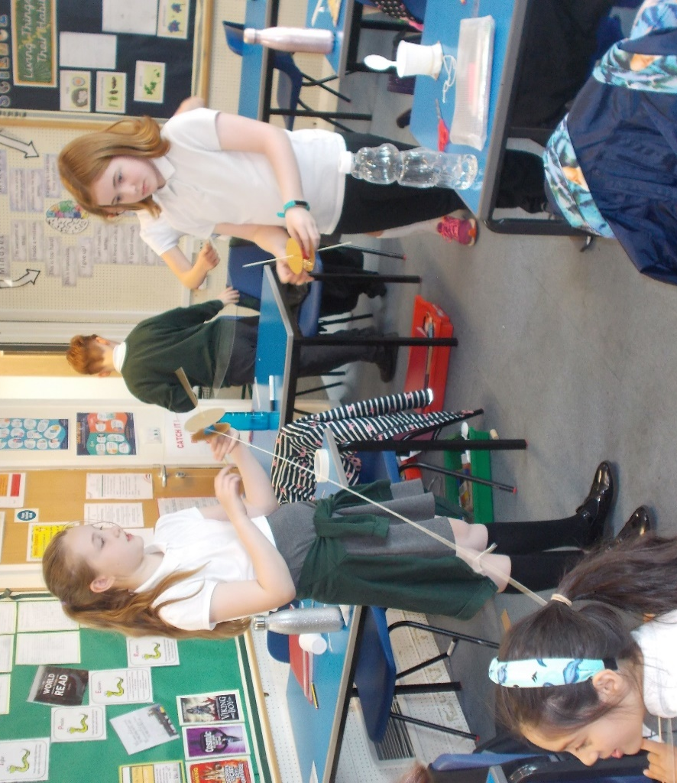

Storing and Managing Information

- All pupils identified with special educational needs have folders that are stored in a locked filing cabinet.
- The SEND folders contain assessment information, reports, ECHPs and other relevant information. Each folder also has a front sheet that provides a chronology of events relevant to the pupils’ support.
- When pupils leave the school, the folder is sent or taken to the SENDCo at the receiving school. This information can only be accessed by teachers and teaching assistants employed by the school.
- GDPR compliant

Dealing with Complaints

If you wish to make a complaint details about how to do this can be found in our
Complaints Policy, which is available on the school website via a link to all DEMAT
policies: www.williamdeyaxley.cambs.sch.uk

Approved by Governors on: _________________

Chair of Governors _____________________

Review date: September 2026.

Appendix 1

List of current SEND needs (September 2024)

There are currently 11 pupils in school with Education Health and Care plans.

Primary areas of need are:

Communication and Interaction needs -

Cognition and Learning difficulties -

Additionally, there are currently 38 children receiving provision additional to or different from that of their peers to support them in one or more area of need. (Cognition and Learning Difficulties, Social Emotional and/or Mental Health Needs, Communication and Interaction Needs, Sensory and/or Physical Needs)

