William de Yaxley CE Academy
Times tables Policy

Mathematics in the National Curriculum
An aim for mathematics teaching in Key stage 2 is to ensure that all pupils ‘become fluent in the fundamentals of mathematics, including through varied and frequent practice with increasingly complex problems over time, so that pupils develop conceptual understanding and the ability to recall and apply knowledge rapidly and accurately.’

Part of their mathematical fluency comes from children having a rapid and accurate recall of multiplication and division facts.

In our Calculation Policy we identified some of the knowledge and stages of development that children needed to have in order to have a secure grasp of multiplication. These included:

- Multiplication as repeated addition
Children can use numbered lines to support the concept of multiplication as repeated addition

3x5=
3+3+3+3+3=15 or 3, 5 times

3 3 3 3 3

0 1 2 3 4 5 6 7 8 9 10 11 12 13 14 15

It is important to remember that the other way gives the same answer:

5+5+5=15 or 5, 3 times

5 5 5

- 1 2 3 4 5 6 7 8 9 10 11 12 13 14 15

- Multiplication linked to arrays

Children can use objects to show groups or arrays, which help when counting out the answer.
Children can be challenged to look for arrays in the environment, for example window panes, egg boxes, baking trays and tiles.
Creating an array (3 rows of 4) gives children an image of the answer. It is good to show both ways as it develops the understanding that 4x3 gives the same answer as 3x4.
- Multiplication linked to scaling
Find a ribbon that is 4 times longer than the blue one.
5cm

20cm

- Multiplication as repeated addition on an empty number line

3x5=
3+3+3+3+3=15 or 3, 5 times

3 3 3 3 3

0 3 6 9 12 15

Initial benchmarking in September of year 3 will check that children have met the statutory requirements in multiplication and division for children at the end of year 2. They should be able to:
- recall and use multiplication and division facts for the 2, 5 and 10 multiplication
tables, including recognising odd and even numbers
- calculate mathematical statements for multiplication and division within the
multiplication tables and write them using the multiplication (×), division (÷) and equals (=) signs
- show that multiplication of two numbers can be done in any order (commutative) and
division of one number by another cannot
- solve problems involving multiplication and division, using materials, arrays, repeated
addition, mental methods, and multiplication and division facts, including problems in
contexts.
For those children who have not reached the expected standard at the end of year 2, teachers will use the autumn term of year 3 to help them to catch up.

In Year 3 children will be taught to:
- count from 0 in multiples of 4, 8, 50 and 100; find 10 or 100 more or less than a given
- recall and use multiplication and division facts for the 3, 4 and 8 multiplication table.
- Through doubling, they connect the 2, 4 and 8 multiplication tables.
- write and calculate mathematical statements for multiplication and division using the
multiplication tables that they know, including for two-digit numbers times one-digit
numbers, using mental and progressing to formal written methods (by applying their knowledge of times table facts)
- Pupils develop efficient mental methods, for example, using commutativity and
associativity (for example, 4 × 12 × 5 = 4 × 5 × 12 = 20 × 12 = 240) and multiplication
and division facts (for example, using 3 × 2 = 6, 6 ÷ 3 = 2 and 2 = 6 ÷ 3) to derive related
facts (for example, 30 × 2 = 60, 60 ÷ 3 = 20 and 20 = 60 ÷ 3).

In Year 4 children will be taught to:
- count in multiples of 6, 7, 9, 25 and 1000
- recall multiplication and division facts for multiplication tables up to 12 × 12
- use place value, known and derived facts to multiply and divide mentally, including:
multiplying by 0 and 1; dividing by 1; multiplying together three numbers
- recognise and use factor pairs and commutativity in mental calculations
multiply two-digit and three-digit numbers by a one-digit number using formal written(by applying their knowledge of times table facts)

Times tables in years 5
There are no specific objectives which relate to the times tables. However children will need to have secure knowledge of multiplication and division facts to be able to:
- identify multiples and factors, including finding all factor pairs of a number, and
common factors of two numbers
- know and use the vocabulary of prime numbers, prime factors and composite (nonprime) numbers
- establish whether a number up to 100 is prime and recall prime numbers up to 19
- multiply numbers up to 4 digits by a one- or two-digit number using a formal written
method, including long multiplication for two-digit numbers
- multiply and divide numbers mentally drawing upon known facts
- divide numbers up to 4 digits by a one-digit number using the formal written method
of short division and interpret remainders appropriately for the context
- multiply and divide whole numbers and those involving decimals by 10, 100 and 1000
- recognise and use square numbers and cube numbers, and the notation for squared and cubed numbers.

Times tables in year 6
There are no specific objectives which relate to the times tables. However children will need to have secure knowledge of multiplication and division facts to be able to:
- multiply multi-digit numbers up to 4 digits by a two-digit whole number using the
formal written method of long multiplication
- divide numbers up to 4 digits by a two-digit whole number using the formal written
method of long division, and interpret remainders as whole number remainders,
fractions, or by rounding, as appropriate for the context
- divide numbers up to 4 digits by a two-digit number using the formal written method
of short division where appropriate, interpreting remainders according to the context
- perform mental calculations, including with mixed operations and large numbers
- identify common factors, common multiples and prime numbers
- use their knowledge of the order of operations to carry out calculations involving the
four operations

Resources used in lessons
At William de Yaxley the primary resource we use for teaching children the multiplication and division facts is the NumberLink board. Each child should have an individual board and each teacher has an enlarged version for modelling on.

Using the NumberLink Board to learn multiplication tables with understanding
The NumberLink board uses the same principle as the counting stick, but differs in three main ways:
- It exposes the multiplicand – the number in the group or set
- It has a second line so connections can be made and patterns spotted
- Each child has their own dry-erase NumberLink board so learning can be personalised

Teaching children how to use the NumberLink board – what to write and where

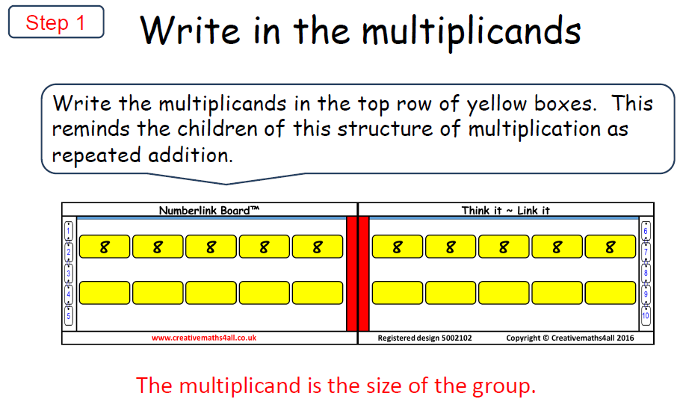

Step 1
To begin with, the children do not need to write any products on the NumberLink board. They need to be shown how the NumberLink board can show five lots of 8 – the teacher circling the first five of the multiplicands with their finger or drawing a circle around them. This needs to be around all five, not just the fifth one. This will help to indicate that multiplication can be repeated addition and it is the multiplicand which is being added repeatedly. The teacher should highlight the red line down the centre of the NumberLink board. This is an easy way of finding five lots of. The teacher should model how this can be used to identify six lots of (it is one multiplicand more than five lots of) or four lots of (it is one multiplicand less than). This strategy can also be used with the tenth multiplicand to help find the ninth. The children need to be able to do this independently. Teachers need to use the word multiplicand, so children understand that it means the size of the group.

To develop their conceptual understanding, children will need to see different resources being used alongside the NumberLink board. Coins, Numicon, dots and Dienes can all be used. They help to show children the cardinality of the number.

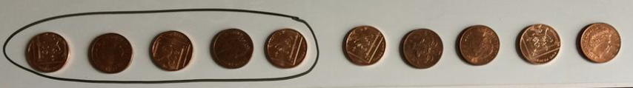

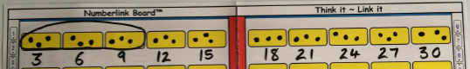

The use of resources is not just for less able children working with smaller numbers.

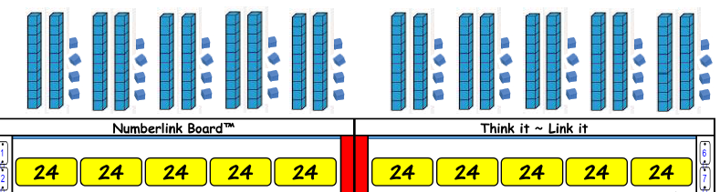

Step 2
When children know how to show ‘how many lots of’ and can correctly identify/group together the correct number of multiplicand boxes, they can be shown how to add the where the multiples. The multiples are not added in order. The teacher needs to model ‘1, 10, 5 derive’. They will model where to add the 1st, 10th and 5th multiples of the multiplicand – in the white space below the multiplicands.
The teacher will draw attention to patterns/links between the numbers, e.g. the tenth multiple is 10 times larger and the 5th multiple is half of the 10th multiple.
Children need to practice adding the 1st, 10th and 5th multiples of the multiplicand – in the white space below the multiplicands. They need to be able to do this quickly and accurately for a variety of multiplicands.

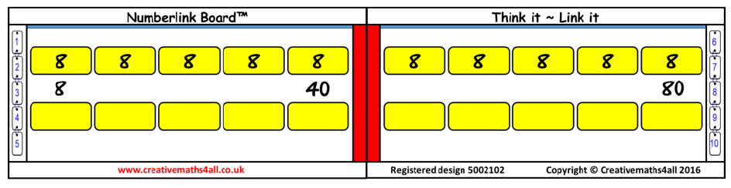

This is a great time/opportunity to make sure that children are confident, accurate and speedy at multiplying numbers by 10. They can also practise multiplying a variety of numbers by 5 mentally. For example they should be able to do the following without using a formal written method: 32 x 5, or 126 x 5, or even 6.4 x 5

Step 3
When children are confident with ‘1, 10, 5 derive’, they can be shown how to use these key facts to derive some other facts. Careful modelling at this stage can show children how to make connections to other multiples. E.g. if 8 x 5 is 40, what is 8 x 6? 48 is 8 more than 40.
If 8 x 5 is 40, what is 8 x 4? 32 is 8 less than 40.
If 8 x 10 is 80, what is 8 x 9? It is 8 less than 80. It is 72.
This DOES NOT nee to be done for all the other products.

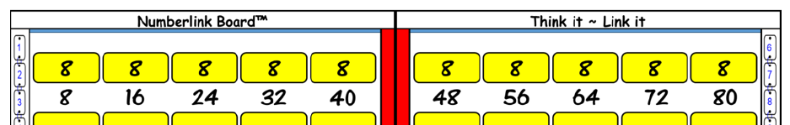
Once the key derived facts have been added the teacher can then add the remaining multiples, which are likely to be three lots, seven and eight lots.

Step 4
Practising adding multiples to improve fluency.
When children have completed a NumberLink board using ‘1, 10, 5 derive’ and then added the other multiples, they should rub off the facts that they are confident with. They should practise the times table facts that they are less confident with and then rub off another fact.

When all of the facts are removed, the multiplicand can stay on the NumberLink board to give children a picture of the structure which will strengthen the visual image of the multiplication. Children can have this on the table when they are completing times table tests. Children can be challenged to complete the board as quickly as possible, or within a given time. The children can all be working on different times tables.

Division
Division should be taught alongside or immediately after a multiplication unit, so that connections can be made. It is a good idea to go back to using concrete apparatus again.

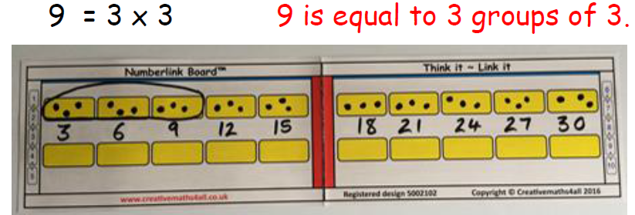

Using the concrete apparatus or representations of the number will also support early work on division with remainders:

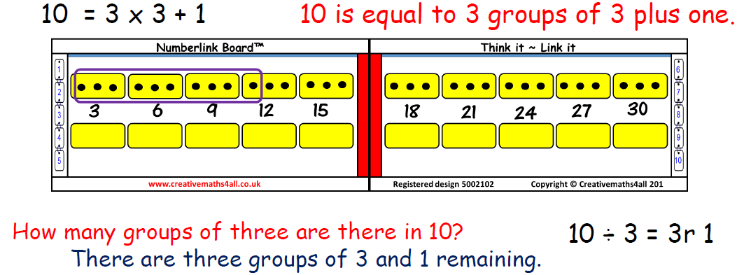

Children can be asked to identify numbers which are not multiples of 3, for example 16, 20 or 29. Can they identify numbers which are 1 more than a multiple of 3, 2 more than a multiple of 3? Can they identify numbers which are 3 more than a multiple of 3? What do they notice about these numbers? Investigations and discussion around this will help children to understand why a remainder is not larger than the divisor.

Children can use the NumberLink board to divide larger numbers. These should be related to the times table facts initially.

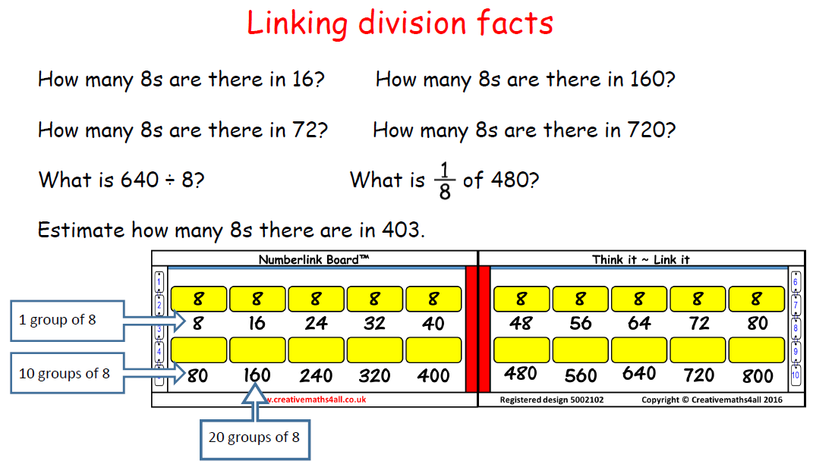

When children are confident to divide larger linked multiples, they should be asked to estimate which quotients an answer will lie between. For example: 208÷8 will lie between 20 lots of 8 (160) and 30 lots of 8 (240). They should practice doing this, without having to calculate the actual answer. Estimation is an important skill and should be taught and practised explicitly.

An appendix has been included with slides outlining some games which can be played on the Numberlink boards.

Assessment
Children are tested at least once a week on their times table knowledge. We use a bronze, silver and gold system of assessment.

Bronze tests
In all bronze tests the children need to know the multiplication facts in order. Children have 60 seconds to complete a bronze test. If they have answered all of the questions correctly within the time, they can move on to the silver test for that times table. If there are any incorrect answers, the correct answer(s) need to be written and the test sent home so that parents know which facts still need practice and learning. Children will need to take the test again. Some children may need to retake the test more than once.

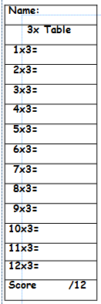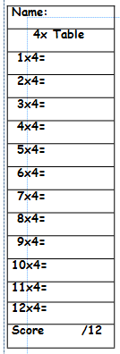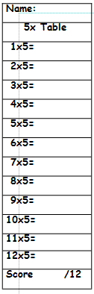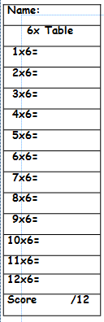

Silver tests
When children have passed the bronze test they can move straight on to the silver test. In all silver tests the children need to know the multiplication facts, but the questions are not in order. They have 60 seconds to answer all 12 questions correctly. On each sheet there are 4 different versions of the test (the same questions are in different orders), so children can be sitting next to each other working on the same times table, but not completing the same assessment. If they have answered all of the questions correctly within the time, they can move on to the gold test for that times table. If there are any incorrect answers, the correct answer(s) need to be written and the test sent home so that parents know which facts still need practice and learning. Children will need to take the test again. Some children may need to retake the test more than once.

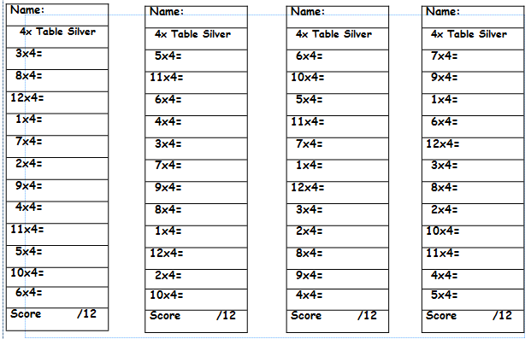

Gold tests
When children have passed the silver test they can move straight on to the gold test. In all gold tests the children need to know the division facts, but the questions are not in order. They have 60 seconds to answer all 12 questions correctly. On each sheet there are 2 different versions of the test (the same questions are in different orders), so children can be sitting next to each other working on the same times table, but not completing the same assessment. If they have answered all of the questions correctly within the time, they can move on to the bronze test for the next times table. If there are any incorrect answers, the correct answer(s) need to be written and the test sent home so that parents know which facts still need practice and learning. Children will need to take the test again. Some children may need to retake the test more than once. Some children find learning the division facts particularly difficult. For these children, it may be advisable to work through the bronze and silver tests for all of the times tables and then come back and learn the division facts separately.

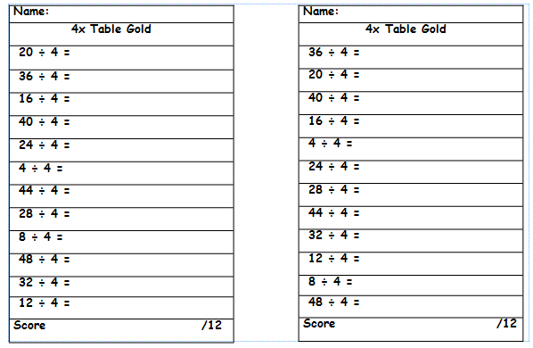

Other times table resources
As already mentioned in the NumberLink section, children need to see and use a variety of *concrete materials and pictorial representations to support their understanding of the different concepts of multiplication and division. These should be used every time children are being introduced to a new concept.

Another fantastic resource we subscribe to is Times Tables Rockstars. This is a carefully sequenced programme of times tables practice that can be accessed both online or sheets can be printed for each pupil. In the online version, incorrect answers are always immediately corrected in front of the pupil so that they start to associate the correct answer to every question.More than that, the clever code behind the scenes works out which times tables facts each pupil is consistently taking longer to answer and then it gradually starts to present these facts more frequently until pupils have mastered them. It will also ask related division questions 20% of the time in order to reinforce division facts.

*Concrete materials include: complete and empty number lines, arrays, Cuisenaire rods, coins, Dienes and counting sticks.

Appendix – games to play on the Numberlink boards

