Year group | Autumn A | Autumn B | Spring A | Spring B | Summer A | Summer B
Year 3  Asi soy yo | Introducing and describing yourself in Spanish  Saying your age in Spanish  Assess speaking and listening  Say and Write short phrases | Months of the year in Spanish  Saying the month of your birthday  Assess speaking and listening  Say and Write short phrases | Saying your name, age and birthday in Spanish  Count 1-20 in Spanish  Count in tens in Spanish  Assess speaking and listening  Say and Write short phrases | Basic Math  Mas (plus)  Menos(minus)  Por (multiplied)  Para (divide)  Examples  Dos mas dos (two plus two)  Cuatro menos uno (four minus one)  Tres por cuatro (3 multiplied by 4)  Ocho para dos (8 divided by 2)  Practise times tables  Assess speaking and listening  Say and Write short phrases | Donde Vives?  Saying your nationality  Saying which country you live in and which language you speak  Assess speaking and listening  Say and Write short phrases | Days of the week song  The seasons song  Months of the year song  Spanish Festival  Spanish cultures/artist  https://study.com/academy/lesson/spanish-speaking-culture-in-colombia.html  (Please choose a Spanish Speaking country to explore festivals and culture)  Assess speaking and listening  Say and Write short phrases
Yr 4 continue  Donde Vives?  Eso, Que es?  Me visto | Saying which language you don’t speak, which country you don’t live in and which nationality you aren’t  Saying where you live, your nationality and which language you speak  Eso, Que es?  Saying the names of 6 pets  Assess speaking and listening  Say and Write short phrases | Saying it is or isn’t a certain pet  Describing the pets with some colours  Describing pets with more colours and joining descriptions with conjunctions  Assess speaking and listening  Say and Write short phrases | Count 1-100  Count in tens  Count in 25s  Creating strange animals and describing them  Me visto  Naming items of clothing  Describing clothes using colours  Assess speaking and listening  Say and Write short phrases | Basic Math  Mas (plus)  Menos(minus)  Por (multiplied)  Para (divide)  Examples  Dos mas dos (two plus two)  Cuatro menos uno (four minus one)  Tres por cuatro (3 multiplied by 4)  Ocho para dos (8 divided by 2)  Practise times tables  Assess speaking and listening  Say and Write short phrases | Describing clothes with colours, sizes and styles  Saying clothes that you have and using a conjunction  Saying which clothes you do or don’t have and joining descriptions with a conjunction  Assess speaking and listening  Say and Write short phrases | Days of the week song  The seasons song  Months of the year song  Spanish Festival  Spanish cultures/artist  https://study.com/academy/lesson/spanish-speaking-culture-in-colombia.html  (Please choose a Spanish Speaking country to explore festivals and culture)  Assess speaking and listening  Say and Write short phrases
Yr 5  Describo un monstruo  ! A Comer! | Describing someone else’s size and colour  Describing parts of the head and face with colours and sizes  Describing parts of the head and face with colours, sizes  Assess speaking and listening  Say and Write short phrases | Describing a monster’s head and face and joining descriptions with conjunctions  Making monster description better using intensifiers  Assess speaking and listening  Say and Write short phrases | Count 1-100  Count in tens  Count in 100s  ! A Comer!  Saying some food words and saying you want to have some of these foods  Saying you or someone else is hungry, hot and cold  Assess speaking and listening  Say and Write short phrases | Basic Math  Mas (plus)  Menos(minus)  Por (multiplied)  Para (divide)  Examples  Dos mas dos (two plus two)  Cuatro menos uno (four minus one)  Tres por cuatro (3 multiplied by 4)  Ocho para dos (8 divided by 2)  Practise times tables  Assess speaking and listening  Say and Write short phrases | Giving opinions about singular foods and joining opinions using conjunctions  Giving opinions about plural foods and joining opinions using conjunctions  Giving someone else’s opinion about singular and plural foods and joining opinions using conjunctions  Assess speaking and listening  Say and Write short phrases | Days of the week song  The seasons song  Months of the year song  Spanish Festival  Spanish cultures/artist  https://study.com/academy/lesson/spanish-speaking-culture-in-colombia.html  (Please choose a Spanish Speaking country to explore festivals and culture)  Assess speaking and listening  Say and Write short phrases
Yr 6  Hago deporte  Mi pueblo | Saying different sports  Saying which sports you play and do, which sports you don’t play and do, and joining sentences using conjunctions  Giving opinions of different sports and joining opinions using conjunctions  Assess speaking and listening  Say and Write short phrases | Saying what sports you do in different weathers  Saying what kind of clothes you wear to do different sports.  Mi pueblo  Saying some places there are in town  Assess speaking and listening  Say and Write short phrases | Count 1-100  Count in tens  Count in 1000s  Saying what there is and is not in the town  Saying where in town you are going to and what transport you are taking there  Assess speaking and listening  Say and Write short phrases | Basic Math  Mas (plus)  Menos(minus)  Por (multiplied)  Para (divide)  Examples  Dos mas dos (two plus two)  Cuatro menos uno (four minus one)  Tres por cuatro (3 multiplied by 4)  Ocho para dos (8 divided by 2)  Practise times tables  Assess speaking and listening  Say and Write short phrases | Giving opinions of the town and explaining those opinions  Describing the places in town  Assess speaking and listening  Say and Write short phrases | Days of the week song  The seasons song  Months of the year song  Spanish Festival  Spanish cultures/artist  https://study.com/academy/lesson/spanish-speaking-culture-in-colombia.html  (Please choose a Spanish Speaking country to explore festivals and culture)  Assess speaking and listening  Say and Write short phrases
https://classroom.thenational.academy/units/mi-pueblo-5c2c
https://study.com/academy/lesson/spanish-speaking-culture-in-colombia.html
Days of the week song https://www.youtube.com/watch?v=C4fREj60Crk
Months of the year song https://www.youtube.com/watch?v=IKznbHvPFwc
The Seasons in Spanish for Children https://www.youtube.com/watch?v=bR7BGPMDEos
Song about the seasons https://www.youtube.com/watch?v=2s79YMrRgEU
Counting in Spanish 0-20 https://www.youtube.com/watch?v=JU9loKPhA7
Count in tens https://www.youtube.com/watch?v=pHgwUxGy08k
Counting from 1-100 with actions https://www.youtube.com/watch?v=FF717ys9Ask (My favourite)
Spanish Numbers from 100-1000 https://www.youtube.com/watch?v=Z608hl91G3Y

Verbs
Spanish conjugation animated explanation video https://www.youtube.com/watch?v=hfWcAgihqVw
Spanish verb conjugation in the present tense https://www.youtube.com/watch?v=1YANO9QTzp0
Spanish verb SER to-be https://www.youtube.com/watch?v=pdDxosGfcq0
Tener conjugation song (To have) https://www.youtube.com/watch?v=eJVbgJvdHZk
Tener (to have) https://www.youtube.com/watch?v=YJCk6y3fO9g
Vivir conjugation (to live) https://www.youtube.com/watch?v=vQukCdskUgA
Present tense ir verb (vivir) https://www.youtube.com/watch?v=eK52jgxRklw
Present tense regular verbs ending with er https://www.youtube.com/watch?v=5k6KQ-OO2uU
Present tense regular verbs ending with ar https://www.youtube.com/watch?v=3bTJ0qHk3hs
Pronouns

https://www.youtube.com/results?search_query=pronouns+in+spanish
https://www.youtube.com/results?search_query=pronouns+in+spanish demonstrative adjectives and pronouns

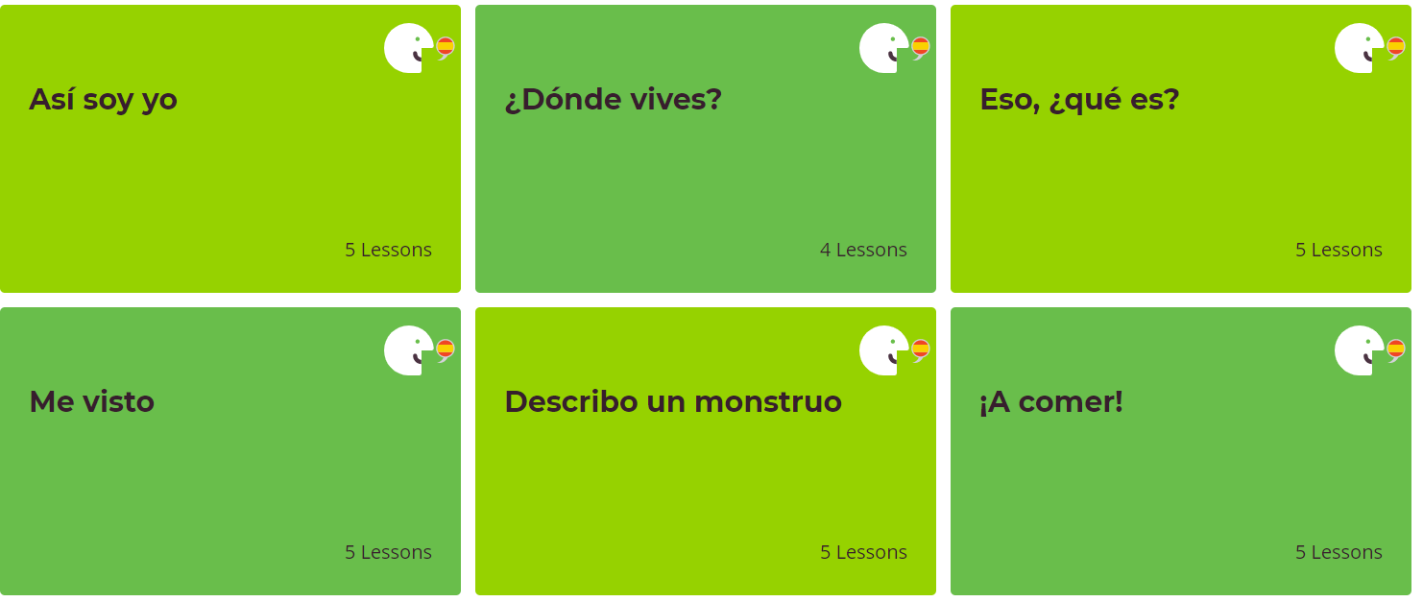
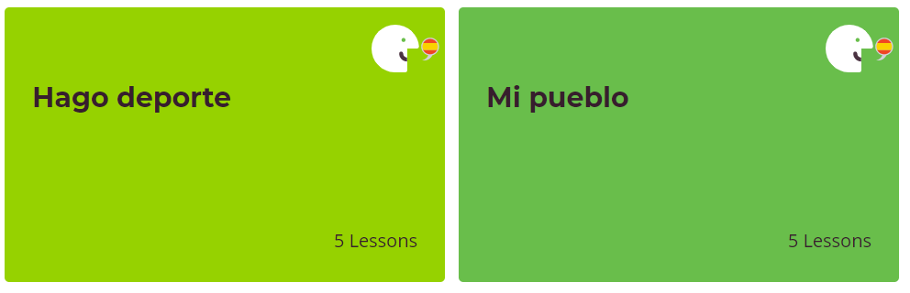

Asi soy yo | Introducing and describing yourself in Spanish  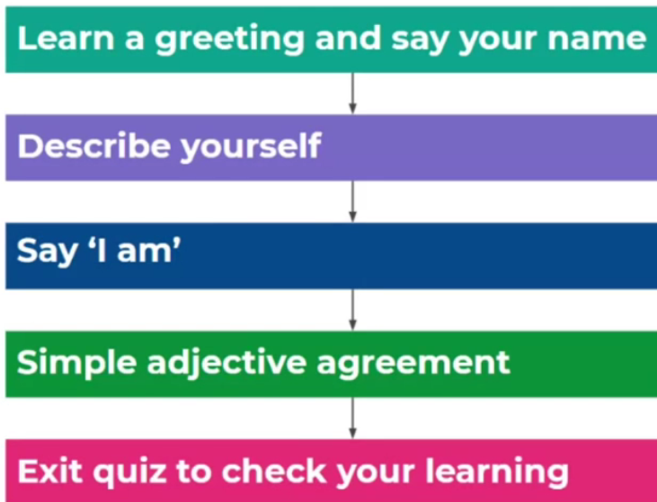 | Saying your age in Spanish  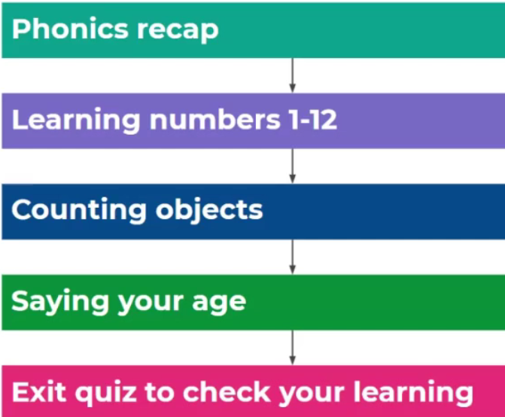 | Months of the year in Spanish  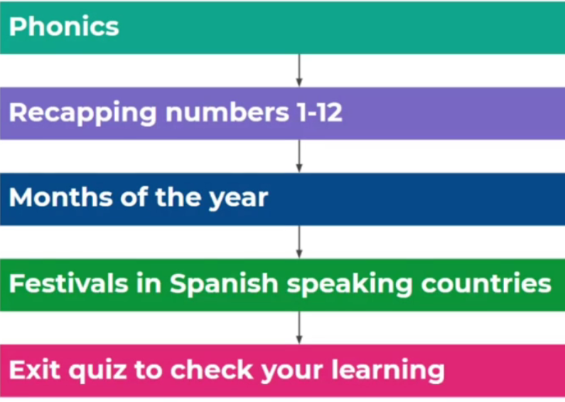 | Saying the month of your birthday  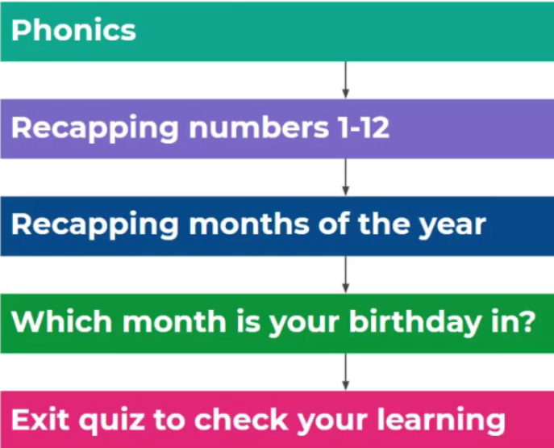 | Saying your name, age and birthday in Spanish  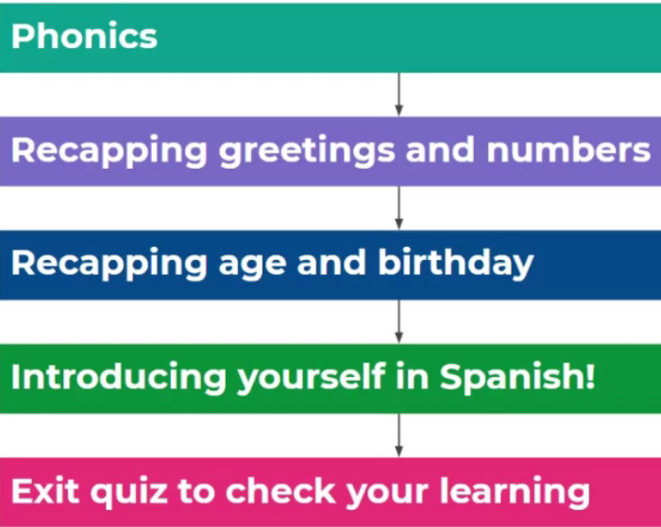
Donde Vives? | Saying your nationality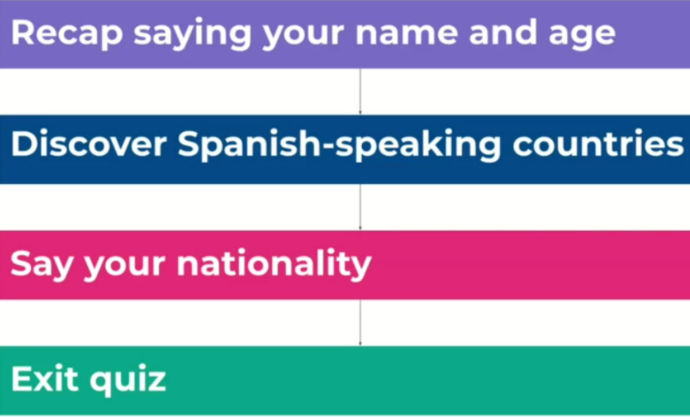 | Saying which country you live in and which language you speak  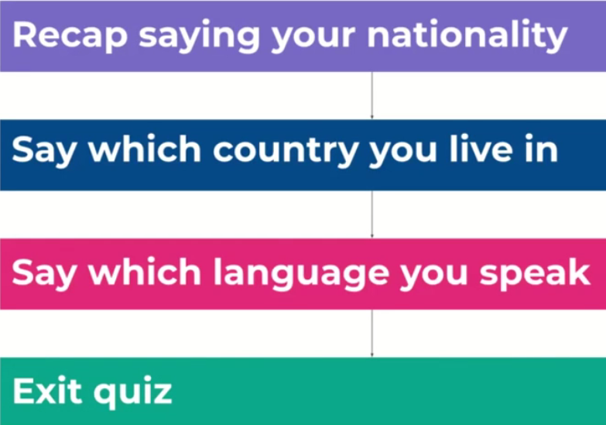 | Saying which language you don’t speak, which country you don’t live in and which nationality you aren’t  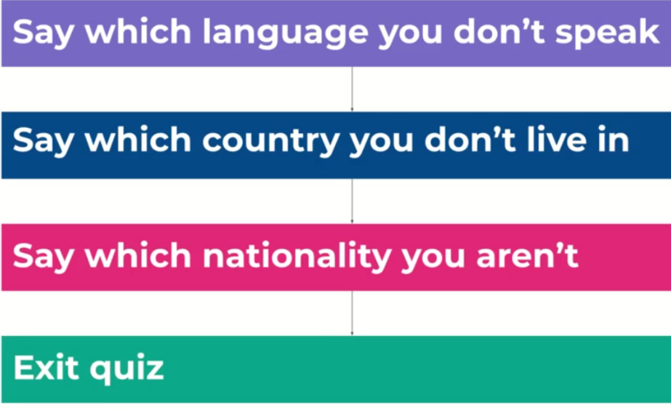 | Saying where you live, your nationality and which language you speak  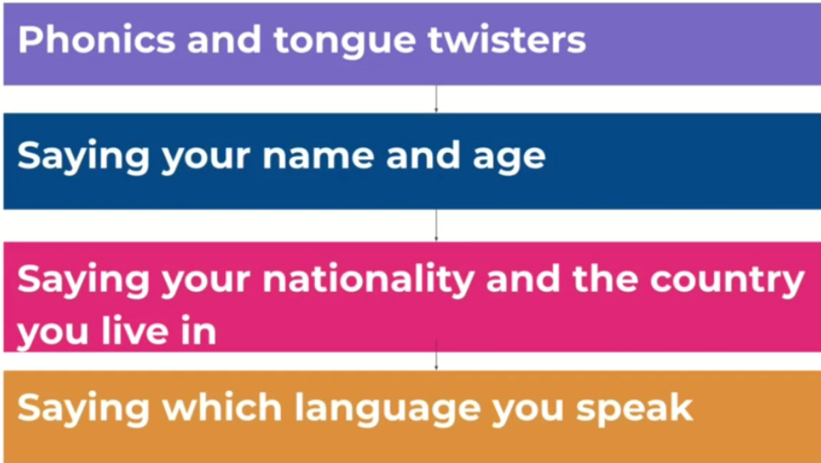
Eso, Que es? | Saying the names of 6 pets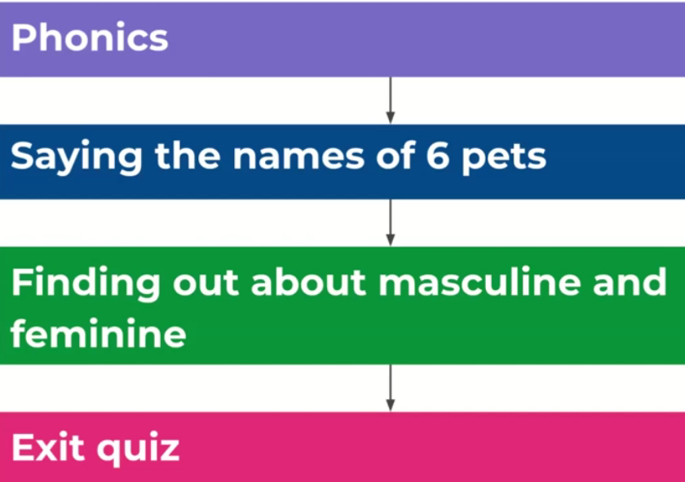 | Saying it is or isn’t a certain pet  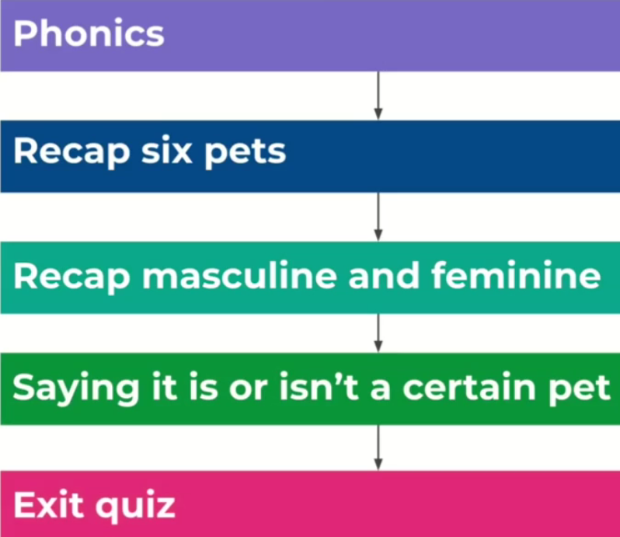 | Describing the pets with some colours  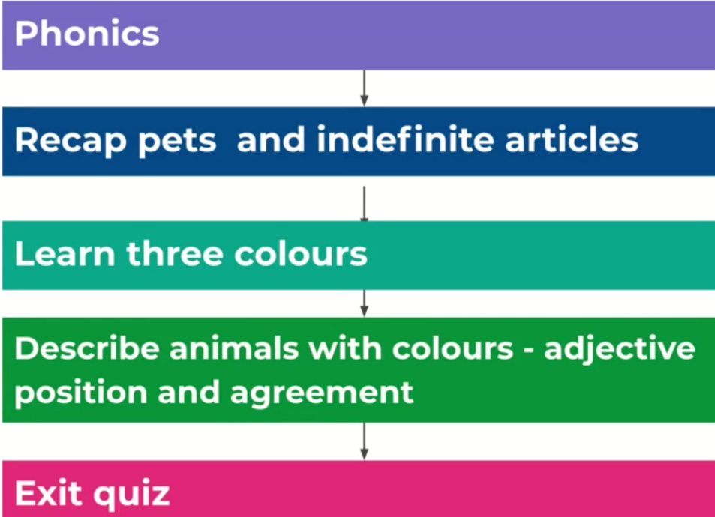 | Describing pets with more colours and joining descriptions with a conjunction  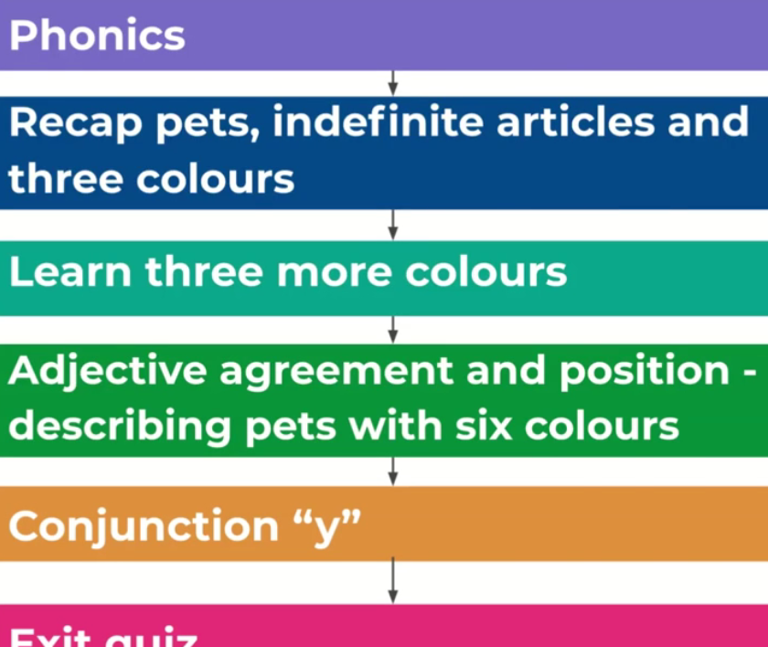 | Creating strange animals and describing them  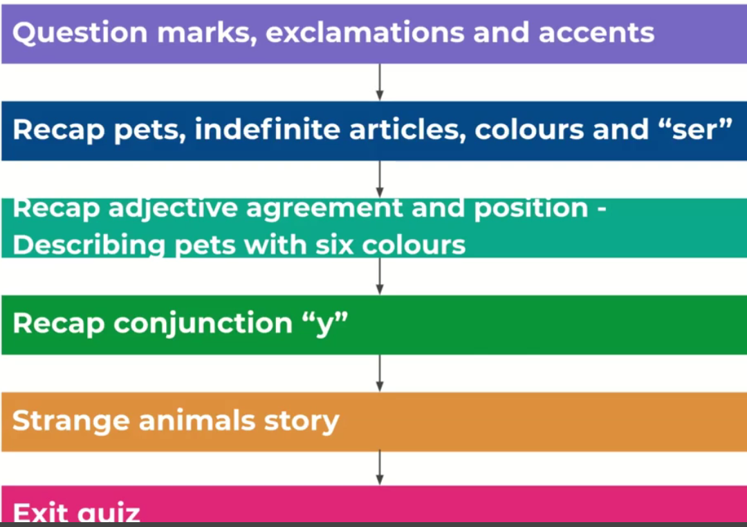
Me visto | Naming items of clothing  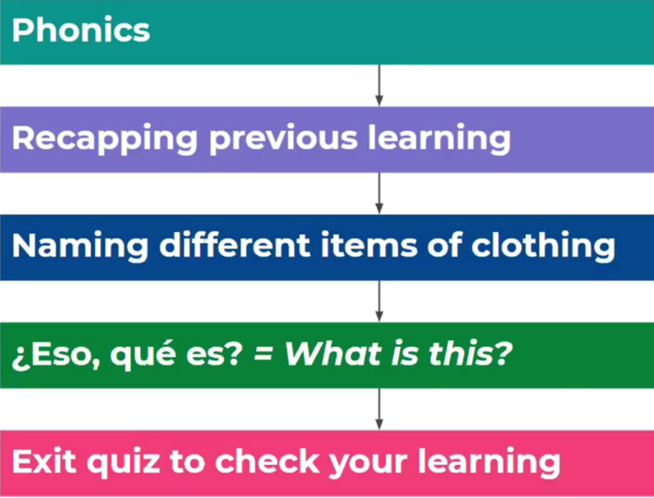 | Describing clothes using colours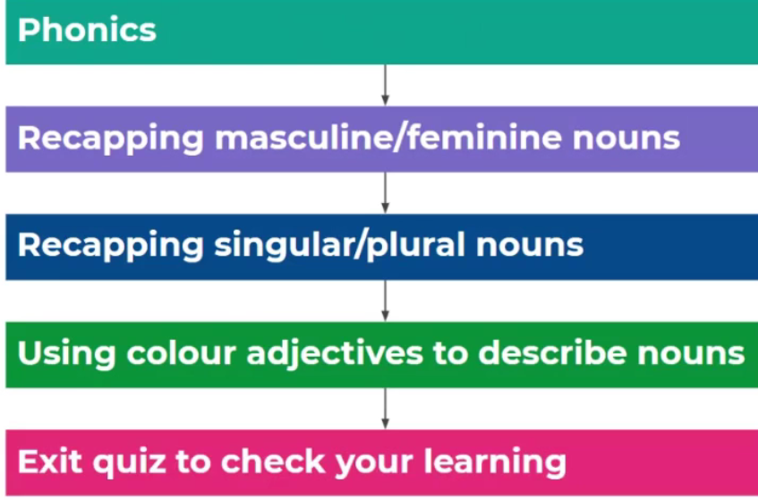 | Describing clothes with colours, sizes and styles  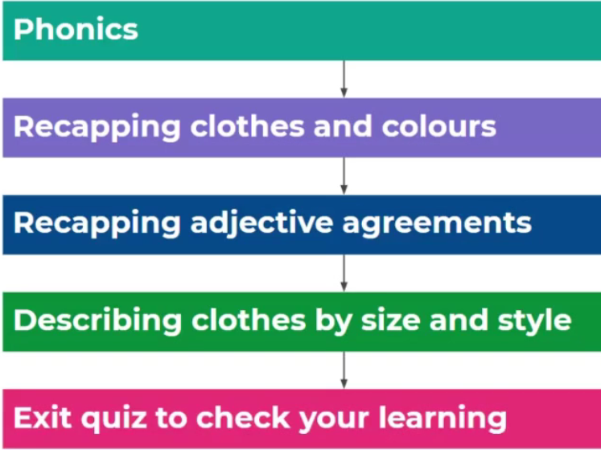 | Saying clothes that you have and using a conjunction  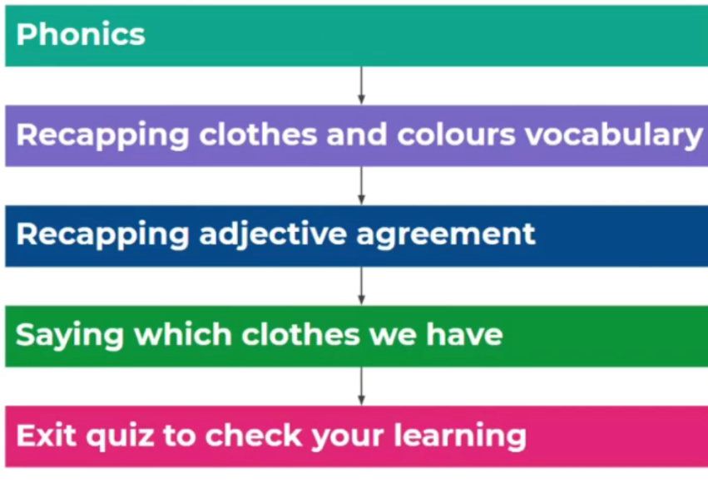 | Saying which clothes you do or don’t have and joining descriptions with a conjunction  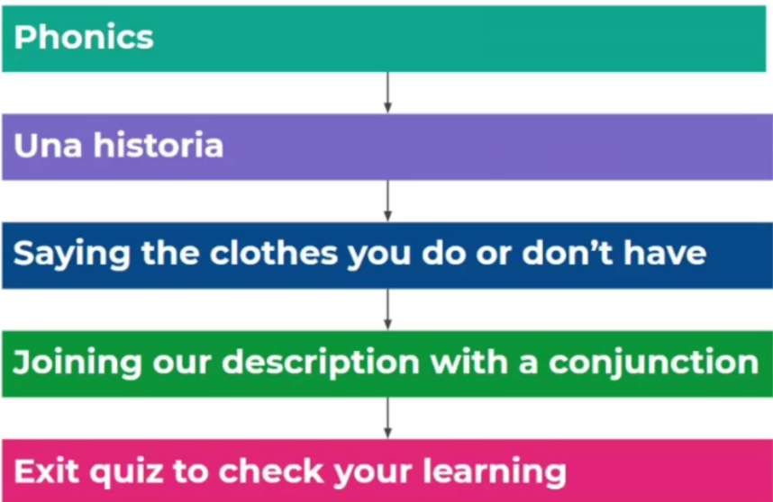
Describo un monstruo | Describing someone else’s size and colour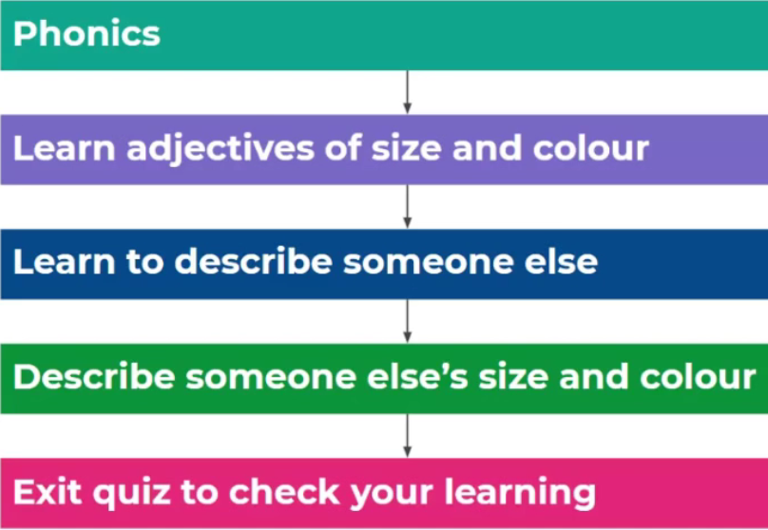 | Describing parts of the head and face with colours and sizes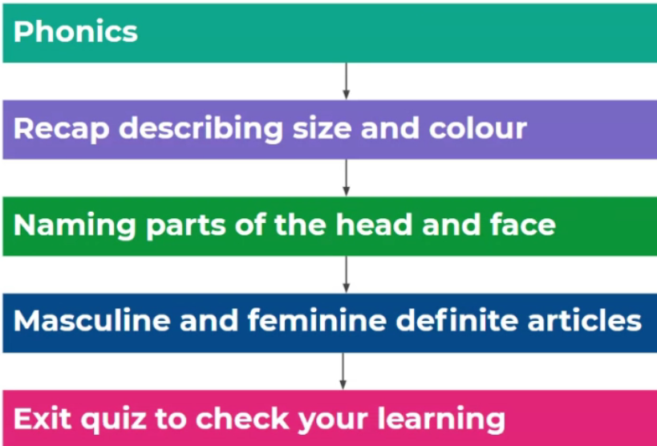 | Describing parts of the head and face with colours, sizes  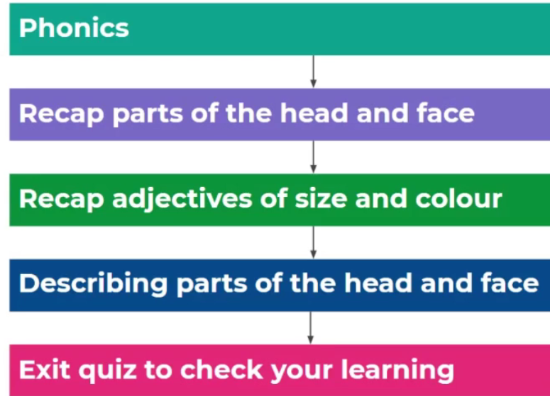 | Describing a monster’s head and face and joining descriptions with conjunctions | Making monster description better using intensifiers  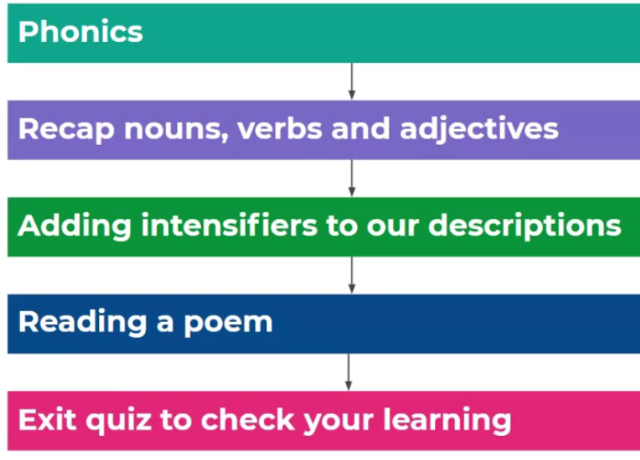
! A Comer! | Saying some food words and saying you want to have some of these foods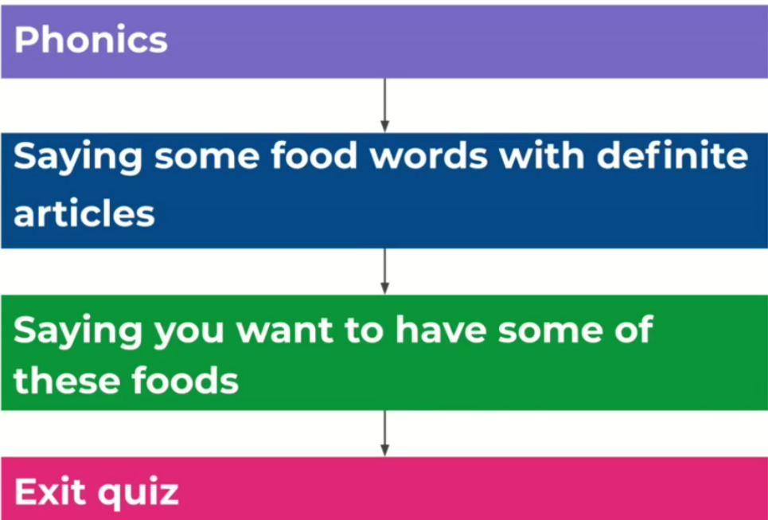 | Saying you or someone else is hungry, hot and cold  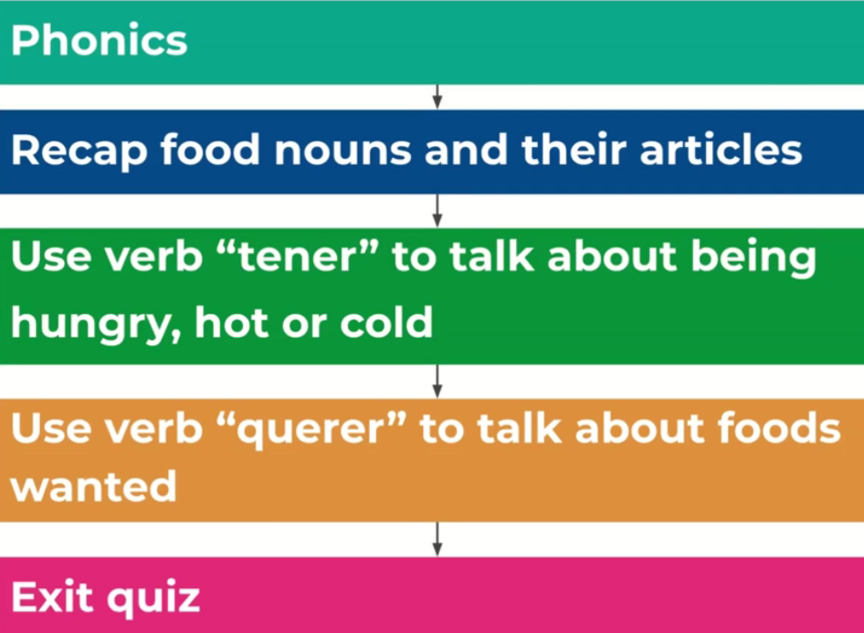 | Giving opinions about singular foods and joining opinions using conjunctions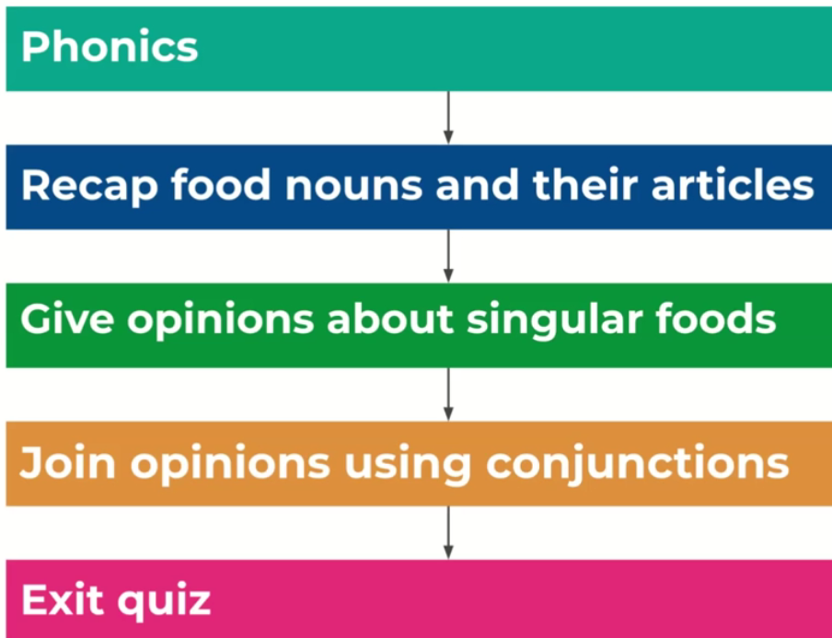 | Giving opinions about plural foods and joining opinions using conjunctions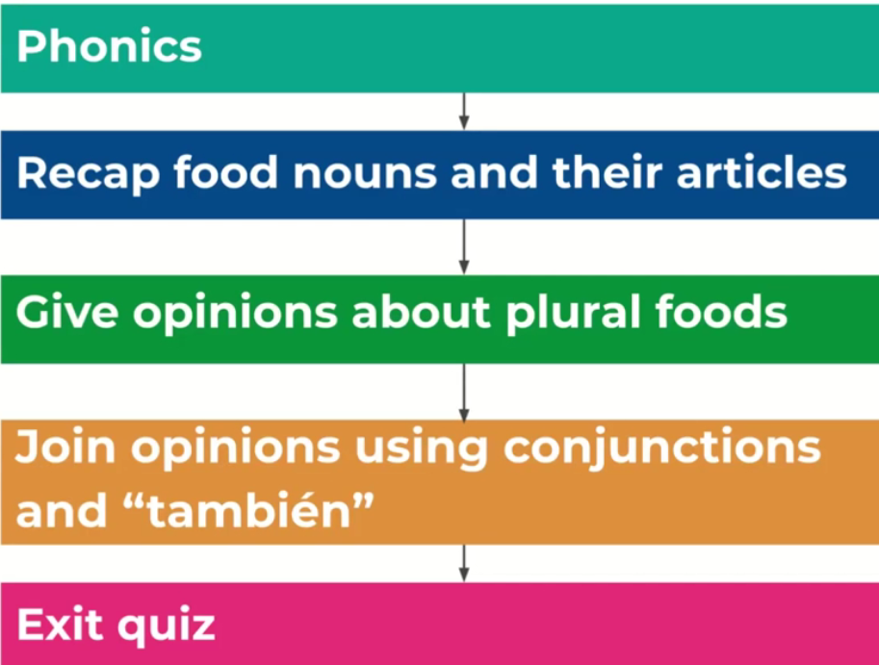 | Giving someone else’s opinion about singular and plural foods and joining opinions using conjunctions  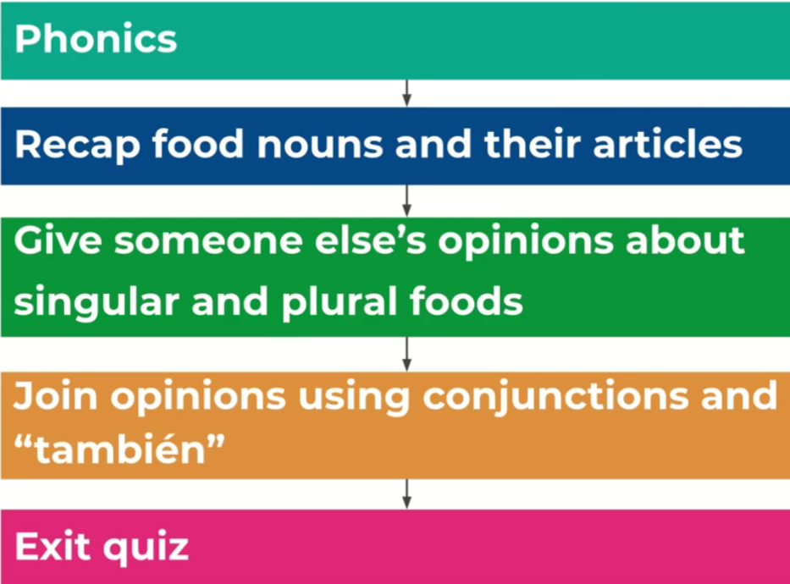
Hago deporte | Saying different sports  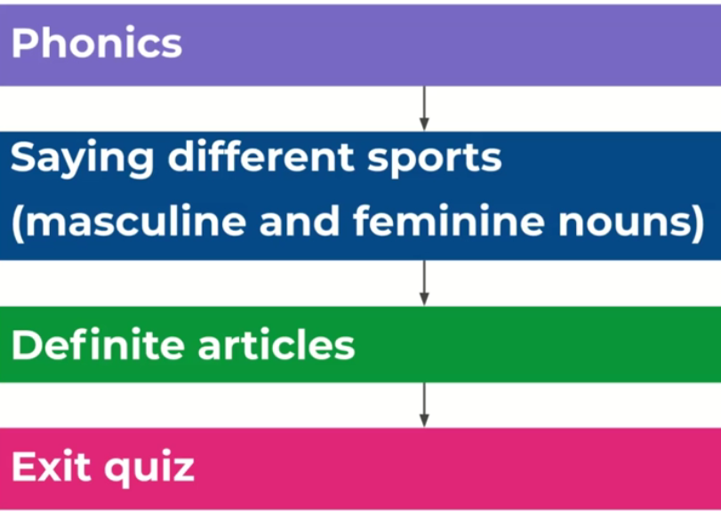 | Saying which sports you play and do, which sports you don’t play and do, and joining sentences using conjunctions  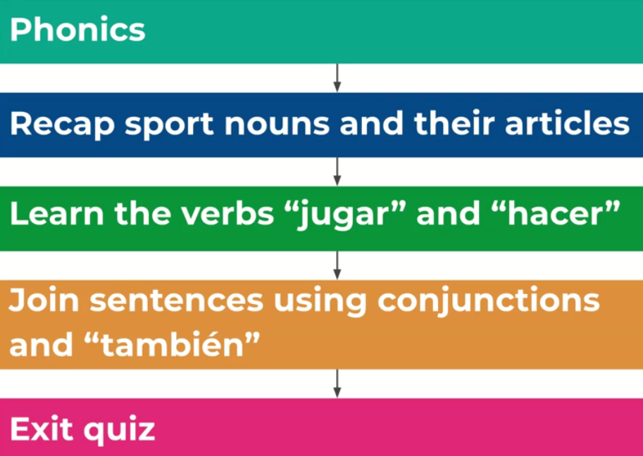 | Giving opinions of different sports and joining opinions using conjunctions  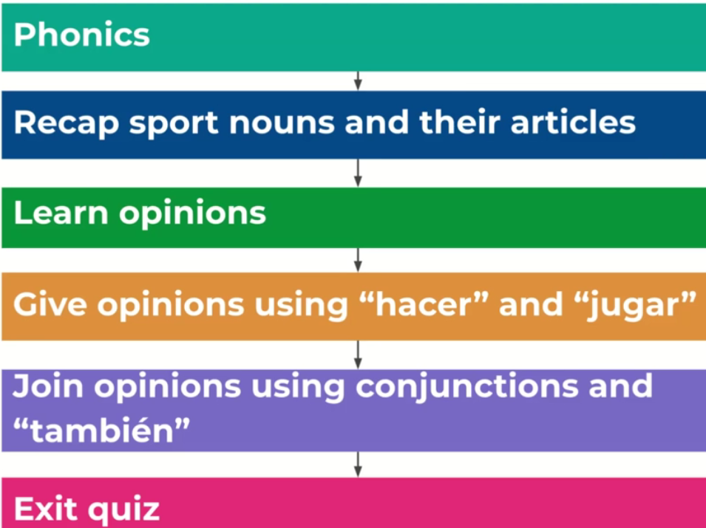 | Saying what sports you do in different weathers  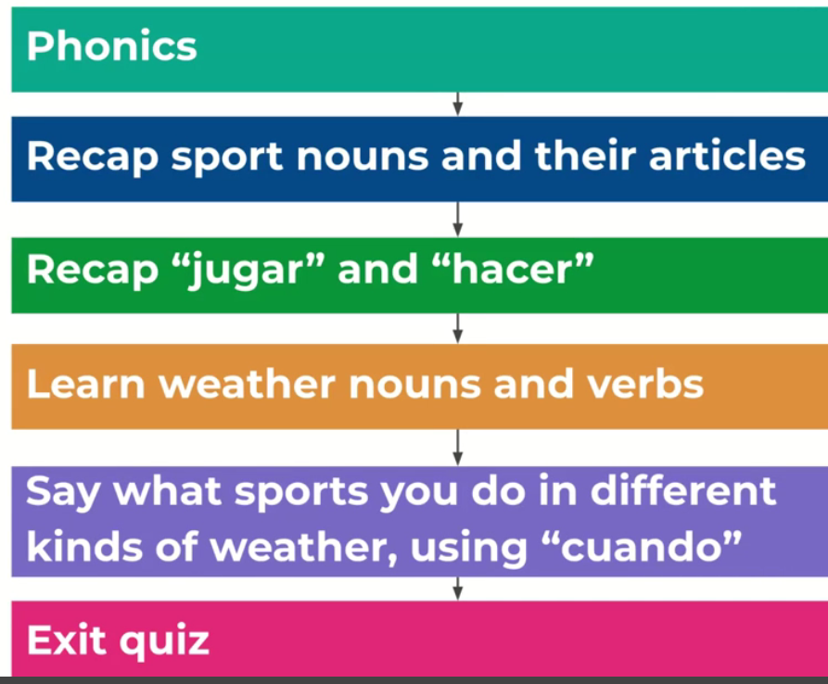 | Saying what kind of clothes, you wear to do different sports.  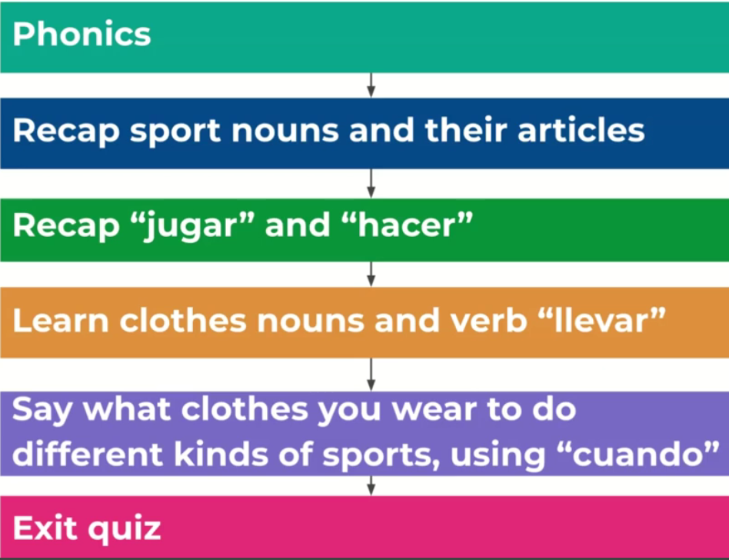
Mi pueblo | Saying some places there are in town  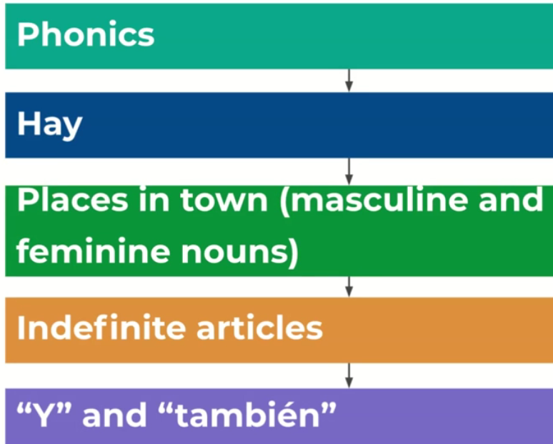 | Saying what there is and is not in the town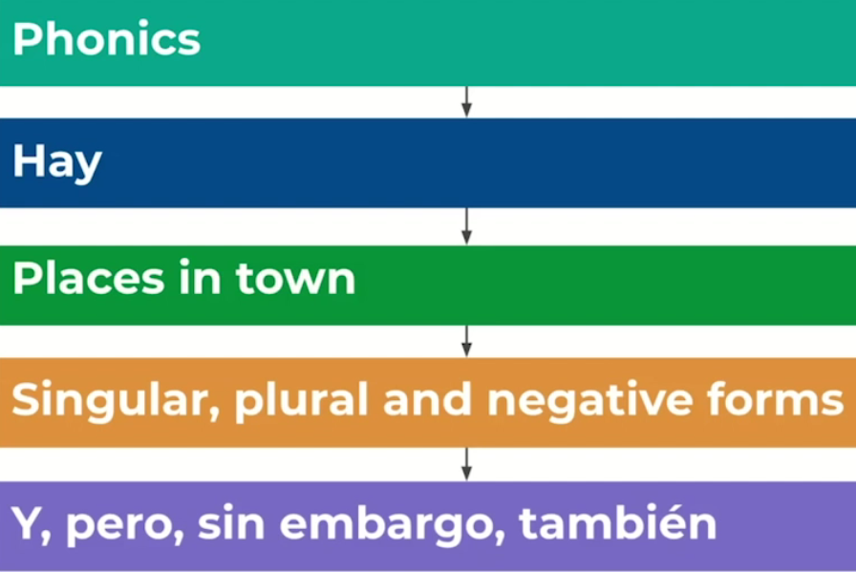 | Saying where in town you are going to and what transport you are taking there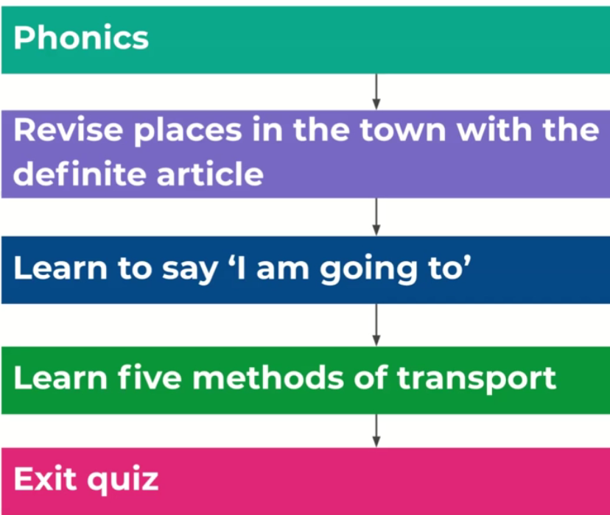 | Giving opinions of the town and explaining those opinions  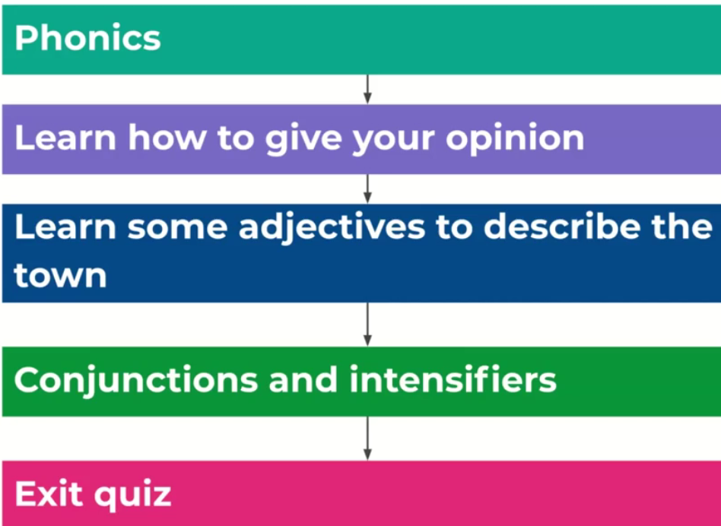 | Describing the places in town  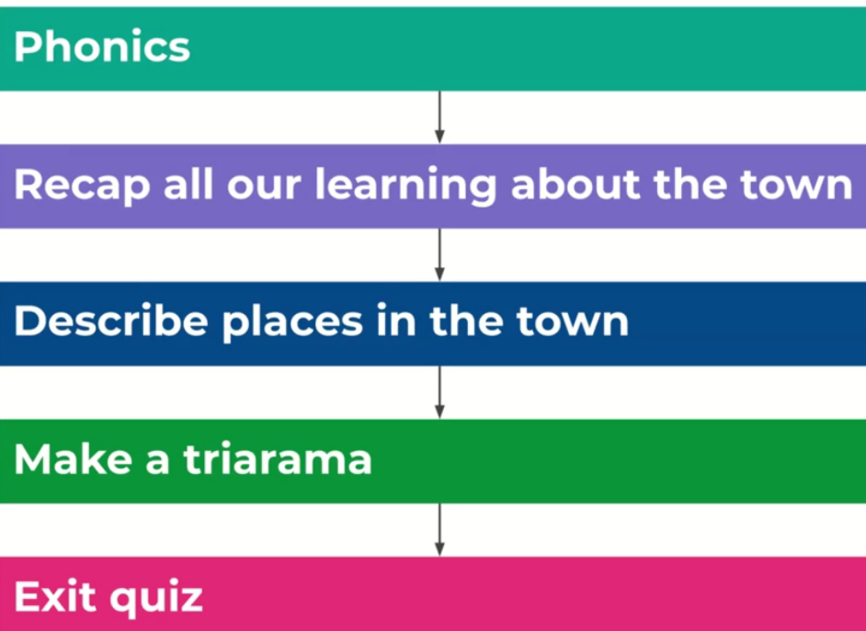

25 verbs | https://www.youtube.com/watch?v=9q5o7yktKVc
Verb conjugation- In Spanish, verbs need to be conjugated - this means the ending of verbs change depending on who is performing them. | https://www.bbc.co.uk/bitesize/topics/zvhxt39/articles/zf428hv
Verbs in Spanish | https://www.stthomaswernethprimary.co.uk/spanish-verbs/
Spanish videos | https://www.youtube.com/watch?v=cjXoSBulHRM
Alfabeto song | https://www.youtube.com/watch?v=Z7R-QkOXgcU
The Spanish Alphabet | https://www.youtube.com/watch?v=whqAML-sdqo

