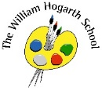

Maths

We will learn about Time, Statistics and Position and Direction. We will also consolidate our learning to prepare for transitioning to Year 3.

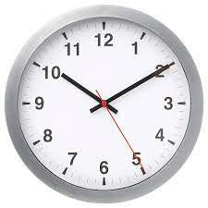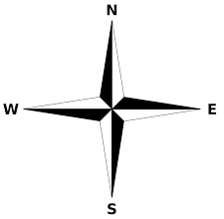

P.E.

We will learn about striking & field games. We will also learn about spinning, twisting and turning in gymnastics.

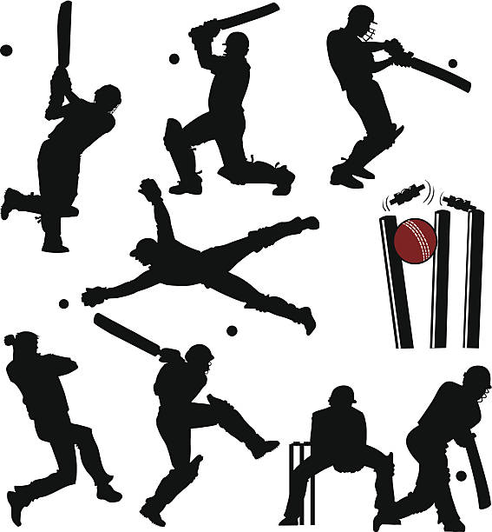

Science

In science we will learn all about Living Things and their Habitats

Plants! We will also find out about microhabitats and characteristics of living things.

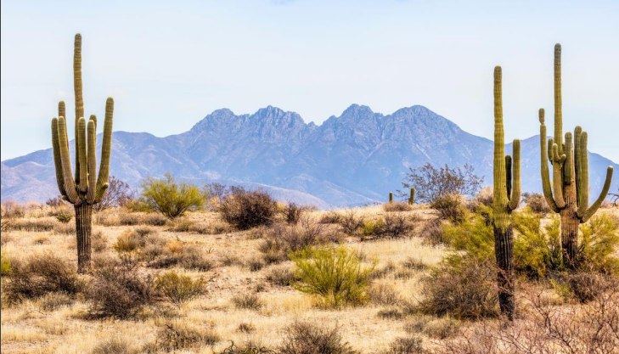

English

Our English book this half term is Jack and the Baked Beanstalk. From this story we will be writing a persuasive letter and a twisted narrative.

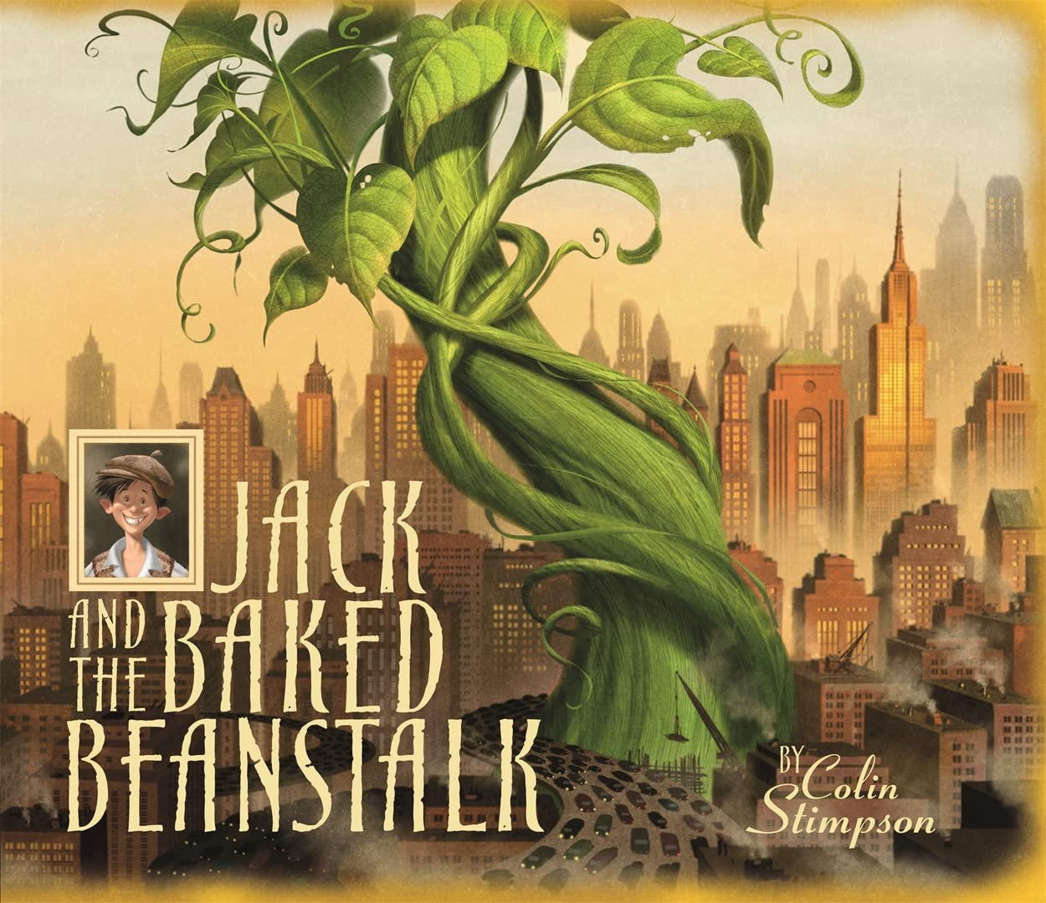

Computing

We will explore what information technology is and where we have seen it before. We will also explore programming & coding through Lego WeDo 2.0 resources

.

Geography

Our Geography topic this half term is ‘What is it like to live by the coast?’ We will be naming and locating continents and oceans of the world while revisiting countries and cities of the UK and surrounding seas.  Children learn about the physical features of the Jurassic Coast and how humans have interacted with this, including land use and tourism.

Art and D&T

In DT we will be exploring and using different fabrics to cut and join the fabric using simple techniques.

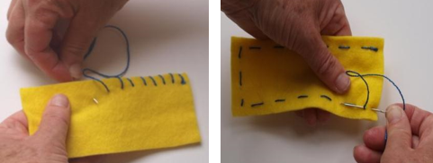

PSHE

We will be explaining how we have changed over time and will be able to use correct terms to label body parts. Children will be encouraged to express their likes/dislikes about changes. 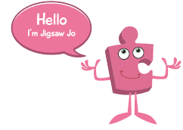

RE

We are focusing on the key question ‘Where do some people talk to God?’ We will be exploring places of worship in the Muslim, Jewish, Christian, Alevi and Pagan worldviews; investigating why people choose to go to places of worship.

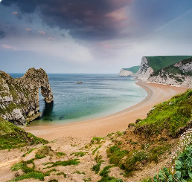

;p

Music

Our music topic is ‘Playing Together’. This unit brings together the musicianship skills learnt throughout the year.

