**Spring Term 1 Curriculum Map - Nursery**

Communication & Language and Literacy

Listen to farm stories and begin to join in with refrains. Talk about the characters and retell part of the story.

Speak in full sentences and extending ‘and’, ‘because’, ‘but’.

Ask questions using what and why and use vocabulary related to the topic.

Recognise own name from a group and begin to write some letters of own name.

Become interested in print in the environment and ask related questions. Sing rhymes and songs.

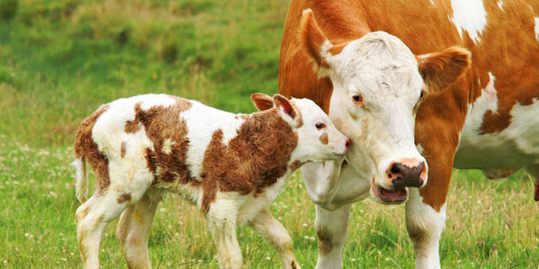

Physical Development

Make marks and copy letters of own name.

Use scissors safely.

Move around, over and through objects and tunnels. Continue to develop gross motor skills.

Understanding the World

Learn about the farm, farm animals and vegetation. Use all of their senses to explore natural materials.

Comment about what they see and ask questions about the environment.

Begin to show interest in different occupations.

Mathematics

Recite numbers beyond five.

Explore pattern.

Recognise numerals in the environment.

Writing numbers to 5

Explore size and make comparisons.

**Farm animals**

Expressive Arts and Design

Use a range of construction materials to build.

Take part in pretend play, using an object to represent something else.

Use movement to express feelings.

Use a range of techniques and resources to express self creatively.

PSED

Select and share equipment with others and wait your turn.

Begin to manage own behaviour and know to ask for help.

Become more outgoing with unfamiliar visitors to the setting.