******Spring 1 Term Newsletter Monet Class**

**English**

This term we shall explore the book “Leaf” by Sandra Dieckmann. This book has wonderful illustrations and explores the themes of acceptance of others, friendship and trust. We shall use the text to study narrative writing and also a diary recount. In grammar, we will be focussing on fronted adverbials, the use of apostrophes for possession and contractions and also expanded noun phrases.

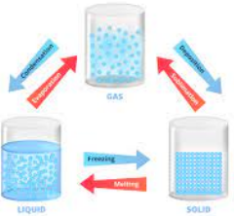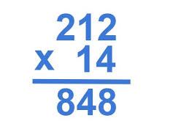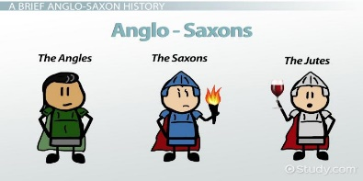

**R.E.**

This half term marks the beginning of our new religion scheme. In our first topic, we will be looking at the importance of our religious beliefs and how we display them. We will be looking at various different religions throughout.

**Science**

Our science topic this term is all about states of matter. We will look at solids, gases and liquids in depth and delve deeper into the science behind them, their properties and how they can be changed.

**P.E.**

We will be continuing our swimming this term on Thursdays. We will also be looking into health related fitness and how we can use sport as a tool for long-term fitness and health.

**Maths**

We will continue to look at multiplication and division this half-term. To begin with, applying times table facts to multiplication and division and then moving into both formal& informal written methods for both operations. Later on in the term, we will move on to Fractions.

**PSHE**

We will be focusing on perseverance and positive attitudes when it comes to personal challenges. We will look at effective teamwork and how we can all achieve our goals.

**Computing**

We will be looking at data logging using computer software. We will be looking at the best ways to obtain and store data using computers.

**Music**

We will look at numerous techniques involved in singing e.g. rhythm, tone and pace. We will also take part in some festive singing.

**Humanities**

Year 4 will be learning about the Anglo-Saxons and Scots. The children will explore what we know about the Anglo-Saxons, who invaded Britain after the Romans, Daily life for Anglo-Saxons, their beliefs and reasons why they built forts. We will build up all of the information from these lessons into an essay at the end of this topic.