 **Summer 2 Newsletter LKS2**

**Maths**

We begin this half-term looking at statistics (bar charts, pictograms and line graphs). We will then move into shape and position on a grid. Within these lessons, the children will participate in lots of practical learning and have lots of opportunities to develop reasoning and problem solving.

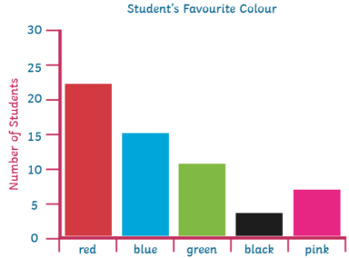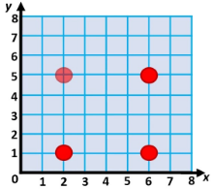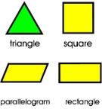

**Music**

This term in music, we will be learning about the Genre of Musical Theatre and explore the composition process. This unit uses songs from a range of shows and the children will learn to sing and paly along to them. The children will learn to sing in harmony.

  

**R.E.**

In religion this half-term, we will be exploring the question: “Are all religions equal?” We will be looking at the importance of religious equality and respecting each other’s’ beliefs whilst also discussing the similarities and shared values of various religions.

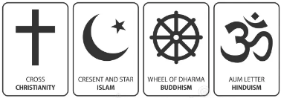

**Science**

We will be exploring sound for our final half-term. We will learn how sound waves travel through different mediums, understand pitch and frequency, examine volume and amplitude, and investigate how sound changes over distance and in different environments.



**P.E.** Summer seems like the perfect season to be learning to play the field game of hockey; consolidating our dribbling, passes and shooting skills. We will also be continue with our swimming lessons every Thursday.

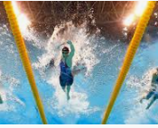 

**Humanities**

In humanities, we will be studying the use of natural resources. We will delve into what was used historically and what countries are aiming to use in the future (sustainable sources of energy). We will focus on the natural resources of Chile as a case study.

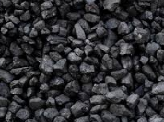  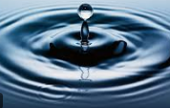

.

**PSHE**

We are learning about changing me, with some exploration into how our bodies change both inside and out, respecting those changes in ourselves and others.

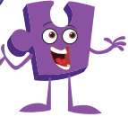

**English**

This term we shall explore the book “Manfish: A Story of Jacques Cousteau” by Jennifer Berne. We will use the invention aspects of the story to think up inventions that could help our own world/ help use to discover it. We will be focussing a lot on detail within writing and developing self-checking strategies to improve work with more independence.

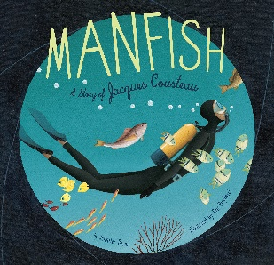

**Computing**

We will be looking at the internet. More specifically, we will be focusing on internet safety, its features, the many uses of it and what makes a website good. We will create our own web pages by the end of term!

