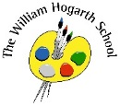**Summer 2 Curriculum Map – Reception**

**Communication Language & Literacy**

Continue to practise responding using full sentences in a clear voice. Focus on adhering to the topic at hand when answering questions. We will continue to read and listen to a range of books across the current topic. Children will read books aloud books that are consistent to their phonic knowledge.

Continue developing writing skills and write simple and phrase that can be read by other.

**PSED**

Children will be encouraged to try new activities and develop their confidence, independence and perseverance when facing challenges.

Children will be encouraged to form good relationships and show sensitivity to others.

We will reinforce the importance of telling an adult about an incident or feeling; learn how to resolve them together and apologise if necessary.

**Understanding the World**

We will explore sea creatures and describe their physical appearance and special qualities.

We will discuss the effects of pollution on the environment and the importance of looking after the natural world.

We will discuss how we’ve changed as we have grown up, from baby to adult. Also what we want to be when we are older.

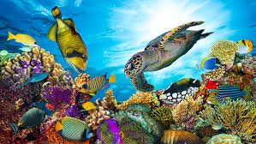

**Mathematics**

We will be consolidating key maths skills: Subitise, adding, subtraction bonds to 5 and 10, doubles with real objects and familiar maths objects.

Introducing sharing and grouping like sharing the fruit in snack time.

Introducing the idea of evens and odds with numicon.

Problem solving with real life examples, changing the context of learning.

**Physical Development**

The children will continue to develop their fine motor skills by mark making, developing cutting and handwriting skills.

Outdoors the children will develop ball skills by practising to throw and catch bean bags and small balls; climbing structures and landing carefully.

**The Ocean**

**Expressive Arts and Design**

The children will explore how to draw and paint sea animals using a variety of shapes and cutting and sticking shapes to make a picture of their choice.

Engage in imaginative small world play about sea animals, using props to enhance communication.