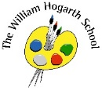**Autumn Term 1- Curriculum Map Reception**

Communication Language and Literacy

Children will continue to develop their language skills by talking about their own experiences at school and beyond. They will listen to stories and rhymes and share their ideas and thoughts about the text.

PSED

The children in Reception will spend time settling in and getting to know each other and staff in the school. They will start to familiarise themselves with school rules and routines. We will discuss the importance of self-value and also of friendship and kindness and begin to understand how we can make the school enjoyable for all.

Understanding the World

The children will compare and share similarities and differences between school and their previous setting. We will talk about our families, languages we speak and places we have visited. We will discuss the importance of personal hygiene and how to look after ourselves.

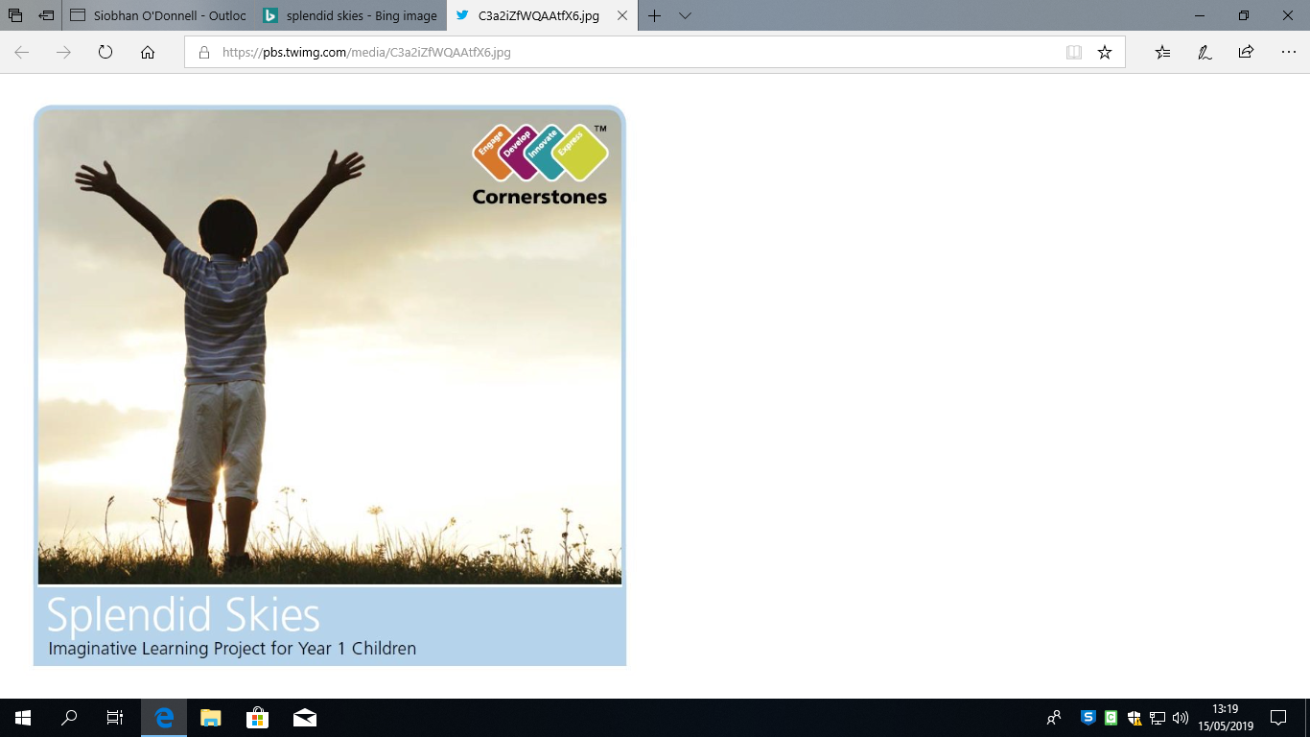

Physical Development

Children will have opportunity to explore physical activities in a range of ways on a daily basis e.g.: jumping, skipping, hopping, side- stepping and balancing. They will learn how to move safely indoors and outdoors.

We will focus on the toilet routine and the importance of proper handwashing.

We will practice putting coats and shoes on independently.

Expressive Arts and Design

Children will explore a range of media and will create self-portraits, collages and other art forms.

They will have the opportunity to build and construct using a range of materials.

Mathematics

This term we will count, recognise numbers in our environment and start to think about accurately counting objects. We will look at 2D shapes and begin to discuss their similarities and differences.

All About Me