 **Summer Term 1 Curriculum Map – Reception**

Communication Language & Literacy

Listen attentively to stories and maintain concentration. Follow and respond to stories without pictures or props. Connect ideas and speak clearly using full sentences.

Read books that reflect phonic knowledge.

Write lists, letters, make own books, make fact files and posters of mini beasts. Use finger spaces, full stops and capital letters when writing.

Spell phonically regular words of one and two syllables.

Understanding the World

We will observe minibeasts and explore the differences between them.

We will write fact files and make lists of the minibeasts we find in the garden. We will explore the anatomy of these different mini beasts also.

We also start to learn about maps and use a map of the Early Years garden.

PSED

Learn about honesty and sincerity. Know to listen to each other and apologise when necessary.

Express own ideas and understand that everyone has a right to their own opinions. Express own opinions.

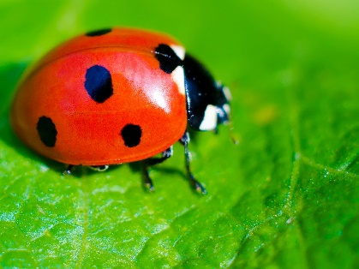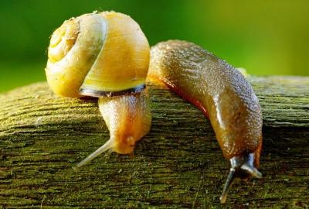

Physical Development

Revise and refine fundamental movements e.g.: skipping, rolling, running, climbing, and hopping. Combine movements with ease.

Develop fine motor skills in a variety of ways in order to use tools such as pencils, scissors, forks, spoons, paintbrushes and knives competently, safely and confidently.

Expressive Arts and Design

We will be observing different minibeasts and taking observational drawings and labelling these. We will also consider different mediums that best represent these different minibeasts. For example collaging for snails, painting rocks to represent ladybirds and threading to represent caterpillars.

Role Play in the green grocers, learning how to pay for fruit and vegetables and trying to write simple receipts.

Listen to music from around the world. Explore music, and patterns from around the world.

Mathematics

Use and apply mathematical knowledge in role play when adding, taking away and estimating.

We will be developing confidence in building numbers beyond 10.

Sort, order, measure and record findings.

Consolidating our knowledge of 2D shapes.

**Minibeasts**