Mathematics

Subitise to 3 (recognising an amount without counting)

Compare quantities ‘more and fewer’.

Use positional language in play.

Recognise numerals and match correct amount of items up to 5, then 10.

 **Spring Term 2 Curriculum Map - Nursery**

Communication Language & Literacy

Understand who and how questions and begin to use these in conversations.

Listen to stories with increasing attention and recall. Respond to simple sentences related to text.

Show interest in print in the environment. Listen to a range of stories relating to plants, growth and mini beasts and share their thoughts.

Understanding the World

Talk about how things work and why they happen.

Join in with planting activities and talk about what they see and do. Use all the senses to explore fruit and vegetables and talk about it.

Talk about what they see and know about plants and the natural environment.

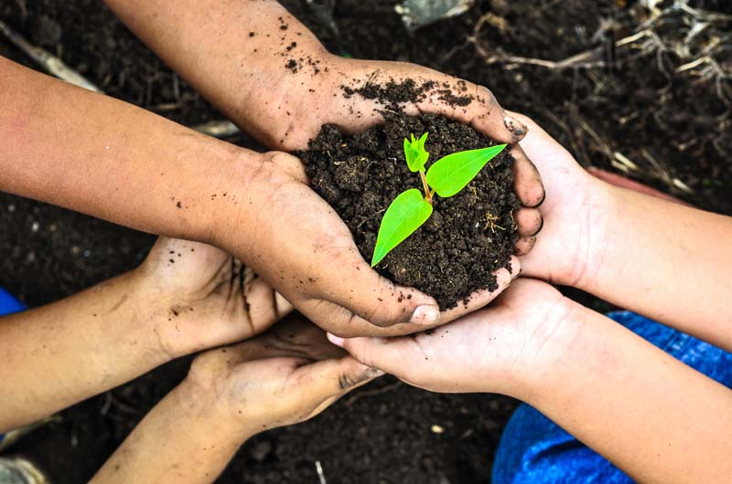

PSED

Show friendly behaviours by greeting others, smiling and using kind words and gestures.

Know to ask adults and friends for help when needed.

Expressive Arts and Design

Build a repertoire of songs and rhymes and begin to make up some.

Explore the sounds musical instruments make and how they can be changed (soft, loud, fast, and slow).

Use oil pastels to create a sunflower picture, inspired by Van Gough.

Learn about what an Artist is and different forms of Art.

Physical Development

Move in different ways, hop, jump, and slither.

Stand on one leg.

Use, tools effectively to make changes to creations, such as scissors, tape, brushes, etc. Begins to dress self independently and attempts to button and zip items.

**Planting & Growing**