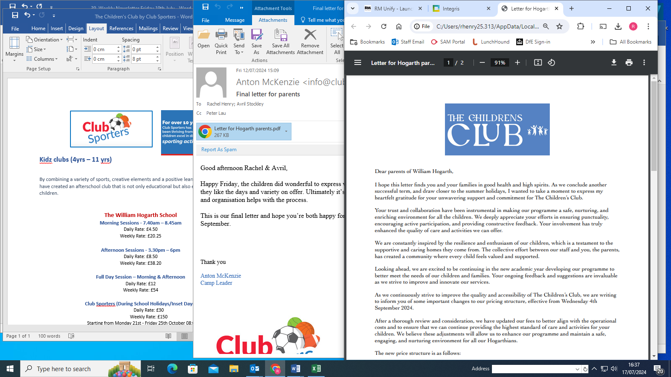

**The William Hogarth School – from September 2024**

**Morning Sessions - 7.40am – 8.45am**

Daily Rate: £4.50

Weekly Rate: £20.25

**Afternoon Sessions - 3.30pm – 6pm**

Daily Rate: £8.50

Weekly Rate: £38.20

**Full Day Session – Morning & Afternoon**

Daily Rate: £12

Weekly Rate: £54

**Club Sporters (During School Holidays/Inset Days)**

Daily Rate: £30

Weekly Rate: £150

*Starting from Monday 21st - Friday 25th October 08:00-18:00*

[www.clubsporters.co.uk](http://www.clubsporters.co.uk)

