## What should I do if I think my child is being bullied?

Concerns can be reported to any adult in school. We recommend the following procedure:

***CLASS TEACHER***

*In the first instance, concerns should be reported to the class teacher.*

***LEADER of INCLUSION / DEPUTY HEAD***

*If concerns persist, the leadership team may be asked to become involved. The current Leader of Inclusion is Mrs Katy Luciani. The current Deputy Head is Miss Katie Rees.*

***HEADTEACHER***

*If concerns have still not been resolved after an agreed period of time, the matter may be escalated to the Headteacher, Ms Avril Stockley.*

The Headteacher and / or leadership team may become involved at any point in the process if deemed appropriate.

## Contact Us

Issues linked to behaviour and/or bullying can often be very upsetting for all parties involved. We strongly encourage families to come and talk to a member of staff as soon as possible so that we can offer support. Approaching other families and children out of school / in the playground is usually unhelpful in resolving matters and can often cause more upset. We aim to listen to, work with and support children and families in reviewing and resolving issues.



|  |  |  |
| --- | --- | --- |
| Anti-Bullying:  A Guide for Parents | | |
|  |  |

# **What Is Bullying?**

The William Hogarth School has adopted the Anti-Bullying Alliance’s shared definition of bullying, which is based on 30 years of research.

**Bullying is the repetitive, intentional hurting of one person or group, by another person or group, where the relationship involves an imbalance of power. It can happen face-to-face or online.**

## Bullying VS Friendship ‘Fall-Outs’

Occasionally, the word ‘bullying’ can be used incorrectly. Bullying is different from other incidents and friendship ‘fall-outs’ and it is important that the word is used correctly.

**Bullying is when there is:**

* **a deliberate intention to hurt or humiliate**
* **a power imbalance that makes it hard for the victim to defend themselves**

**It is usually persistent / repetitive.**

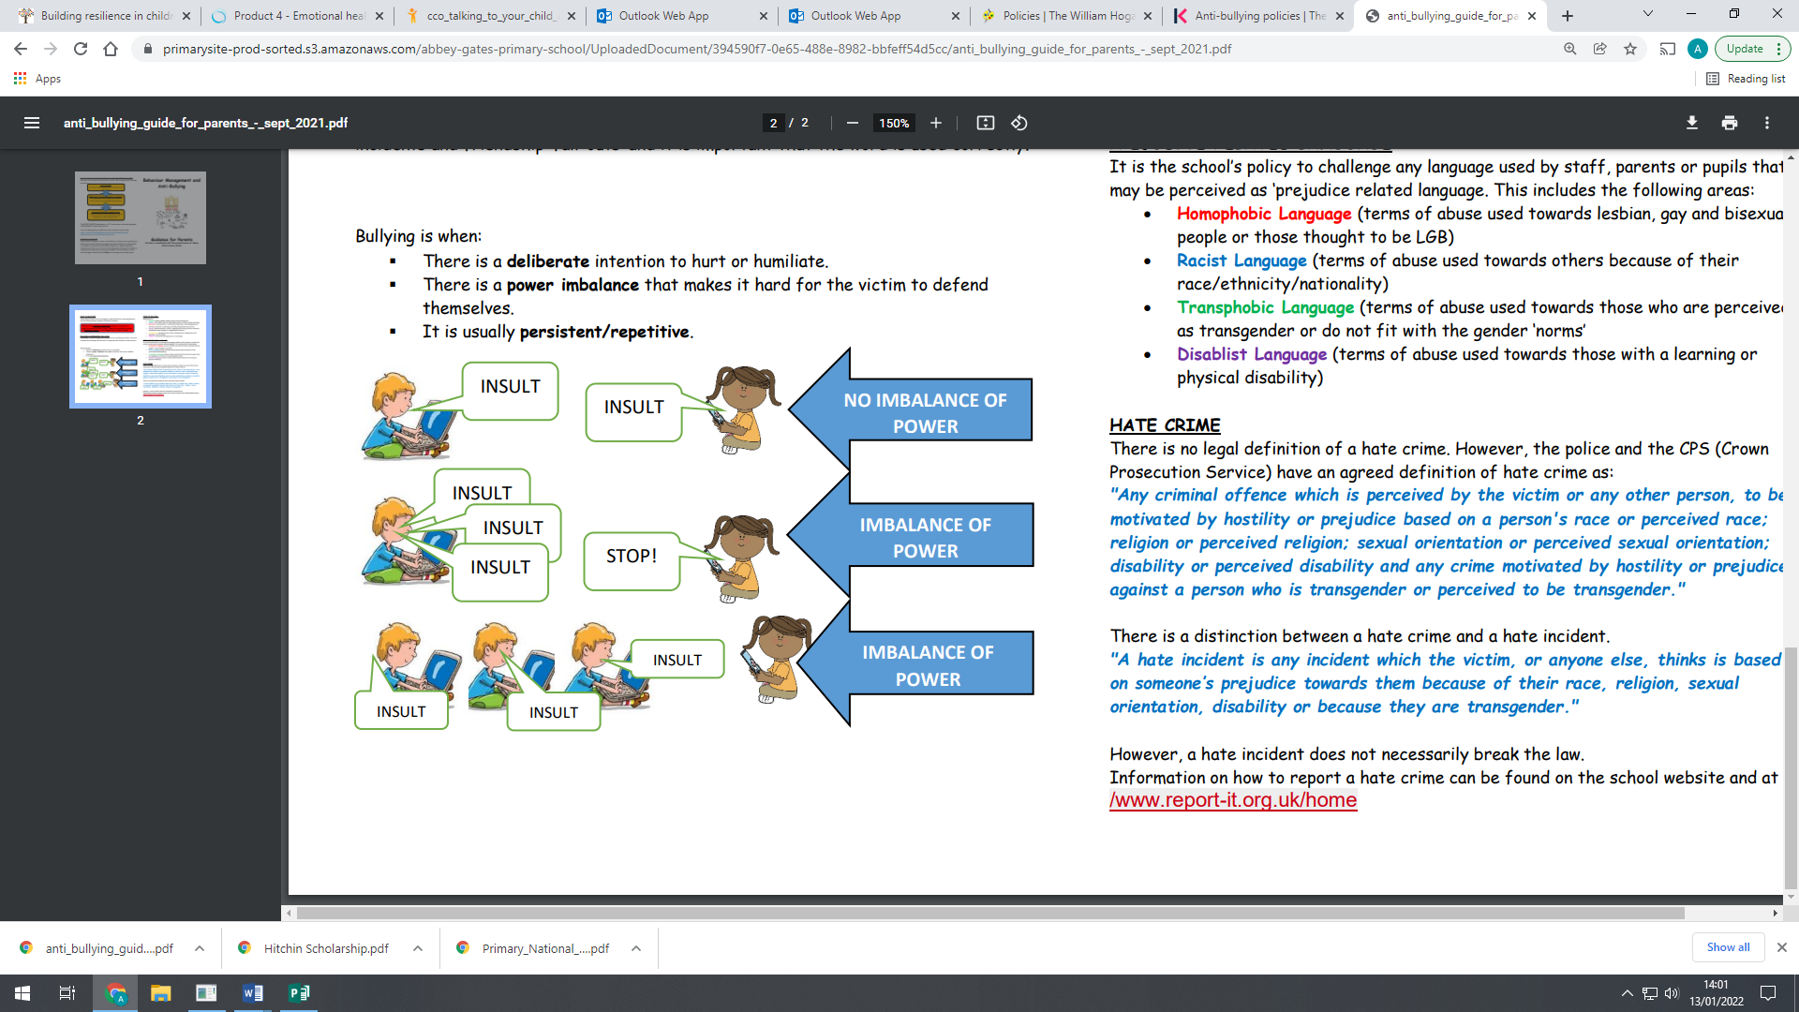

The **Anti-Bullying Alliance (ABA)** have created an online toolkit to support parents:

[**https://www.anti-bullyingalliance.org.uk/tools-information/adviceparents/interactive-anti-bullying-tool-parents**](https://www.anti-bullyingalliance.org.uk/tools-information/adviceparents/interactive-anti-bullying-tool-parents)

## Types of Bullying

* Physical – pushing, poking, kicking, hitting, biting, pinching etc.
* Verbal – name-calling, sarcasm, spreading rumours, threats, teasing, belittling etc.
* Emotional – isolating others, tormenting, hiding books, threatening gestures, ridicule, humiliation, intimidation, excluding, manipulation and coercion.
* Sexual – unwanted physical contact, inappropriate touching, abusive comments, homophobic taunts, exposure to inappropriate films or images etc.
* Online / Cyber- posting on social media, sharing photos, sending nasty text messages, social exclusion
* Indirect – exploitation

## Prejudice-Related Language

It is the school’s policy to challenge any language used by staff, parents or pupils that may be perceived as ‘prejudice-related language’. This includes, but is not limited to the following areas:

* **Homophobic Language (terms of abuse used towards lesbian, gay and bisexual people, or those thought to be LGBQT)**
* **Racist Language (terms of abuse used towards others because of their race / ethnicity / nationality)**
* **Transphobic Language (terms of abuse used towards those who are perceived as transgender or who do fit with the gender ‘norms’)**
* **Disablist Language (terms of abuse used towards those with a learning or physical disability).**