* 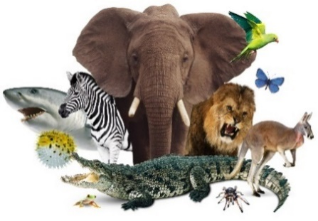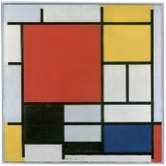 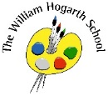

English

We will be learning about a range of text types this term. These include: recounts, instructions, letter writing, descriptions, and information books. These text types will be used in a cross curricular manner across all subjects. We will also be following the **Read Write Inc. Scheme in Phonics.**

Science  
Our topic this term is ‘Animals including humans’. Children will be learning about food chains, types of animals and their diets. We will learn important scientific skills such as questioning and observation and about how to use simple equipment to perform tests safely.

Maths  
In Maths we are looking at place value up to 50, followed measurement (length, height, mass and volume). Children will apply their mathematical knowledge and use manipulatives and resources to demonstrate their understanding, deepen thinking and develop mastery.

Year 1

P.E.  
This term we will be doing invasion games and target games. These approach focuses on the development of movement, balance, coordination and teamwork.

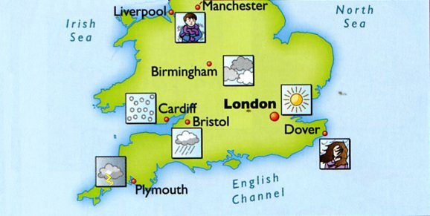

PSHE

Our PSHE this term will continue ‘Think Equal’ and are reading books that reflect the changing topics of each week. Such as celebrating the similarities and differences of people, building self-confidence, kindness and mindfulness.

Topic  
Our topic this term is *What is the weather like in the UK?* They will be naming and locating the four counties on a map of the UK. Identifying the seasons and describing the seasonal changes. Use a compass for directions and describe the location of features. They will also observe and describe daily weather patterns.

* Begin to locate the four capital cities of the UK.

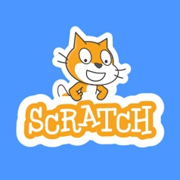

RE  
This term we will be answering *Why should we care for the world?* Children will be able to explain different belief about who own the world. Recognise why only humans can care for the world and identify reasons why it is important to care for the world.

Art

This term we are working on exploring water colour. Children will use the elements of surprise and accident to help create art. They will develop their paintings by reflecting upon what they can see and adding new lines and shapes to help develop imagery.

Music

In music we will learn and we have music lessons with a specialist music teacher every Thursday afternoon. These lessons cover rhythm and pulse, pitch, singing games and instrumental activities.

Computing

This term we will be introduced to onscreen programming through Scratch Jr. The children will be exploring the way a project looks by investigating sprites and backgrounds.