Summer 2 home learning: Geography

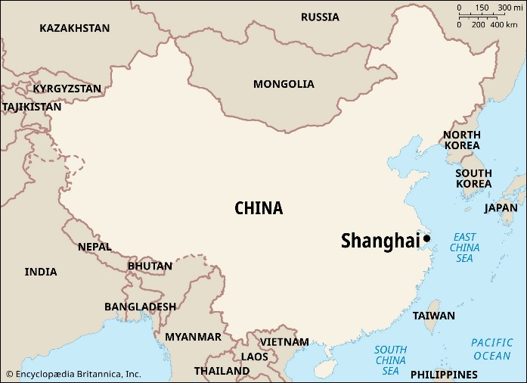This term's big question in geography is “**What is it like to live in Shanghai**?”. The home learning project should reflect any ideas that link to this question.

Some suggestions you could make are:

* Is living in Asia the same as living in Europe? Compare what it is like to live on a different continent. Is the weather the same? Transport links? Time zones? Lifestyle? Traditions and culture?
* Draw a map of the UK and China. What are the physical and human features that make them similar or different?
* What famous landmarks are found in London and Shanghai? Can you compare the localities?
* What is life like in Shanghai, and how is this similar to and different from living in Chiswick?

Or any other creative ideas that link to the learning.

Due: tbc (most likely the last week of term)