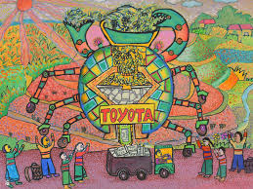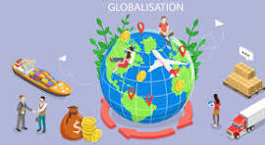Globalisation

Home Learning Project.

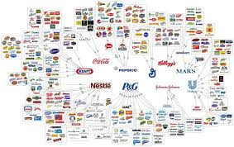

Choose a transnational corporation and create a poster that highlights the brands owned by the corporation.

Design and create your own food product and packaging.



Create a news report video of you presenting your research about fast fashion brands.

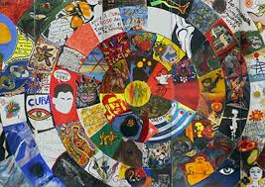

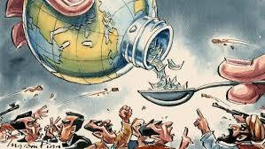Create a piece of art that showcases an area of globalisation that you have found interesting. Must be accompanied by a verbal presentation when presented in class.

Research and create a presentation about how globalisation has changed the world.