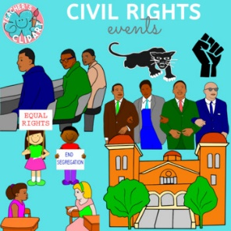**Home Learning Project – Spring 1 – Civil Rights**

There are a number of ideas below for you to complete as a learning project that you could share at our Celebration of Learning event at the end of the half term. Please work with an adult and complete the project together if you can.

1. Write your own Civil Rights speech inspired by the movement.
2. Create a presentation about a significant figure during the Civil Rights Movement.
3. Create a leaflet comparing the Civil Rights movement today vs Martin Luther King’s period.
4. Create a piece of art that celebrates the heroes of the Civil Rights movement.
5. Write a poem that includes key information about the Civil Rights movement.