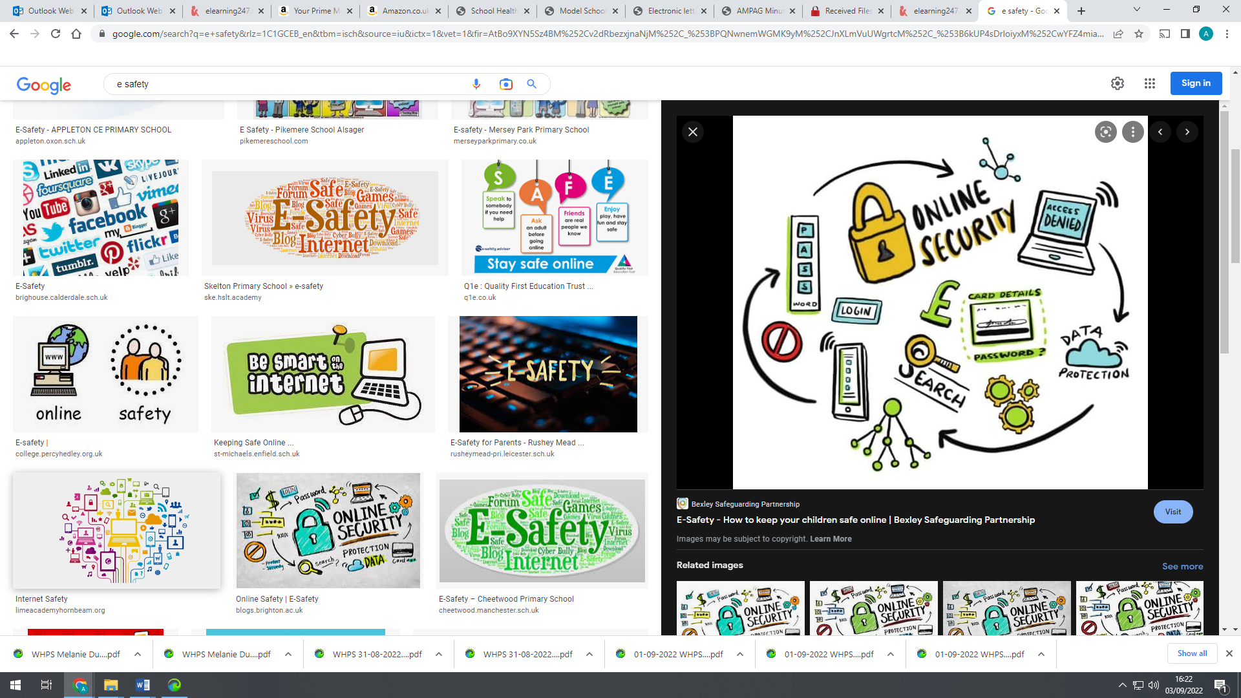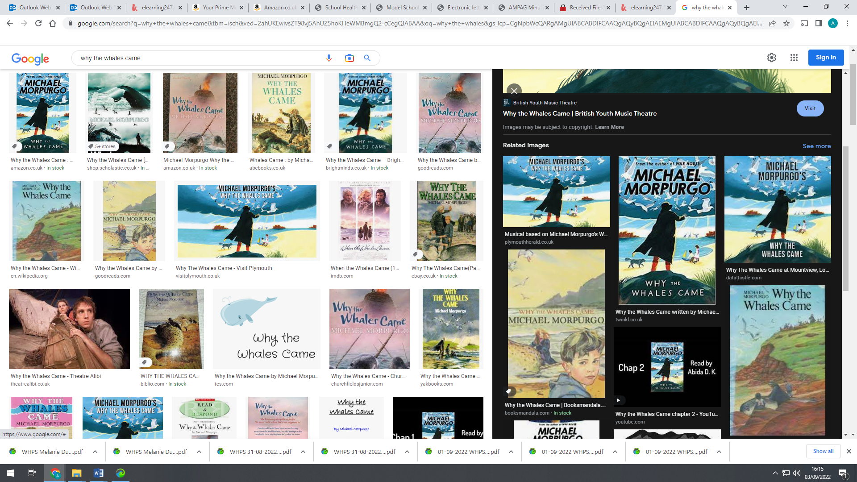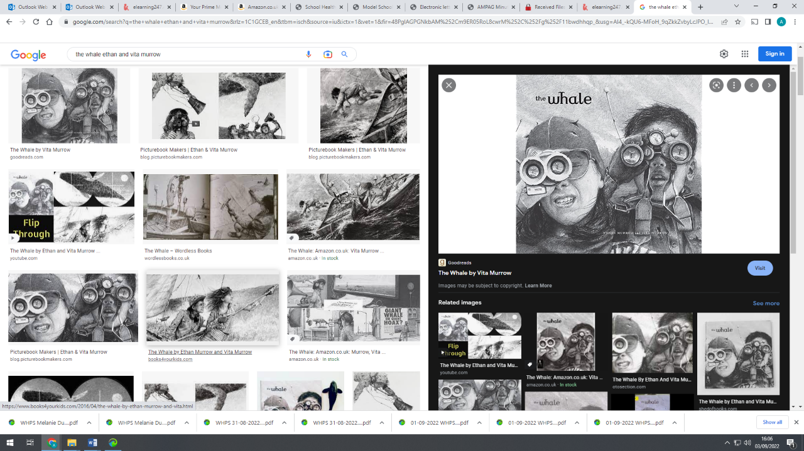

**Science**

We will learn all about space, such as solar and lunar eclipses, planets of the solar system and the universe.

**Computing**

This half term our key focus is E-safety and particularly privacy of personal information, cyberbullying, dealing effectively with online situations and keeping ourselves safe while using games/ apps.

**Maths**

We will begin with place value: understanding the value of digits up to 10000 and representing these numbers. We will partition numbers and know 10, 100 and 1000 less of any given number. We will also look at written methods for addition and subtraction and then multiplication, focussing on calculations that include exchanges.

**P.E.**

We will be taking part in dance and invasion games. Values such as teamwork and leadership will be incorporated into these lessons.

**English**

This term we will explore “The Whale” – a spectacular wordless adventure brought to life with stunning illustrations that capture the majesty of the whale and convey the drama and haunting beauty of the ocean. We will use the vehicle text to study narrative writing and newspaper reporting. In grammar, we will develop our understanding of verb inflections fronted adverbials, inverted commas and noun phrases expanded by modifying adjectives.

Class Novel

Why the Whales Came, Michael Morpurgo

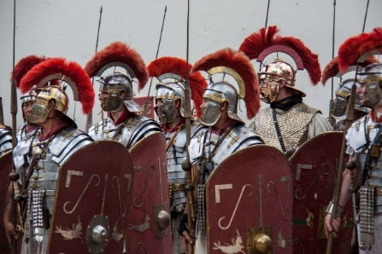

**Cookery**

Our recipes this half term include:

* Breakfast treats
* Soup
* Healthy snacks

We will be cooking every Thursday. Please make sure your child has an apron!

**R.E.**

This term we are learning about Judaism and Buddhism

**Music**

We will learn what a PULSE or a steady beat means. To learn to keep a pulse through actions while singing a song and to follow a changing

tempo.

**PSHE**

Year 4 will be focusing on ‘Being Me’. We will look at how to make our school community a better place, everyone’s rights to learn and working well with others.

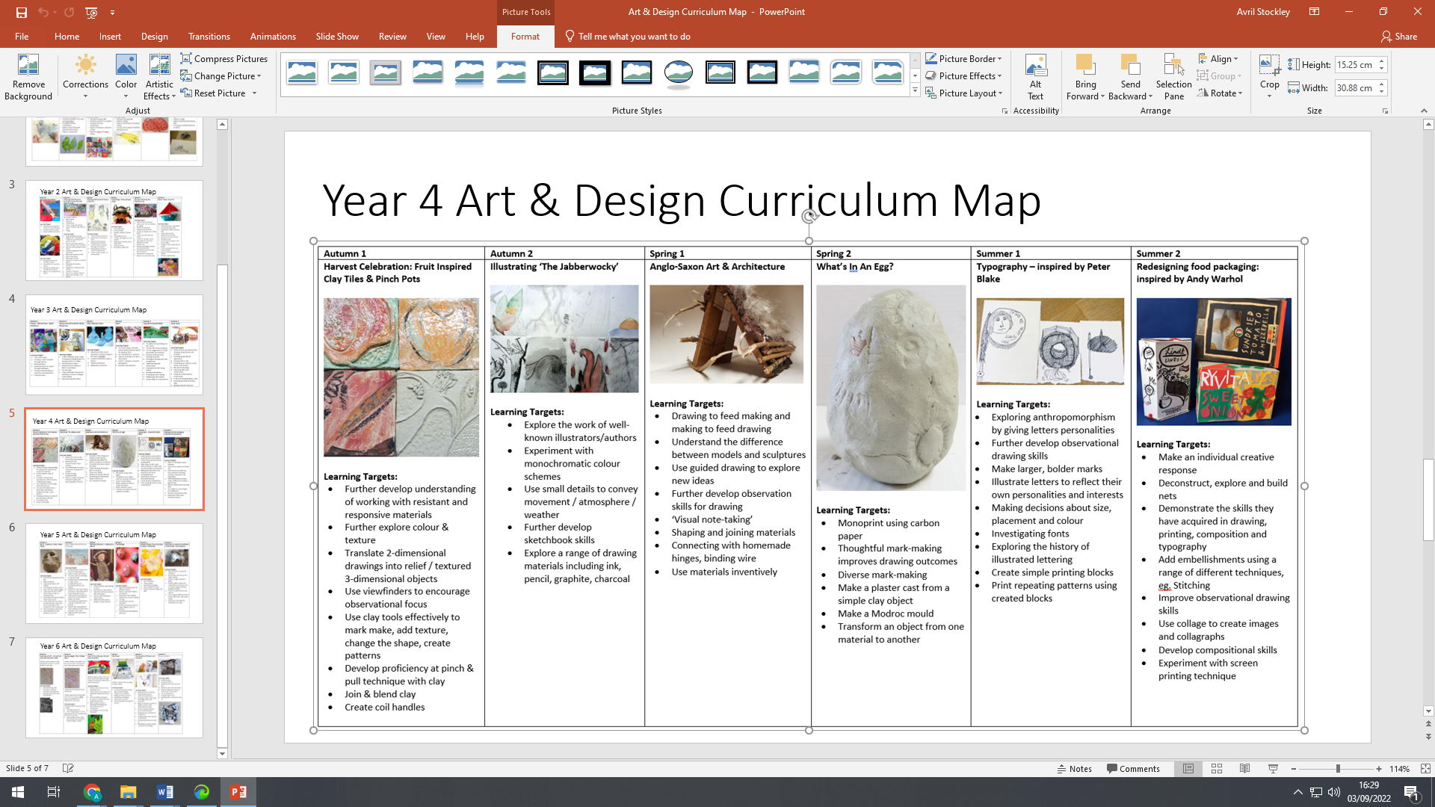

**History**

We are learning about Roman Britain. The children will explore the secrets behind the Romans’ success, their invasion of Britain and how Britain changed as a result. We will consider which factors were the most important in the fall of the Roman Empire.

**Art & Design**

We are exploring clay and translating 2-dimensional drawings into 3-D decorative clay tiles.