**Nursery Newsletter**

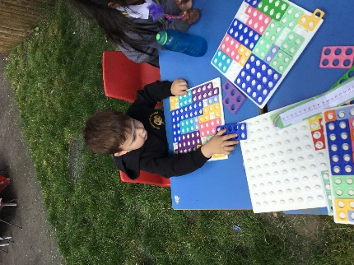W/B 10th June 2024

We have been:

• learning about our new topic ‘the seaside’

• reading our new focus story ‘The smiley shark’

* discussing any holidays we have taken to the seaside and what we did there
* exploring our new mud kitchen and seaside café outdoors

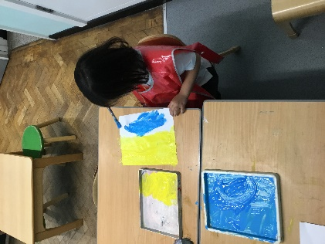• learning about different sea creatures, particularly sharks

* discussing why sharks are dangerous animals and how to stay safe at the seaside
* Practicing our 1 to 1 counting with fish and writing numbers
* learning how to read and write new sounds in our phonics lesson e, l, h

• practicing our blending skills (squashing sounds together to make a word) using Fred the frog

• practicing counting forwards to 20 and backwards from 10

* practicing our Subitising skills (recognising an amount to 5 without counting)

• singing a variety of nursery rhymes

* Going to the library and riding bikes and scooters outdoors

• remembering to go to the toilet, flush the toilet and wash our hands

**Important reminders:**

|  |  |
| --- | --- |
|  | * **No nut-based food in school due to allergies** * **Please ensure that your child is in the correct uniform** * **Any donations for our outdoor mud kitchen would be greatly appreciated** * **Please ensure your child has a spare change of clothes in school in case of an accident.** * **Early years sports day will be on Monday 15th July (a parent mail will be sent out)** |