**Nursery Newsletter**

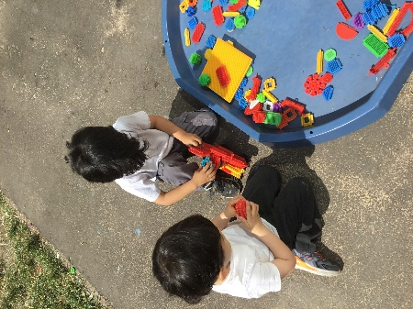W/B 17th June 2024

We have been:

• reading our new focus story ‘Starlight sailor’

• creating and decorating our own boats following instructions from our focus story

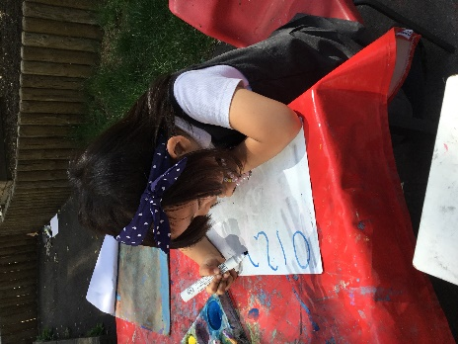-Learning about different types of boats e.g life boats

* Colouring in pictures of boats
* Completing a science experiment outdoors, (do the objects float or sink?)
* practicing our cutting and sticking skills by cutting out starfish
* painting our numbers and letters outdoors
* welcoming the new little girl into our class
* learning how to read and write new sounds in our phonics lessons

• practicing our blending skills (squashing sounds together to make a word)

• practicing counting forwards to 20 and backwards fr om 10

* discussing ‘more’ or ‘less’/ ‘fewer’
* learning about repeated colour patterns in maths e.g red, blue, red, blue

• singing a variety of number songs

* Going to the library and riding bikes and scooters outdoors
* Practicing for our sports day

• remembering to go to the toilet, flush the toilet and wash our hands

**Important reminders:**

|  |  |
| --- | --- |
|  | * **No nut-based food in school due to allergies** * **Please ensure that your child’s jumper is labelled so that we do not get mixed up** * **Please ensure your child has a spare change of clothes in school in case of an accident.** * **Early years sports day will be on Monday 15th July (a parent mail has been sent out)** |