**Nursery Newsletter**

W/B 14th May 2024

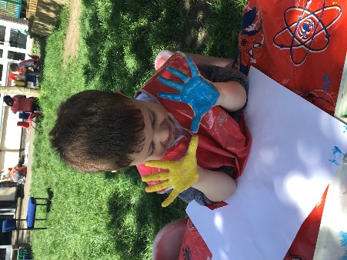

We have been:

• reading our new focus story “Supertato”

• making our own potato characters

• learning about how potatoes are grown and observing this in our outdoor area

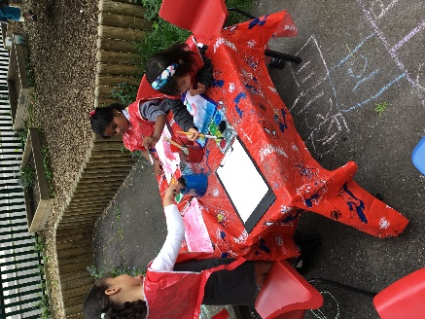• creating our own superhero masks

* Vegetable printing using the characters from the story (carrots etc)
* Learning how to read and write new sounds in our phonics lesson s (o,c,k,u)

• practicing our 1 to 1 counting skills

• hunting for mini beasts in our outdoor area

• practicing counting forwards to 20 and backwards from 10

• singing a variety of nursery rhymes

* Colour mixing with paints outdoors
* Going to the library and riding bikes and scooters outdoors

• remembering to go to the toilet, flush the toilet and wash our hands

**Important reminders:**

|  |  |
| --- | --- |
|  | * **No nuts or nut-based food in packed lunches, please** * **Your child will get a library book every Friday. Please ensure these are returned the following Thursday so that your child can receive their next book.** * **Please ensure that your child is wearing the correct uniform, only has 1 piece of jewellery, and no hoops/dangling earrings.** * **The professional basketball player will be visiting our school next Wednesday!** |