**Nursery Newsletter**

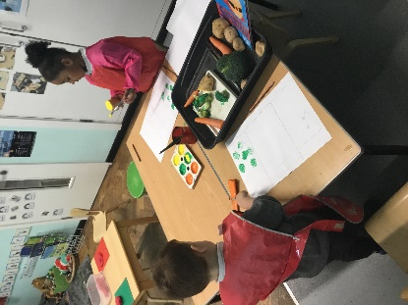W/B 20th May 2024

We have been:

• reading a variety of non-fiction books about mini beasts

• creating collages to develop our art skills

• jazzing up our mud kitchen area outdoors (thank you for any donations that have been made)

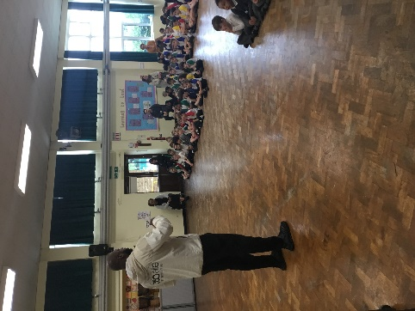• Painting with water colours

* vegetable printing using the characters from Supertato
* learning how to read and write new sounds in our phonics lesson s (u,b,f)

• practicing our blending skills (squashing sounds together to make a word) using Fred the frog

• hunting for mini beasts in our outdoor area

* We had a very exciting visit from a professional basketball player and the children wowed me with their motivation in the fitness circuits!

• practicing counting forwards to 20 and backwards from 10

• singing a variety of nursery rhymes

* Going to the library and riding bikes and scooters outdoors

• remembering to go to the toilet, flush the toilet and wash our hands

**Important reminders:**

|  |  |
| --- | --- |
|  | * **Have a lovely, well-deserved half term break!**      * **Thank you so much for any donations for our mud kitchen!** * **There will be no school on Monday 3rd June.** |