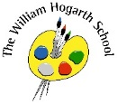

**Year 1 Summer 2**

Science

Children will be looking at how to plant a bean and will observe the changed over time. They will also investigate what plants grow in the wild, the types of trees and the parts of a plant and tree.

Maths  
We will continue our learning on place value. We will also learn about position and direction, money and time. 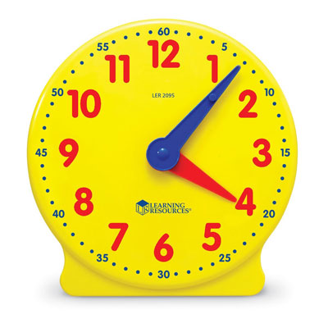

P.E.  
We will learn about and striking & field games. We will also be creating an underwater dance!

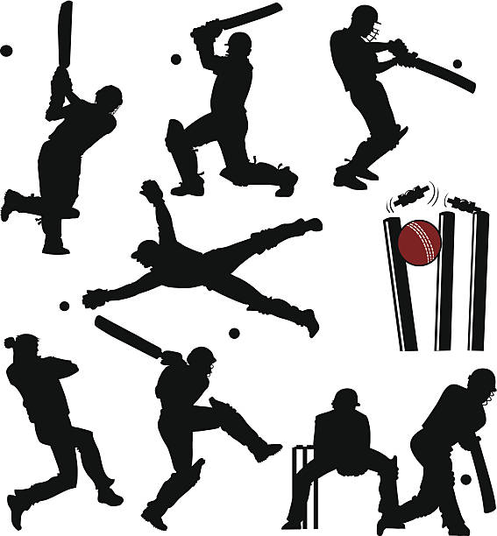

English  
Our English book this half term is ‘The Last Wolf’. From this text we will write a hunting story and a recipe.

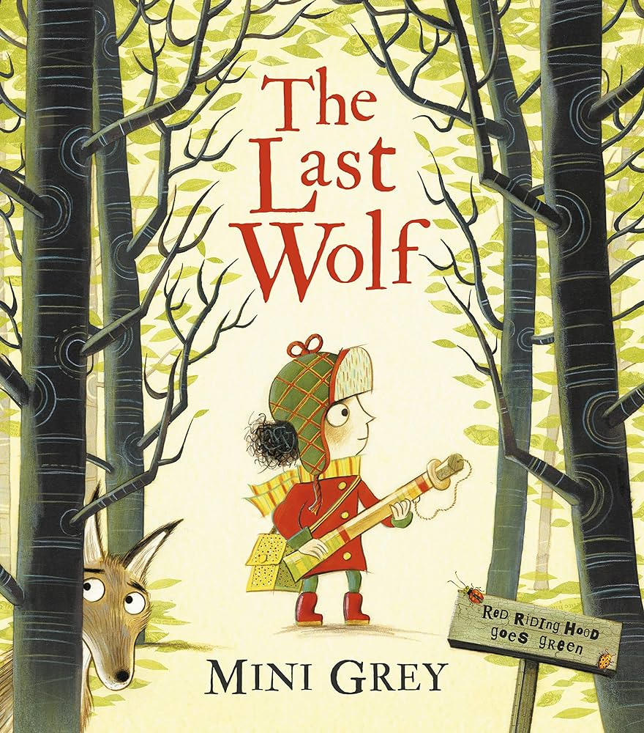

Art and D&T  
Our focus is magic spells! We will be making still drawings then turning them into a shared magic spell pot.

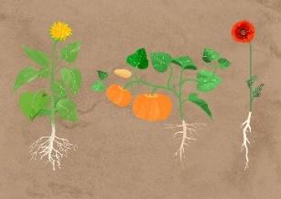

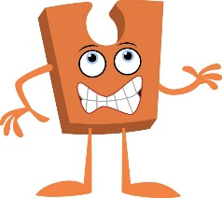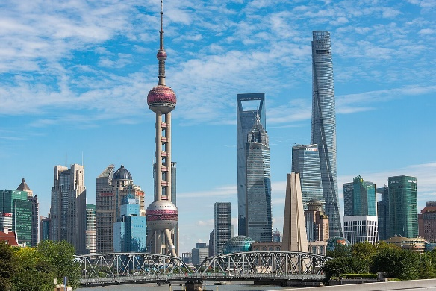

Humanities  
Our Geography topic this half term is ‘What is it like to live in Shanghai?’ Children will be investigating the physical and human features of China, compare Shanghai to the locality of Chiswick and continue to improve on their map skills.

PSHE  
We will be explaining how we have changed over time. We will discuss changes that have happened in our lives.

RE

This term children will be thinking about the big question *Why should we care for others?* They will be looking at the teachings of Christianity, Islam, Hinduism and Humanist approach.

Music  
Our music topic is ‘Playing Together’. This unit brings together the musicianship skills learnt throughout the year.

Computing  
This term children will be introduced to on-screen programming through ScratchJr. Learners will explore the way a project looks by investigating sprites and backgrounds.

.

