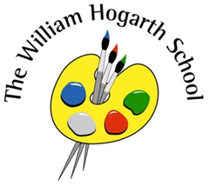
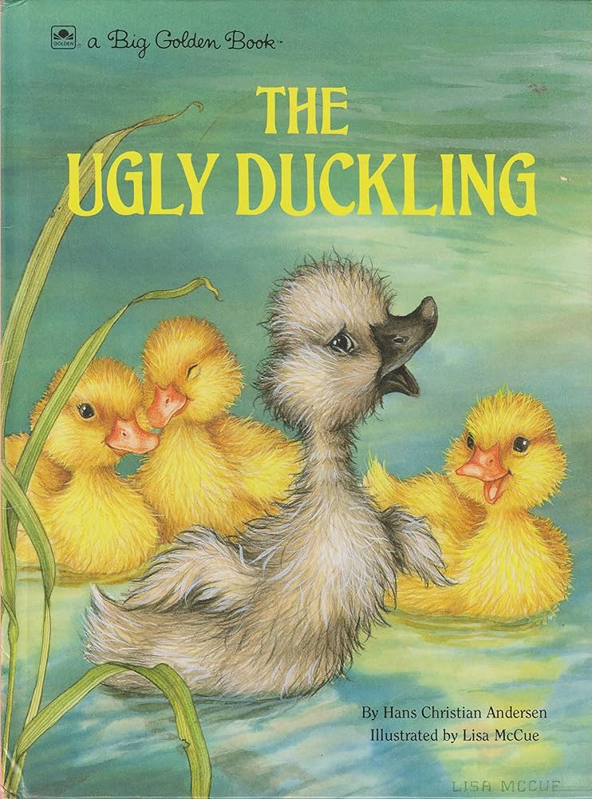
Reception Newsletter
15th March 2024

Our focus book for this week is:

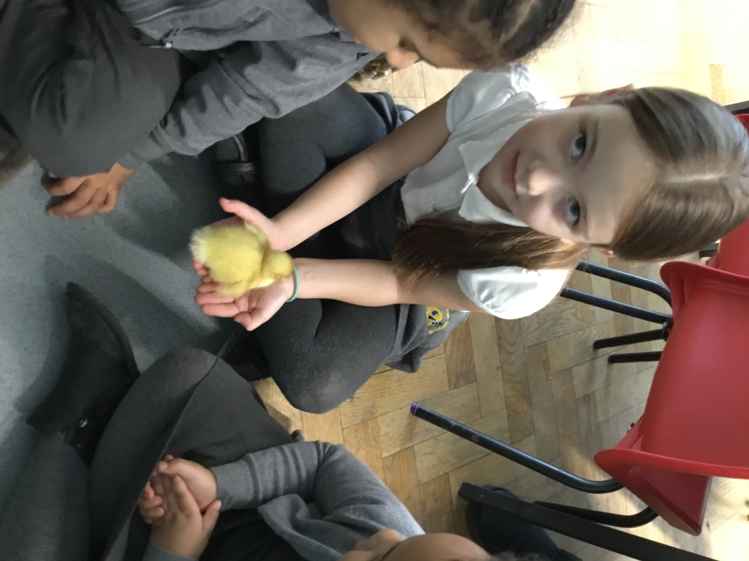
We have been:

- listening carefully to the story “The Ugly Duckling”
- drawing a picture of the egg and writing what is inside
- watching the ducklings hatch and talking about the first stages of the duckling’s development
- once the ducks have hatched talking about what they need to survive and stay healthy
- building duck houses
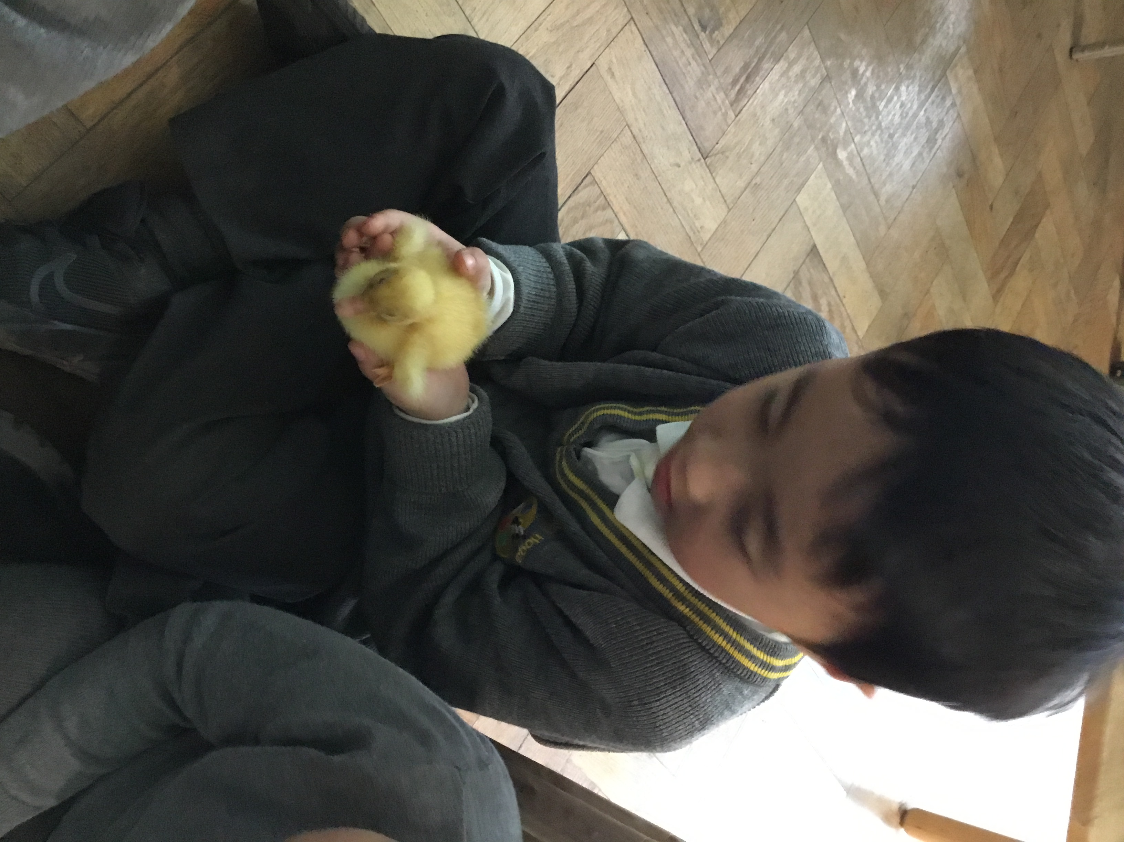
- taking care of the ducklings by feeding them, changing their bedding and refilling their water
- writing a list of how to take care of the ducklings
- playing duck duck goose!
- following recipes in the mud kitchen
- measuring the height of the different natural objects
- developing gross motor skills with stilts and stepping stones
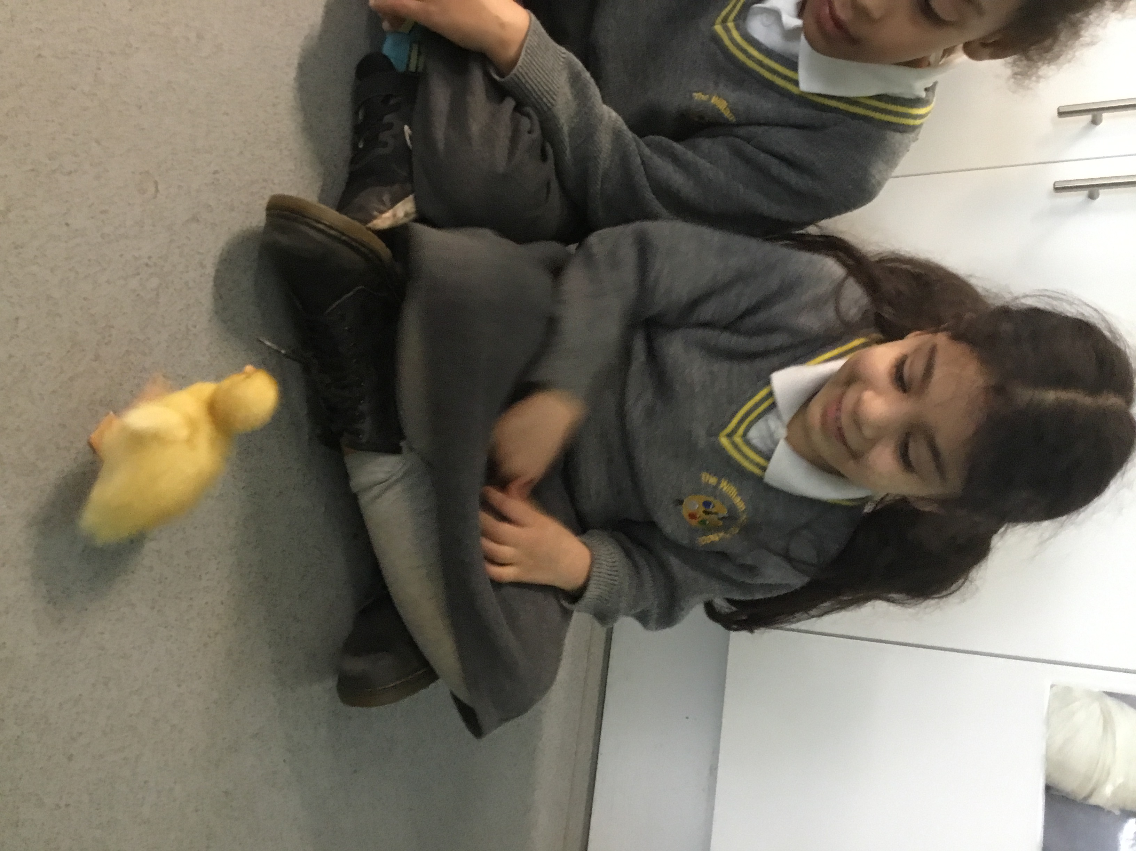
- introducing the idea of a double number, having equal parts in a number
- using our fingers to look at simple doubles
- developing our knowledge of the 3D shapes further and sorting these
- counting forwards and backwards from 10
- going on number hunts in the garden
- revisiting counting to ten and building these numbers

 | - No nuts or nut-based food in packed lunches, please.  - Writing names on jumpers and cardigans.  - Writing names on water bottles.  - Practice adding two groups of items together, e.g. 3 apples and 2 pears is 5 pieces of fruit all together

