Home Learning ideas for ‘Energy and Sustainability’
- To investigate the life history of a food.
In this sustainability activity, you will need to select a food item and explore the three stages of the item’s life.
- Production
- Sale
- Disposal
- Investigate and present ways of reducing your Carbon Footprint.

- Find an object or item to use as the inspiration for a short story on sustainability.
It may be something you collected during your nature walk, a food product examined in the Life History of Stuff activity), or a commercial item that you already own.
- Write your own poem or rap about saving the earth.

- Explore how Electric Cars use Renewable energy.
Research different models of all-electric and hybrid cars, compare and contrast the technical and design features of each.
- Research and discuss some of the major issues surrounding sustainability, such as:
- Water
- non-renewable and renewable energy
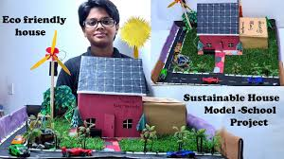
- greenhouse gases
- recycling
- or landfill.
