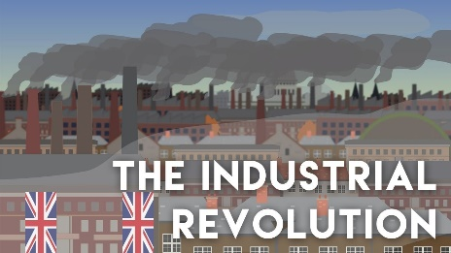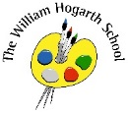**Autumn 1 Term Newsletter Year 6**

**Music**

This term we are looking at rhythm and pulse within music and comparing different genres of music and analysing how the pulse and rhythm change for different styles. We are also looking at ensemble work and singing in rounds. There will be opportunities to perform and collaborate building on our musical knowledge.

**Humanities**

Year 6 will be having an in-depth look at the Industrial Revolution this half term. This topic is an integral part of British history. Throughout this topic we will explore the impact of the Industrial Revolution on society and how the introduction of laws including The Factory Act and The Great Reform Act changed working conditions and led to a fairer society. The Victorians experienced great change during this period and a visit to The Water and Steam Museum, in Brentford, will hopefully bring this period of history to life for the children.

**P.E.**

We will be fortunate enough to receive Tennis coaching led by specialist coaches from Duke’s Meadows Tennis Club. Children will learn a range of skills such as: serving, rallying and ball control.

We will also have swimming sessions each week.

**Class reading text**:

Street Child

**PSHE**

Year 6 will be focusing on transition and finding their place at the top of the school. The children will identify their goals for the year and understand their fears and worries, learning how to express them. There will be opportunities for them to put themselves forward for a variety of leadership roles, starting with House Captains.

**R.E.**

This term are looking at why religion looks different around the world and comparing Abrahamic religions. We will be discovering how some of these practices are observed giving the children a chance to reflect and question in a safe space. .

**Computing**

This term we will be looking at how children can stay safe online and what needs to be done to keep their personal information safe. We will be looking at and questioning things we see online and what is presented to us so that we question what they are being asked to share. Children will look at scams and misinformation and how to go about spotting these bogus requests.

**English**

This term we shall explore the book “Dreams of Freedom”. This book focuses on different human rights and the importance of these human rights in creating a happy, safe and fruitful society. The children will be creating poems, writing letters to their local MP and writing a cross curricular essay regarding the Industrial Revolution.

**Science**

Our first unit in Science this year is Physical and Chemical Changes. We will look at the changes of state between gases, liquids and solids and how some are reversible and some are irreversible. We will also experiences changes of state through our cooking curriculum as we make a variety of sweet and savoury dishes.

**Maths**

We will begin with place value and recapping all the important work done in Year 5. We will then move on to the four operations where the children will gain the opportunity to develop problem solving skills and reasoning skills as well as secure their fluency. There will be ample opportunities for children to build their stamina when answering questions mentally.