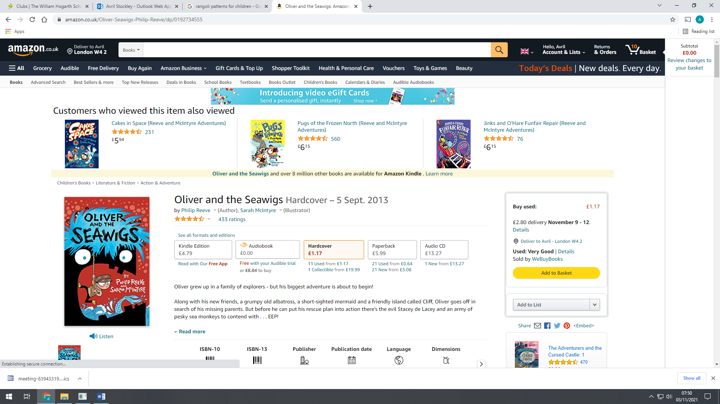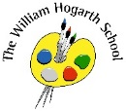**Autumn 2 Newsletter Year 3 Picasso**

**English**

Our stimulus book, The Iron Man by Ted Hughes and illustrated by Chris Mould. A well-known story about a little boy who realises the Iron Man is not here to destroy earth. He might even be here to save the planet! We will explore writing an Approaching Threat Narrative and Explanation text.

**Story time Book**

**Oliver and the Seawigs**

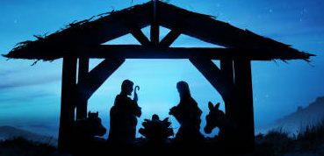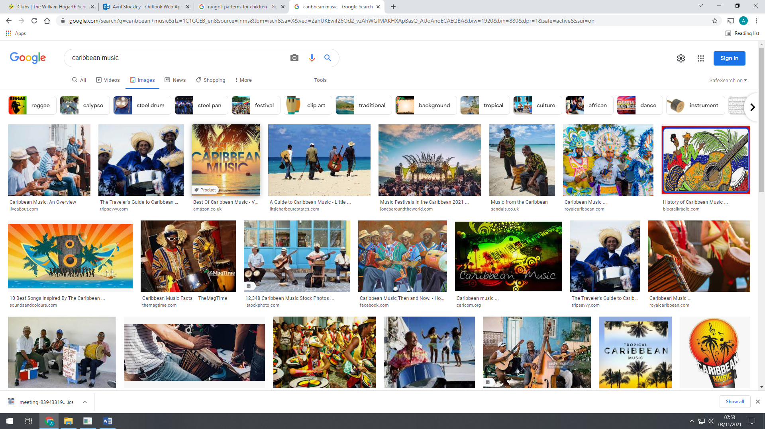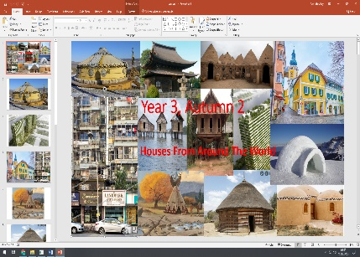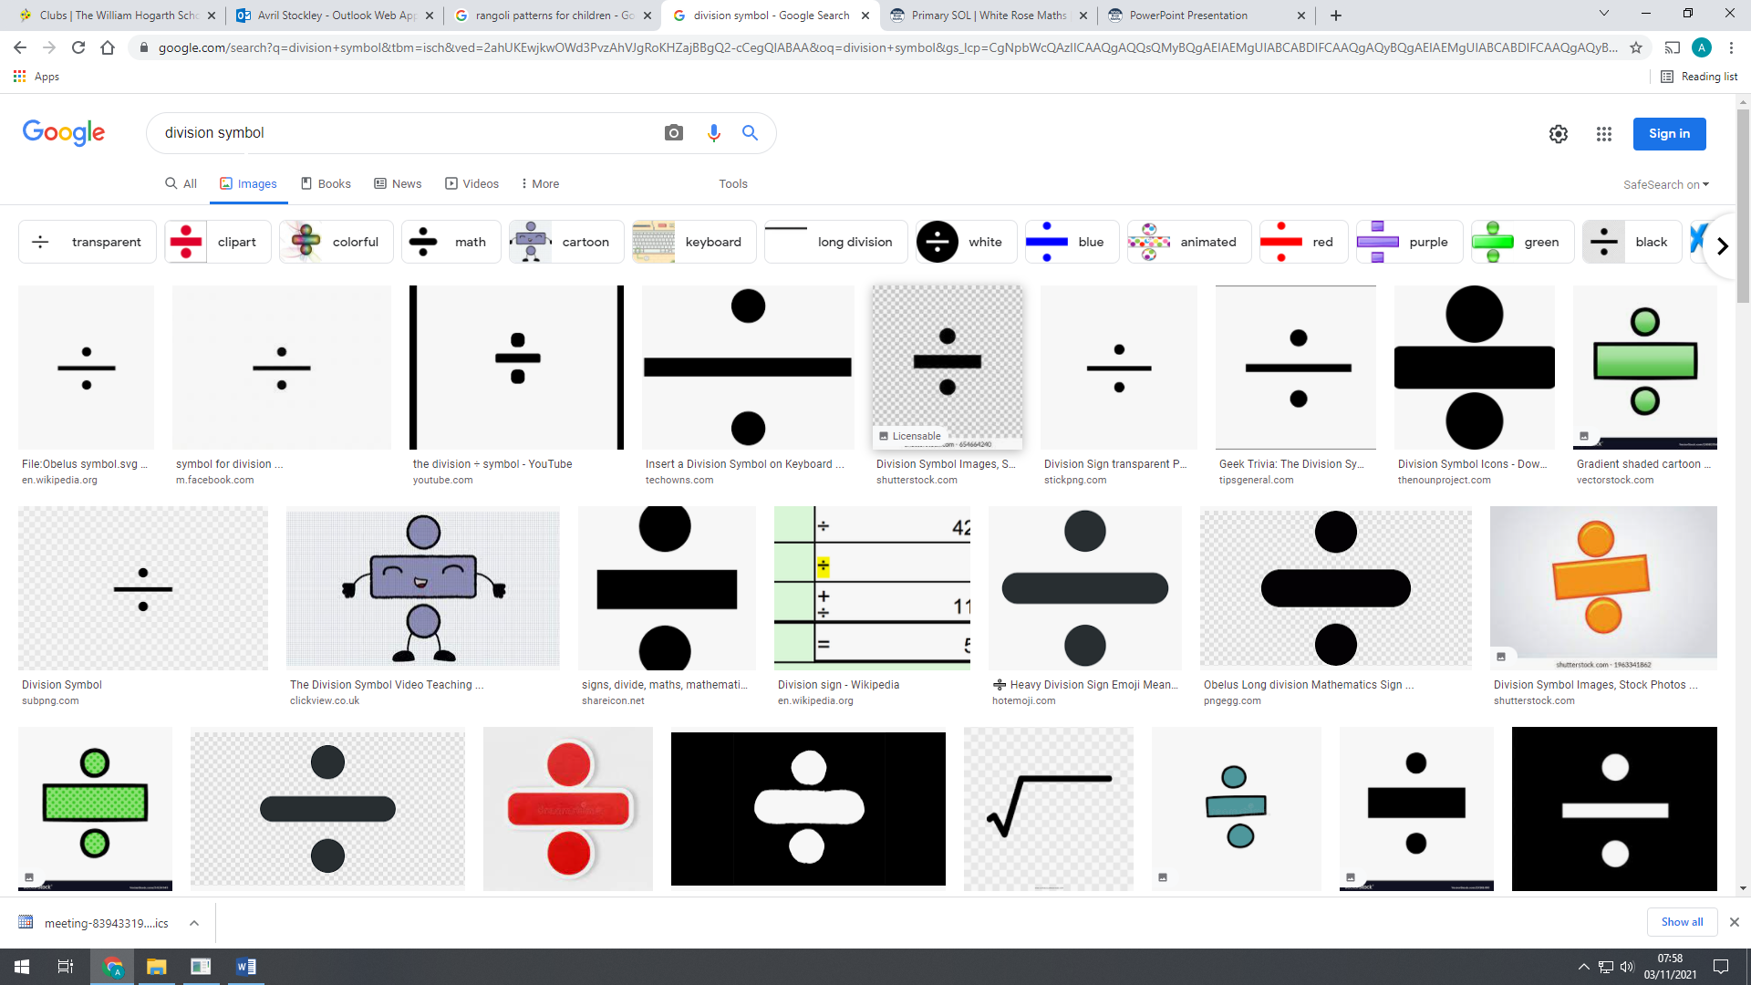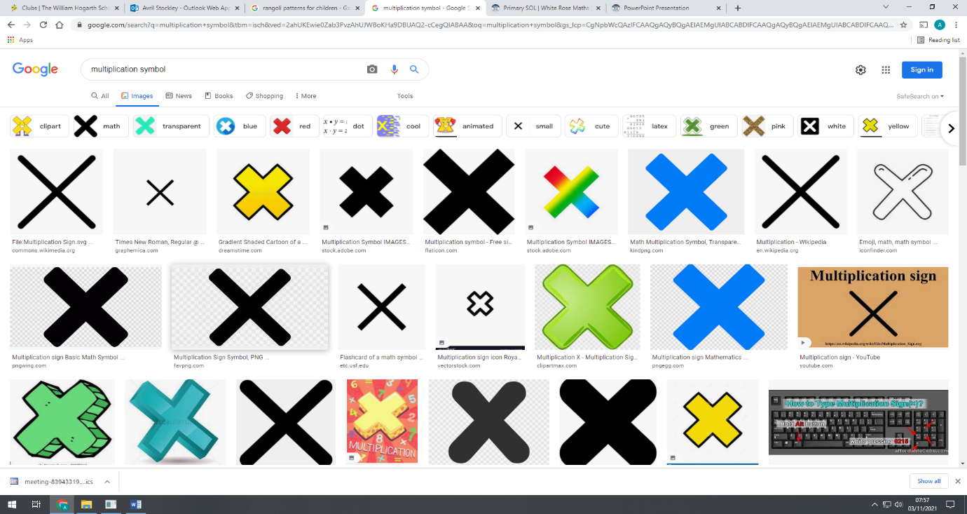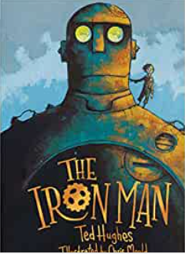

**Computing**

We will be are learning about Computational thinking, both with or without a computer. To practice our computational thinking, we will learn to use Stop-Motion Animation on I-pads.

**PSHE**

We are celebrating differences amongst us. Different families, different looks, different cultures. In looking at differences, we will explore conflict, bullying and how to resolve conflict and how to stand up to bullying.

**Music**

MUSIC AROUND THE WORLD! Children explore music from the Caribbean, Ireland and the USA by learning folk songs and games. They will build on what they have learned on the glockenspiel and continue to explore key elements of music.

**Humanities**

Year 3 will be learning about the Villages, Towns and Cities as part of Geography. We will learn about where people live and why. We compare and contrast the three main types of settlement and answer the essay question “Where do people live?”

**Art**

Our stimulus this half term is houses around the world which will support our celebration of differences in PSHE and humanities lessons. As well as focusing on line, children will experiment with textiles and how these can be used to ‘draw’.

**R.E.**

This term we will be learning about Christianity and Christmas. We will explore and answer the question “Has Christmas has lost its true meaning?”

**Science**

We have a focus on physics this half term, with an in-depth look at phases of matter and behaviour of particles.

**P.E.**

On Mondays, we will be looking at invasion games. On Fridays, we will be learning about Gymnastics, linking movements together.

**Maths**

In Maths our focus this half term is multiplication and division, with the children exploring grouping and sharing. Our times tables focus is 3, 4 and 8.