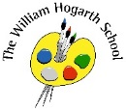**Autumn 2 Term Newsletter Year 5**

**P.E.**

We will be taking part in Dance this term (Tuesday) and learning how to swim. (Thursday)

**Science**

We will be learning about ‘States of Matter’. Matter makes up our physical universe. The children will learn about the matter on Earth, which exists in one of three main states: solid, liquid or gas.

**Maths**

We will begin with multiplication and division, statistics and measurement. We will be looking at problem solving and reasoning strategies.

Story time Book

Alice in Wonderland

**English**

This term we shall explore the book “Farther”. A young boy, bewitched by his **father's** unrelenting passion to fly; a desperate craving that absorbs his every waking minute, finds himself ...We shall use the text to study Fiction and Non-fiction writing, such as – a setting narrative and letter writing.

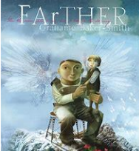

**PSHE**

Year 5 will be focusing on ‘Celebrating Differences’. This will helps us to understand different cultures.

**Humanities**

Year 5 will be learning about Slums. The children will explore how slums are developed, the challenges that occur for people living in slums and how slums can be improved.

Our key question is: - ‘The state should shut down all slums around the world’.

How far do you agree with this statement?

**Music**

We will learn what a percussion and rhythm 1 - through rhythm games, songs and percussion activities, children will reinforce their knowledge of pulse and rhythm. Children

will read and write basic rhythmic notation, develop their skills on the glockenspiel and begin to develop an understanding of bar lines and time signatures.tempo.

**R.E.**

This term we will be learning about Christianity and understand how to put it into practice.

Our key question is: - **Is the Christmas Story true?**

**Computing**

We will be learning Video Editing. Our focus will be – understanding what a video is, learning about film techniques, creating a story board, importing video and editing.