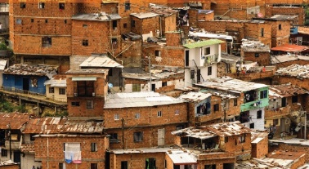
Home Learning Ideas
Slums
Build your own slum. | Make a typical food dish that you would find in a slum. | Make a musical instrument (out of everyday household items) and create a song related to slums.
Create questions for a fun quiz based on slums. | Explore life in an urban slum and identify the difference between ‘need’ and ‘want’. | Visit your local library and identify what you would do to improve conditions in a slum.
Write a diary entry about living in a slum. | Take a walk around what you would consider to be your area – can you see anything you may also find in a slum? | Research what types of crime occur in slums and explain why.

