**Autumn 2 Term Newsletter Monet Class**

**P.E.**

We will be continuing with our swimming every Thursday. I have heard of some very positive progress in swimming over the last half-term! We will also be starting our topic on dance.

**English**

This term we shall explore the book “Leaf” by Sandra Dieckmann. This book has wonderful illustrations and explores the themes of acceptance of others, friendship and trust. We shall use the text to study narrative writing and also a diary recount. In grammar, we will be focussing on fronted adverbials, the use of apostrophes for possession and contractions and also expanded noun phrases.

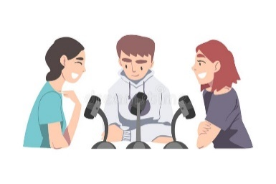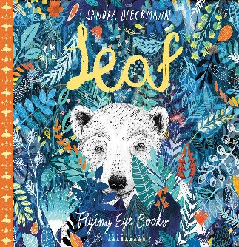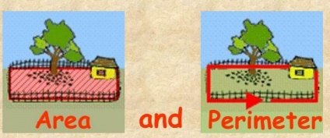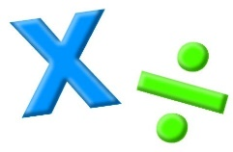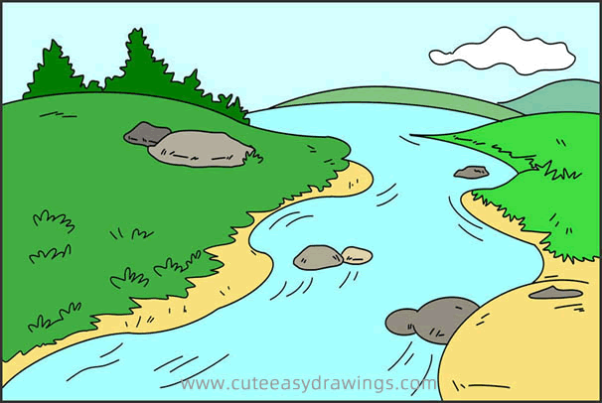

**Humanities**

We will be learning about Rivers. The children will explore the world’s rivers, how they shape the land, Landforms Rivers can create, the importance of rivers and flooding. Their half-termly project will be based on this topic and we will have another presentation afternoon in mid-December.

**Music**

We will look at numerous techniques involved in singing e.g. rhythm, tone and pace. We will also take part in some festive singing.

**R.E.**

This term we will be learning about what makes some texts sacred. Children look at different ways scriptures are used and what this shows about the value placed on them. They experience how the Guru Granth Sahib is treated like royalty and analyse information collaboratively.

**Maths**

We will begin with addition and subtraction. Children will focus on exchanging and using their place value knowledge to understand how we exchange from one column to the next. We will then move on to area and perimeter and multiplication and division.

**Science**

We will be learning about electricity, Specifically, electric conductors and circuits. We will have the opportunity to build our very own circuit and create our own burglar alarm!

**Computing**

We will be looking at audio creation/ editing. The overall aim is to learn about audio inputs and outputs and eventually create a podcast in class.

**PSHE**

We will be focusing on celebrating difference. We will look at how to make everyone in our community feel valued, important and accepted.