We love learning and achieving together
We are an inspiring learning community with high expectations, where all feel safe and happy and everybody has the opportunity to unlock and realise their potential.

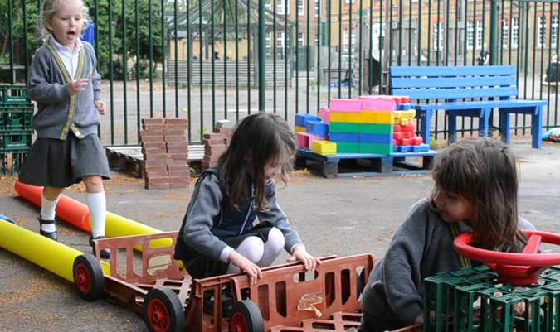
Headteacher: Ms A. Stockley

Deputy Headteacher: Ms K. Rees
Assistant Headteacher Early Years: Mrs T De Jesus

INFORMATION FOR NEW PARENTS

Nursery
2020 – 2021

WELCOME

We are very pleased to welcome your child into The William Hogarth School. We look forward to working in close partnership with you over the coming years to ensure that your child enjoys their time with us and achieves their best.

Thank you for all your support in making your child’s start to Nursery a very positive one.

Avril Stockley
Headteacher

Starting in Nursery
There is one class in Nursery year group – Pollock. This class has a teacher and a qualified teaching assistant.
Nursery and Reception staff work together as an ‘Early Years Team’ at The William Hogarth School. The Early Years Foundation Stage curriculum is followed across the two year groups.
Home School Partnership
Please let staff know if you have a question or concern about your child. We are available at any time for urgent problems, but it is most convenient for us if you make an appointment after school.

Individual ‘parent and child’ meetings are arranged before the start of the school year. This is an opportunity to meet staff, learn about the cur
riculum and discuss daily routines.

Parents’ Evenings take place in the Autumn and Spring terms in order to discuss your child’s progress, with annual reports being sent home at the end of the Summer term. We also offer parent workshops, where you will be invited to find out about particular aspects of the curriculum and how you can support your child’s learning at home.

The Learning Environment
Children in our Early Years explore activities indoors and outdoors throughout the day and in all types of weather. We work to ensure that our learning environments are bright, vibrant, stimulating and interactive.

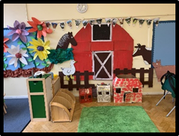

We have a range of equipment & resources that supports learning and development in all areas of the curriculum. These include; an outdoor digging area, a sand pit, mud kitchen and many opportunities for exploratory and imaginative role-play.

Research suggests that children play differently outdoors and learn with their whole bodies. They can make a mess, run and jump, hunt for things in the natural environment and develop their understanding and thinking through talking about these shared experiences.
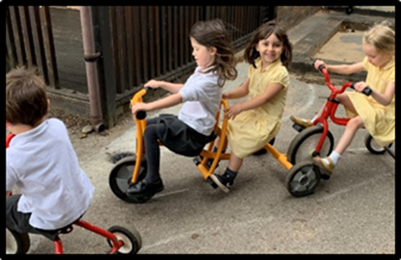

Learning Through Play
Your child may tell you that they just ‘play’ at school. We believe that children learn best, and concentrate for much longer periods, when they are doing something they enjoy.

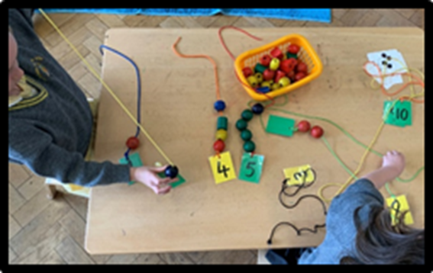
Through ‘play’, children learn to count, recognise colour, use a pencil, work co-operatively with others, talk, listen, solve problems and most of all they learn a love of learning…
‘How do I do this?’ ‘How does this work?’ ‘I’ve only got three left…’
All of these comments and questions can be heard while children are thinking about their own learning – what they may tell you is that they are ‘…just playing’.

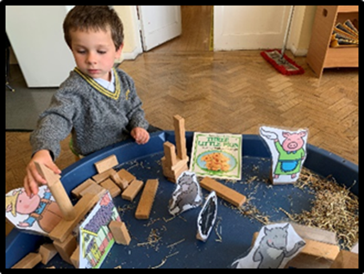

Children come to school with a range of experiences of the world and preferred styles of learning. We look closely at the individual needs of our children and plan activities which build on what they already know and help them to make the next step along their learning journey.
For more information about the curriculum, please refer to the ‘Parents’ guide to the Early Years Foundation Stage Framework’.

Settling into Nursery
Settling into Nursery is an important time for young children and their families. For some children this will be the first time they may have been left with another person and often the first time they have been left in a larger environment. At William Hogarth we aim to make this process as smooth as possible. All children and families are unique and as such their individual needs are taken into account throughout the settling in process. Through discussion with the class teacher and meetings, individual arrangements are agreed for each child.

Start Date
Children’s entry into nursery is staggered to enable staff to spend time welcoming and settling in new children. (See letter)
We hope that by working with parents/carers we can provide the best possible start for your child’s entry into nursery, laying firm foundations for the future. We encourage parents/carers to talk to their child beforehand about the new experience.

The Nursery Day
The Nursery day is split into AM and PM sessions. During the day, practitioners plan short and fun whole class or small group carpet times. At other times, the children learn in different areas, inside and outside. There will be a mixture of child-initiated and adult focus opportunities, with an array of tactile activities for the children to explore.

Session Times
8:45 - 11:45 (mornings)
12:30 - 3:30 (afternoons)

It is important to arrive and collect on time.
Most children are only here for 3 hours and we really want them to make the most of their time with us. It also helps them to learn the necessity for good timekeeping.

If you will be unavoidably late picking up – please telephone so that we can explain this to your child.
If someone other than yourself or a regular person that we have met before is picking up, then you must phone or send a note with that person, we will not send the child home until we have phoned you or your emergency contact.

Dropping off:
We operate a Soft Start routine at the beginning of the school day. This means that children line up at the gate at 8.45am, so that children are ready to say goodbye. The entrance gate is opened at 8.45 for children to come into school and settle, ready for learning.

We would usually welcome parents into the class to support their child during the settling in period, however under current circumstances (COVID-19) children will say goodbye at the school gate.

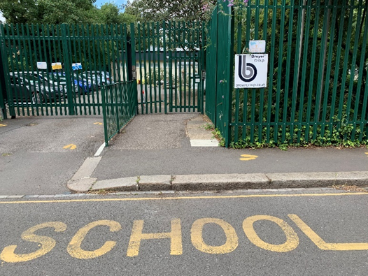

Devonshire Street

The entrance gate on Devonshire Street will be open for drop off from 8:45 to 9:00. If you arrive late, you must go to the school office with your child and sign in. Please endeavour to be on time. The school day starts immediately at 9:00am and lateness causes disruption to the whole class, as well as making a difficult start to the day for your child.

Collection:
Children will be collected at the school gate on Devonshire Street at 3:30pm.

Class practitioners will release your child to you as you reach the front of the line. Please let staff know if an adult other than yourselves (parents / carers) will be collecting your child. In an emergency, you may ring and let the office know alternative arrangements. We will not let your child leave without this permission. Regular ongoing collection arrangements can be detailed on the school form which is included in your child’s pack.
Please note that the gate will shut at 3:40, at which point you can collect your child from the school office.

Punctuality
Punctuality is extremely import for every child, as it helps develop their sense of belonging. Being part of a larger group and arriving on time, encourages well –being and independence.
Moreover, it is paramount in developing personal relations with peers and adults.

A planned input relating to the current theme is shared at the start of the session, which informs the activities and learning for the rest of the day. Children arriving late will therefore miss valuable teaching and learning.

Planning
Practitioners plan on a weekly/daily basis. You will receive regular newsletters to update you on specific learning and events taking place in the nursery. A curriculum newsletter will be sent out half-termly.

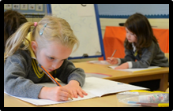

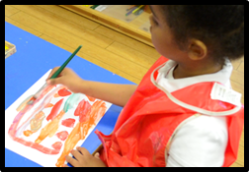

Record Keeping / Parent Consultations
In order to plan for your child’s development, all staff contribute to observations on your child’s development. These begin with the information you share with us at the initial meeting and build up during your child’s time with us. We collect written observations and photographs of things they have done at Nursery.
There will be a parent consultation in the second half of the Autumn Term.

We offer an open door policy so if you have any concerns please speak to staff on drop off and pick up. If you require a longer discussion, please make an appointment.
In the Autumn Term there will be an individual ‘parent and child’ meeting. This will be an opportunity to ask questions and learn more about the curriculum and an opportunity to share relevant information about your child.

Accidents and accident reporting
All accidents requiring treatment are recorded in our accident books.
If in our opinion a child requires medical treatment, we will contact you immediately.
Please make sure we have up-to-date contact numbers.
Absence
We ask that you ensure your child makes full and regular use of the place offered to them. If for any reason your child will not be able to attend please could you telephone school to let us know. Please inform us of any infectious illness so that we can let other parents/carers know.
Toilet Training
It is expected that children are toilet trained before they join the Nursery.

Fruit/ Snack

We receive daily fruit for schools, so your child is entitled to a piece of fruit each day if they want it.
Milk is provided on a daily basis for those children who like it. Please see the separate form on how to order milk online through ‘Cool Milk’.
We ask that children bring in a named water bottle to keep in the classroom – there is always water available for the children to drink.

Toys from Home
Occasionally children like to bring a toy from home to show other children or an adult in the Nursery, or just for security. Could you please discourage this as much as possible. Treasures can easily be lost or misplaced which can be very upsetting for the children.

Uniform
All children are expected to wear the correct William Hogarth School uniform as it helps to give the children a sense of identity and makes a very practical ‘school overall’ as our learning can often be messy and hands on!
Please see the enclosed uniform list and ordering information for items with the school logo.
Non-logo items can be purchased from high street stores or supermarkets.

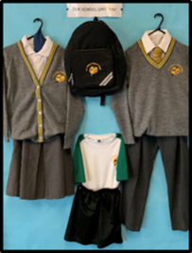
We ask that children wear shoes with Velcro to enable them to be independent. School shoes should be black. It is best for nursery children to wear trousers with an elastic waistband to facilitate using the toilet and encourage independence.
All school clothes should be clearly labelled as you can imagine, many of the items have the opportunity to get mixed up on a daily basis as we change between hot and cold environments. We encourage children to take responsibility for their own clothing, but also have a lost property box where items can sometimes be found.
Extra set of clothing
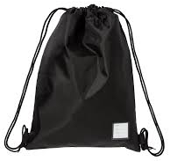

Please ensure that your child has an extra set of regular clothes in school. Nursey children often get wet, muddy or have a toilet mishap and we would like to make them as comfortable as possible. This should be placed in a rucksack or drawstring bag and kept on their peg, until needed.
Also, please send in a pair of wellies to facilitate outdoor learning in all weather.
These will remain in school.

Expectations
The early Years Foundation Stage is a vital and important part of a child’s developmental journey. High quality play experiences will form secure foundations on which future learning can be built. Teachers have high expectations for children – this includes their behaviour and social skills. Adults are consistent, enthusiastic observers, listeners and participants in children’s work and play. We value the process of children’s learning and activity as well as the end product. Play reinforces everything!

The Early Years Foundation Stage Curriculum
THE PRIME AREAS
Personal, Social and Emotional Development  - Self-confidence and self-awareness  - Managing feelings and behaviour  - Making Relationships |  | Physical Development  - Moving and handling  - Health and self-care |  | Communication and Language  - Listening and attention  - Understanding  - Speaking
THE SPECIFIC AREAS
Literacy  - Reading  - Writing | Mathematics  - Numbers  - Shape, Space and Measures |  | Understanding the World  - People and communities  - The World |  | Expressive Arts and Design  - Exploring and using media and materials  - Being imaginative
CHARACTERISTICS OF EFFECTIVE LEARNING
Playing and Exploring  - Engagement  - Finding out and exploring  - Playing with what they know  Being willing to ‘have a go’ |  | Active learning  - Motivation  - Being involved and concentrating  - Keep trying  Enjoying achieving what they set out to do |  | Creating and thinking critically  - Thinking  - Having their own ideas  - Making links  Choosing ways to do things

What you can do now to help your child before they start nursery
- Set up early bed times and routines before the start of term – change is much easier to deal with when you are not tired!
- Encourage your child to be independent and responsible at home. Expect them to hang up their own coat, get dressed themselves and put away their own toys
- Ensure that your child can use the toilet independently and knows to wash and dry their hands afterwards
- Share stories with them. Let them retell and play read to you. Read lots of predictable and patterned texts. Sing nursery rhymes together.
- Model writing in a positive way for your child. Talk to them as you are writing a letter, invitation or shopping list. Ask your child to write their name on anything they produce. Please only use a capital letter at the start of the name.
- Practise counting when laying the table or putting pencils away. Look for familiar numbers on houses, buses or car registrations. Look for shapes in objects around you.
- Praise your child for all efforts. Ask them to describe what they have been doing.
- Read starting school books and stories and talk to your child positively about what to expect when they get to school.

Starting School Books
These may be useful to help your child feel enthusiastic about starting in Nursery:
- Starting School (Janet and Alan Ahlberg)
- Billy and the Big New School (Catherine and Laurence Arholt)
- Lucy and Tom go to School (Shirley Hughes)
- Topsy and Tim Start School (J & G Adamson)
Parent Helpers
We encourage parents to come and help from October half term onwards, once the children have settled. If you are interested in coming into school as a parent helper, you will need to complete the Volunteer Application Form which is available from the office or the website. Regular help is most useful and once your application has been processed, class staff will liaise with you as to when they need help. This may involve working with the children or helping out with other daily jobs.

Friends of The William Hogarth School (FOWHS)
FOWHS organise a variety of successful social and fundraising activities throughout the year. Funds raised are used to buy additional resources and activities which benefit the children. We are always looking for more help so please play an active part, if you can.

OTHER USEFUL INFORMATION
All letters from school and any weekly events can be found on our school website.

Duke Road, Chiswick W4 2JR
Tel: 020 8994 4782 Fax: 020 8742 7736
E-mail: admin@hogarth.hounslow.sch.uk
Twitter: @hogarth_the
Website: www.williamhogarthschool.co.uk

Above all, look forward to the year ahead with your children.

