Nursery Newsletter
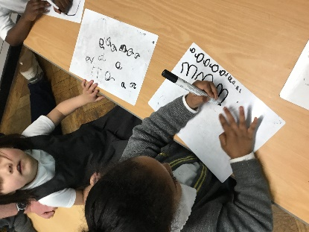
W/B 29th April 2024

We have been:

• reading our new focus story “Oi Frog”
• learning about different Mini beasts, particularly frogs
• learning about the life cycle of a frog
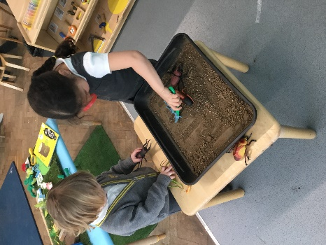
• drawing frogs and completing a variety of arts and crafts activities
- Making books about the life cycle of a frog
- Playing teachers in our new school area
- Learning how to read and write new sounds in our phonics lessons (m,a,s,d,t,i)
- learning how to rhyme
• practicing our cutting and sticking skills
• hunting for mini beasts in our outdoor area
• practicing counting forwards to 20 and backwards from 10
• singing 5 little speckled frogs
• remembering to go to the toilet, flush the toilet and wash our hands

Important reminders:
- No nuts or nut-based food in packed lunches, please
- Your child will get a library book every Friday. Please ensure these are returned the following Thursday so that your child can receive their next book.
- Please ensure that your child is wearing the correct uniform and only has 1 piece of jewellery and no hoops/dangling earrings.
- There is no school on Monday 6th May due to bank holiday
- Please keep collecting as many sponsors as you can for the visit from the professional basketball player on the 22nd May!

