Review of Impact on Outcomes for the academic year 2022-2023

February 2024
Katy Luciani
SENDCo and Inclusion Lead.

Pupil premium strategy outcomes
This details the impact that our pupil premium activity had on pupils in the 2022 to 2023 academic year.
At the William Hogarth school, class teachers have noted anecdotally, that vocab knowledge and usage has expanded and grown in variety. In turn, this has positively influenced our Reading, Maths and Writing results in Year 6, Summer 2023.
DFE website progress in reading, writing in maths.
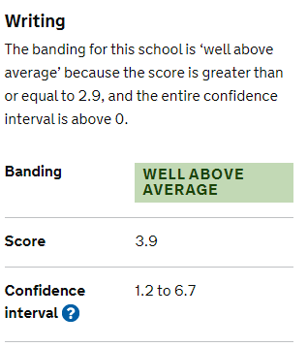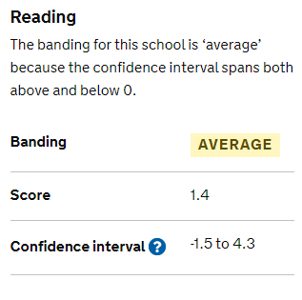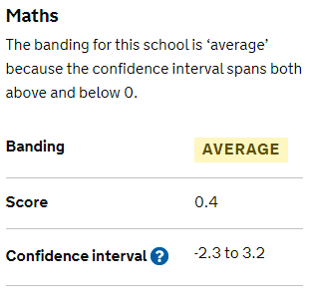

According to the DFE website, the number of pupils meeting expected standard in reading, writing and maths is shown below
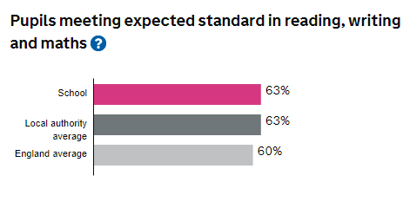
And the number of children achieving the higher standard in reading, writing and maths is shown below

17% of our PPG children now registered in at least one “after school” club.
All children are able and supported to go on school trips that enhance their learning and wider life experiences.
In July 2023, Ofsted noted that our Learning to lead Programme “Pupils experience an extensive range of activities and skills as part of the ‘Learning to Lead’ programme, which prepares them for their future lives. For example, the ‘digi-leaders’ have worked with parents and pupils to emphasise the importance of online safety. Play leaders develop games tailored to each year group and provide accompanying instructions.”
With respect of our singing and music provision “The school offers diverse music options, which enables pupils to express themselves with others in a calm and meaningful way, fostering positive relationships.”
At the William Hogarth school, we have reduced the number of Fixed term exclusions and behaviour and attitudes was judged as Good by Ofsted in July 2023. Our house captains are in charge of collecting and counting up house points each week, and this is fed back to the school at Celebration Assembly.
Each week, the children have a singing assembly, one of the happiest and uplifting experiences of the week. They learn new songs and sing old favourites. There is 100% positive participation. Ofsted commented that “The school offers diverse music options, which enables pupils to express themselves with others in a calm and meaningful way, fostering positive relationships”.
“No More Marking” results indicate that broadly speaking, our PPG children are in line with PPG children in other schools, with a noticeable achievement and progress in Year 4 PPG students. This is an area of targeted support this year through High Quality teaching and Fresh start intervention available to identified children in lower KS2.
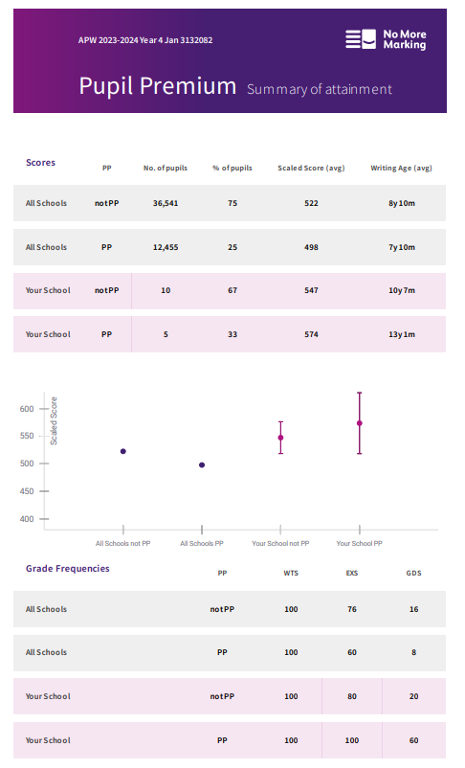
Year 4 January 2024 No more marking results

Lexplore has given the school the tools to identify children who may need glasses, and those children who we need to target with the Lexplore interventions and support, via a QR code. Interventions can be accessed at home

Lexplore results: January 2023 for PPG children
Year group | Percentage of PPG children scoring average or above
Year 6 | 57%
Year 5 | 50%
Year 4 | 80%
Year 3 | 57%
Year 2 | 50%
Year 1 | 50%
Write Read Inc targeted planning and rollout in early Years and KS 1 has meant that out of Year 1 class of 16 children, the 8 eligible to sit the phonics screening (children must have been taught phonics for a year before screening) 7 children passed. In Year 2, 6 children were screened and 5 of those children passed.
87.5 % pass rate in Year 1
83 % pass rate in Year 2.

Externally provided programmes
Please include the names of any non-DfE programmes that you purchased in the previous academic year. This will help the Department for Education identify which ones are popular in England
Programme | Provider
Reading, Grammar and Maths Interventions | PiXL Primary
Wider opportunities Sing Education | PiXL Primary
Primary Futures: Linking education to the world of work | Primary futures
Online writing assessment No More Marking | No More Marking
Read write Inc KS 2 | Read Write Inc
Rocksteady  Peripatetic Piano | Rock steady
 | Hounslow Music Service
Breakfast and After school club | Let’s Leap
 | School Staff
Online reading assessment and intervention Lexplore | lexplore

