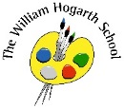

**Spring Term 2 Curriculum Map – Reception**

Understanding the World

We will focus on Life cycles this half term and discuss the many life cycles in close proximity to us. The children will learn about caring for ducklings, as we will have some eggs in incubators in the classroom at the middle of this half term. We will also discuss our impact on the environment.

Communication Language & Literacy

This term we will model how to answer questions in full sentences. We will define new words each week and place them on our word wall. The children will listen to a wide range of topic related stories. The children will use talk to clarify thinking, ideas, feelings and upcoming events.

PSED

The children will continue to learn about the rules and expectations in school. We will discuss many ways to resolve conflict independently. The children will dress independently for outdoor activities. The children will have many teamwork opportunities. We will develop our teamwork skills with traditional playground games.

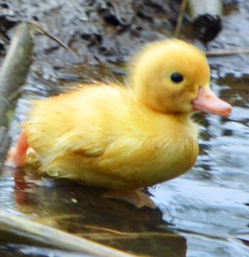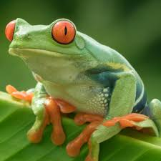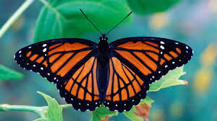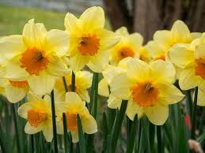

Physical Development

The children will dance, hop and skip in time to music. We will explore tempo and how to move accordingly. We will discuss how to control letters and numbers on the page when we are writing.

**Life cycles**

Mathematics

We will continue comparing groups of numbers and using the language “more” and “fewer”. We will sort items by length and height using key mathematical language. We will explore the structure of numbers, for example 7 is “5 and a bit” and connect these ideas to finger patterns. Understand two equal groups can be called double.

Expressive Arts and Design

The children will explore textures when creating art with a high focus on designing and making. We will discuss what the five senses are in relation to plants and animals. The using we use costumes, stories and key ideas in imaginative play. We will listen to music and compose own songs and dances. We will explore the brightness of the new colours as we more to spring and creating tints and shades through mixing.