We love learning and achieving together
We are an inspiring learning community with high expectations, where all feel safe and happy and everybody has the opportunity to unlock and realise their potential.
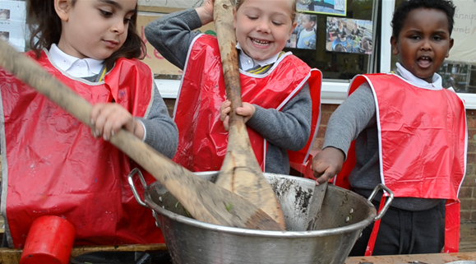
Headteacher: Ms A Stockley

Deputy Headteacher: Ms K Rees
Assistant Headteacher Early Years: Mrs T De Jesus

INFORMATION FOR NEW PARENTS

Reception
2020 – 2021

WELCOME

We are very pleased to welcome your child into The William Hogarth School. We look forward to working in close partnership with you over the coming years to ensure that your child enjoys their time with us and achieves their best.

Thank you for all your support in making your child’s start to Reception and full-time schooling a very positive one.

Avril Stockley
Headteacher

Starting in Reception
There is one class in the Reception year group – Rothko. This class has a teacher and a teaching assistant. There are 30 children in the year group.
Nursery and Reception staff work together as an ‘Early Years Team’ at The William Hogarth School. The Early Years Foundation Stage curriculum is followed across the two year groups.

Home School Partnership
Please let staff know if you have a question or concern about your child. We are available at any time for urgent problems, but it is most convenient for us if you make an appointment after school.

Individual ‘parent and child’ meetings are arranged before the start of the school year. This is an opportunity to meet staff, learn about the curriculum and discuss daily routines. Parents’ Evenings take place in the
Autumn and Spring terms in order to discuss your child’s progress, with annual reports being sent home at the end of the Summer term. We also offer parent workshops, where you will be invited to find out about particular aspects of the curriculum and how you can support your child’s learning at home.

Settling into Reception
We appreciate that this is a very important step for you and your child and we endeavour to make the transition to full-time school as easy as possible. All children and families are unique and their individual needs are taken into account throughout the settling in process.

Your child must feel happy and secure in their new setting in order to be ready to learn. Most children will settle quickly into their new class, but for others it may take a little longer. Practitioners will work closely with you to achieve this.

The School Day

School Times: 9:00am – 3.00pm (gates open at 8:45)

Dropping off:
We operate a Soft Start routine at the beginning of the school day. This means that children line up at the gate at 8.45am, so that children are ready to say goodbye. The entrance gate is opened at 8.45 for children to come into school and settle, ready for learning.

We would usually welcome parents into the class to support their child during the settling in period, however under current circumstances (COVID-19) children will say goodbye at the school gate.

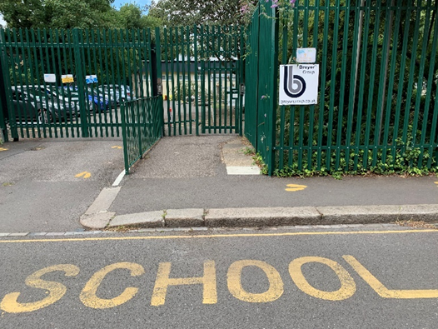

Devonshire Street

The entrance gate on Devonshire Street will be open for drop off from 8:45 to 9:00. If you arrive late, you must go to the school office with your child and sign in. Please endeavour to be on time. The school day starts immediately at 9:00 am and lateness causes disruption to the whole class, as well as making a difficult start to the day for your child.

Collection:
Children will be collected at the school gate on Devonshire Street at 3:00pm.

Class practitioners will release your child to you as you reach the front of the line. Please let staff know if an adult other than yourselves (parents / carers) will be collecting your child. In an emergency, you may ring and let the office know alternative arrangements. We will not let your child leave without this permission. Regular ongoing collection arrangements can be detailed on the school form which is included in your child’s pack.
Please note that the gate will shut at 3:15, at which point you can collect your child from the school office.

Absence:
If your child is ill, please notify the office as soon as possible (and before 9.30am) by telephone on 020 8994 4782.

Due to amendments made to the Education (Pupil Registration) (England) (Amendment) Regulations 2013, holidays will not be authorised during term time. If you choose to take your child out of school, this will be unauthorised and you could be issued with a fine by the Local Authority. If you feel an absence would be classed as ‘special circumstances’, you need to put this in writing to the Headteacher, Ms A. Stockley.

The school day is split into AM and PM sessions. Lunchtime is 11.45am – 12.45pm.

During the day, practitioners will plan short and fun whole class or small group carpet times. At other times, the children work in different classroom areas, inside and outside. There will be a mixture of child-initiated and adult focus activity.
In addition to physical play outside, there are two weekly sessions when the class has access to the hall or ball-park, for targeted Physical Development. During the course of the year, all children will have access to the nature garden for sessions to investigate and observe in the environment. They will use a number of tools and explore the nature garden under the direction of their class teacher.

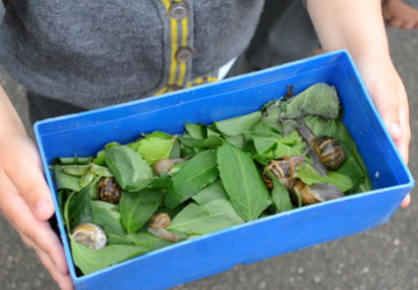

Planning
Practitioners plan on a weekly basis. You will receive regular newsletters to update you about learning and events in reception. A curriculum newsletter will be sent out half-termly.

Punctuality
Punctuality is extremely import for every child, as it helps develop their sense of belonging. Being part of a larger group and arriving on time, encourages well –being and independence.
Moreover, it is paramount in developing personal relations with peers and adults.
A planned input relating to the current theme is shared at the start of the session, which informs the activities and learning for the rest of the day. Children arriving late will therefore miss valuable teaching and learning.

Lunchtimes
Children may choose between packed lunch and school meals. All children from Reception to Year 2 are currently entitled to a free school meal.

Most children look forward to starting lunches at school, but we realise that for some children, this can be challenging.
If your child is a fussy eater, it may be best to start with packed lunches and provide small manageable bits of food that they like. We have a policy of no nut products in school. This includes peanut butter and Nutella.
We encourage children to eat healthy food in their lunches and for that reason we do not allow sweets, chocolate bars or crisps to be brought in. Fizzy drinks are also not allowed.

Reception children have lunch in the early years setting. They are assigned a class midday supervisor for the lunchtime period and play in the Reception outside area.

If your child voices any concerns about lunchtimes, please come and tell us.
Fruit, Milk and Water
We receive daily fruit for schools, so your child is entitled to a piece of fruit each day if they want it.
Milk is also provided on a daily basis for those children who like it. A charge is made for children over 5 years old unless you receive income support. Please see the separate form on how to order milk online through ‘Cool Milk’.

We ask that children bring in a named water bottle to keep in the classroom – there is always water available for the children to drink.

Uniform
All children are expected to wear the correct William Hogarth School uniform as it helps to give the children a sense of identity and makes a very practical ‘school overall’ as our learning can often be messy and hands on!
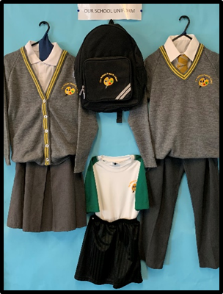

Please see the enclosed uniform list and ordering information for items with the school logo. Non-logo items can be purchased from high street stores or supermarkets.
We ask that children wear shoes with Velcro or buckles (rather than laces) to enable them to be independent. School shoes should be black.

All school clothes should be clearly labelled as you can imagine many of the items (even shoes!) have the opportunity to get mixed up on a daily basis as we change in and out of Wellington boots, PE kits, or move between hot and cold environments. We encourage children to take responsibility for their own clothing, but also have a lost property box where items can sometimes be found.

PE Kit
The children will have two targeted PE sessions every week in addition to physical play and activity in the outside learning area. Targeted PE sessions may take place in one of the halls, the ball-park, or the playground.

On joining, your child will be allocated to one of our houses. They will remain in this house for the duration of their schooling at The William Hogarth School. Initially, reception children will need only plimsolls for PE sessions. In the summer term they will need a school PE Kit- please see the enclosed uniform information sheet for details and guidance on ordering. Children must wear appropriate trainers or plimsolls for PE – Velcro fastenings encourage the children to be independent in getting themselves changed.

PE kits need to be kept in school on children’s pegs at all times – drawstring bags are available for this. PE kits are sent home with the children at the end of every half term. The children are encouraged to
take responsibility for their own clothing and all PE kit items should be named to support this. Lost PE kit will be placed in the lost property box.

Parent Helpers
We encourage parents to come and help from October half term onwards, once the children have settled. If you are interested in coming into school as a parent helper, you will need to complete the Volunteer Application Form which is available from the office or the website. Regular help is most useful and once your application has been processed, class staff will liaise with you as to when they need help. This may involve working with the children or helping out with other daily jobs.

Book Bags
We ask that your child brings a book bag to school every day and for you to empty it each evening at home. Children’s reading and library books, journals and artwork will be placed in their book bags. School book bags and ruck sacks are available to purchase online – please see the information on uniform for guidance.

As soon as children are settled into school, the children will bring home reading books to share (these may not have any words at first!) Home reading books should be kept in the book bag to be used at home and at school. Children may also have letter sounds to learn. The staff will guide you on how to complete the reading record and pupil diary. Staff will be happy to suggest ways in which everyday activities can become useful learning opportunities.

The Early Years Foundation Stage Curriculum
THE PRIME AREAS
Personal, Social and Emotional Development  - Self-confidence and self-awareness  - Managing feelings and behaviour  - Making Relationships |  | Physical Development  - Moving and handling  - Health and self-care |  | Communication and Language  - Listening and attention  - Understanding  - Speaking
THE SPECIFIC AREAS
Literacy  - Reading  - Writing | Mathematics  - Numbers  - Shape, Space and Measures |  | Understanding the World  - People and communities  - The World |  | Expressive Arts and Design  - Exploring and using media and materials  - Being imaginative
CHARACTERISTICS OF EFFECTIVE LEARNING
Playing and Exploring  - Engagement  - Finding out and exploring  - Playing with what they know  Being willing to ‘have a go’ |  | Active learning  - Motivation  - Being involved and concentrating  - Keep trying  Enjoying achieving what they set out to do |  | Creating and thinking critically  - Thinking  - Having their own ideas  - Making links  Choosing ways to do things

Throughout your child’s time in Reception they will be following the curriculum for the Early Years Foundation Stage, working towards the Early Learning Goals by the end of Reception. This curriculum outlines standards for learning and development for all children aged 0-5 and is organised into seven areas of learning:

Personal, Social and Emotional development: Developing independence, confidence, making friends and getting on with other children and telling others how you feel and what you like.

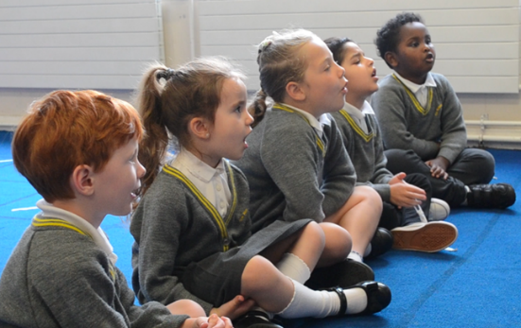

Physical Development: Encouraging an enjoyment of active play and gaining confidence in movement, energetic activity indoors and outdoors, development of skills such as running, throwing, climbing, learning how to make delicate movements with fingers and hands and finding out about health and fitness.

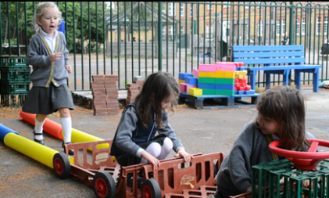

Communication and Language: The development of listening skills, learning to enjoy stories and rhymes, developing their understanding of language and their speaking skills.

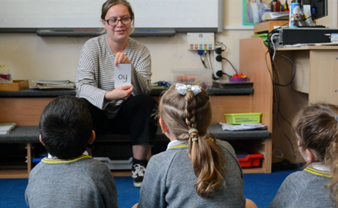

Literacy: Developing skills in reading and writing. Mathematics: Using number names in play, playing counting games, and experimenting with shapes and measure.

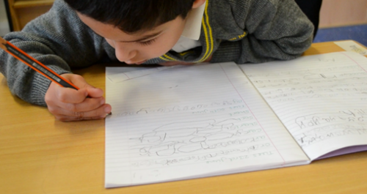

Mathematics: Using number names in play, playing and counting games and measure.
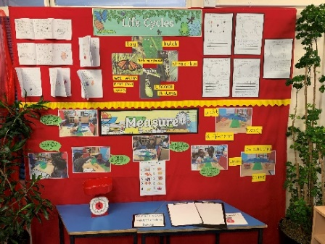

Understanding the World: Encouraging children to use their five senses to notice things in the world around them, finding out about people or places in the local community, designing and making things, learning about animals and plants and how to look after them.

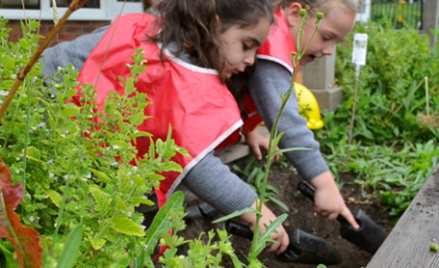

Expressive Arts and Design: Children are given the opportunities to learn to express ideas and feelings through painting, drawing and modelling, acting out different situations, singing and making music and movement and dance.

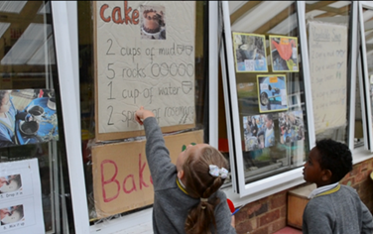

We teach the Early Years curriculum through a topic centred approach, focussing on stories to develop language, imagination and reading.

Each term we have a focus topic that we plan to meet the needs of the children and stimulate their interest for learning.

Each topic covers the seven areas of the curriculum and exploits opportunities for exciting learning opportunities both in school and on regular outings.

The Environment
Reception has inside and outside areas for all children to explore. Our classrooms are well resourced and offer spacious areas for learning.
The inside area is set out each day with a variety of activities such as small construction, writing materials, messy play activities, imaginative play, sand, investigative activities, puzzles, books and role play areas.

The outside area is open all year round and offers unique opportunities to develop social and linguistic skills, such as sharing and turn taking.

There are many opportunities to develop children’s physical skills and role-play opportunities. The children can choose to go outside at regular times throughout the day. Children have access to all areas and will be encouraged to be as independent as possible. Adults will be on hand to support children in their play and learning and lead specific activities inside and out.

Expectations
The Early Years Foundation Stage is a vital and important part of a child’s developmental journey. High quality play experiences will form secure foundations on which future learning can be built. Teachers have high expectations for children – this includes their behaviour and social skills. Adults are consistent, enthusiastic observers, listeners and participants in children’s work and play. We value the process of children’s learning and activity as well as the end product. Play reinforces everything!

What you can do now to help your child before they start school
Set up early bed times and routines before the start of term – change is much easier to deal with when you are not tired!
Encourage your child to be independent and responsible at home. Expect them to hang up their own coat, get dressed themselves and put away their own toys
Share stories with them. Let them retell and play read to you. Read lots of predictable and patterned texts. Sing nursery rhymes together.
Model writing in a positive way for your child. Talk to them as you are writing a letter, invitation or shopping list. Ask your child to write their name on anything they produce. Please only use a capital letter at the start of the name.
Practise counting when laying the table or putting pencils away. Look for familiar numbers on houses, buses or car registrations. Look for shapes in objects around you.
Praise your child for all efforts. Ask them to describe what they have been doing.
Read starting school books and stories and talk to your child positively about what to expect when they get to school.

Starting School Books
These may be useful to help your child feel enthusiastic about the start of the Reception Year.

- Starting School (Janet and Alan Ahlberg)
- Billy and the Big New School (Catherine and Laurence Arholt)
- Lucy and Tom go to School (Shirley Hughes)
- Topsy and Tim Start School (Joan and Gareth Adamson)

FRIENDS OF THE WILLIAM HOGARTH SCHOOL (FOWHS)
FOWHS organise a variety of successful social and fundraising activities throughout the year. Funds raised are used to buy additional resources

and activities which benefit the children. We are always looking for more help so please play an active part, if you can.

OTHER USEFUL INFORMATION
All letters from school and any weekly events can be found on our school website.

Above all, look forward to the year ahead with your children.
Be ready for them to surprise you with their learning and progress!

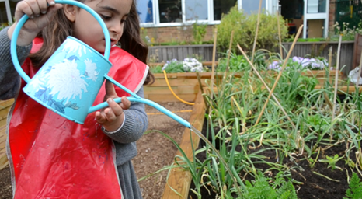

Duke Road, Chiswick W4 2JR
Tel: 020 8994 4782 Fax: 020 8742 7736
E-mail: admin@hogarth.hounslow.sch.uk
Twitter: @hogarth_the
Website: www.williamhogarthschool.co.uk

