School Nursing Weekly Newsletter: Covid19 edition
If your child lives or attends school in London Borough of Hounslow and you would like to speak to the School Nursing Team during the COVID-19 outbreak, please phone 020 3691 1012 or email hrch.hounslowschoolnurses@nhs.net for free confidential health advice and support between Monday – Friday 9am – 5pm.
School Nurses can offer health advice on Diet & Nutrition, Growth & Development, Physical activity, Toileting, Sleep, Managing Behaviour, Keeping a Routine, Allergies, Stress & Anxiety, Relationships and More!

This week’s health message;
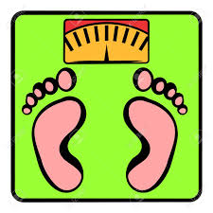
Maintaining a Healthy Weight
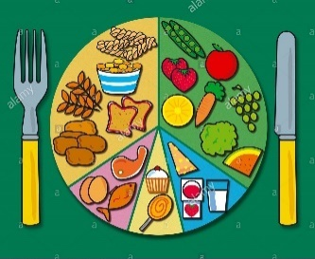
Children who achieve a healthy weight tend to be fitter, healthier, better able to learn, and more self-confident. They're also less likely to have low self-esteem or be bullied. And they're much less likely to have health problems in later life.
Help my child won’t eat:
- Plan meals and snacks so your child eats regularly.
- Make a variety of colourful meals with each food group.
- Eat together and make meals a social event.
- Offer small portions of food on small plates as children can be put of by large portions.
- If you are concerned talk to your school nurse or GP.

My child is overweight:
- Be a good role model – Involve the whole family in changes
- Encourage 60 minutes, and up to several hours, of physical activity a day
- keep to child-sized portions
- Eat healthy meals, drinks and snacks - aim to eat 5 or more portions of fruit and vegetables every day
- Less screen time and more sleep - The less children sleep, the greater the risk of them becoming obese. Lack of sleep can also affect their mood and behaviour.

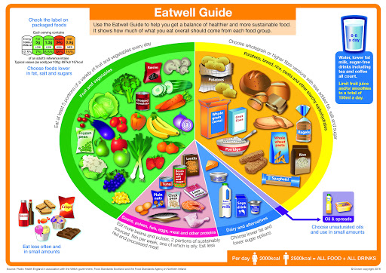
Find out more and visit;
- Join Change4Life
- https://www.nhs.uk/live-well/healthy-weight/underweight-children-6-12-advice-for-parents/
- healthy weight calculator.

Try this at home;

The Hoop app helps you keep your children active by providing information on nearby activities, thousands of which are completely free. It also has recommended ages for each activity, so you only see things that are right for your family.

https://www.nhs.uk/apps-library/hoop/
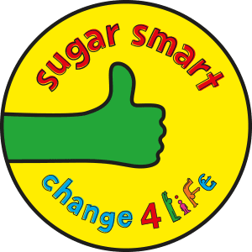

Smart Recipes app has 160 quick, easy and tasty recipes and step-by-step videos.
https://www.nhs.uk/change4life

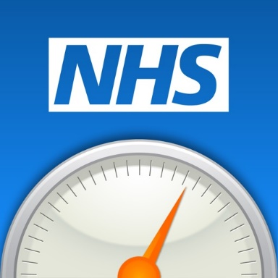
BMI Calculator - Use this calculator to check your child’s body mass index (BMI) and find out if they're a healthy weight. For children and young people aged 2 to 18, the BMI calculator takes into account age and gender as well as height and weight.

https://www.nhs.uk/live-well/healthy-weight/bmi-calculator/

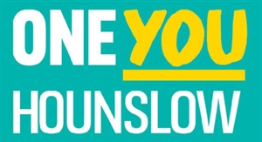
Eat Well - Advice and tips on eating well during the COVID-19 crisis from nutritionists and dietitians.
https://www.oneyouhounslow.org/eat-well/

Remember: Maintaining a Healthy Weight!

