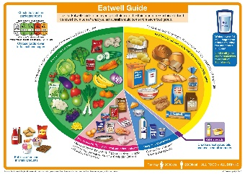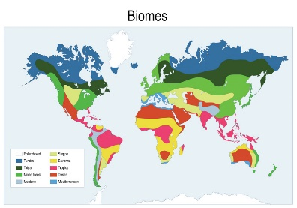**Spring 2 Term NewsletterYear 5**

**Science**

We will be learning about diet and lifestyle. We will be looking at the positive affects of a healthy diet and the importance of exercise. This will be linked into our cooking curriculum as we continue to talk about creating healthy food.

**R.E.**

This term we will continue to. Continuing to investigate concepts relating to death, children learn the meaning of reincarnation and karma.

**PSHE**

Year 5 will be focusing on Healthy Choices. We will be learning how to stay healthy, including why smoking is bad for us and the importance of exercise etc.

**Maths**

This term we will be focusing on fractions, decimals, and percentages. We will be converting between all of these e.g. 1 half = 50% = 0.5.

Towards week 6, we will move into perimeter and area.

**English**

This term we shall explore the book “The Promise”. A story based in a hopeless city where nothing grows. We will be writing a 3rd person character narrative and a newspaper report. During the sequences building up to the writing, we will break down the features, look at key vocabulary etc.

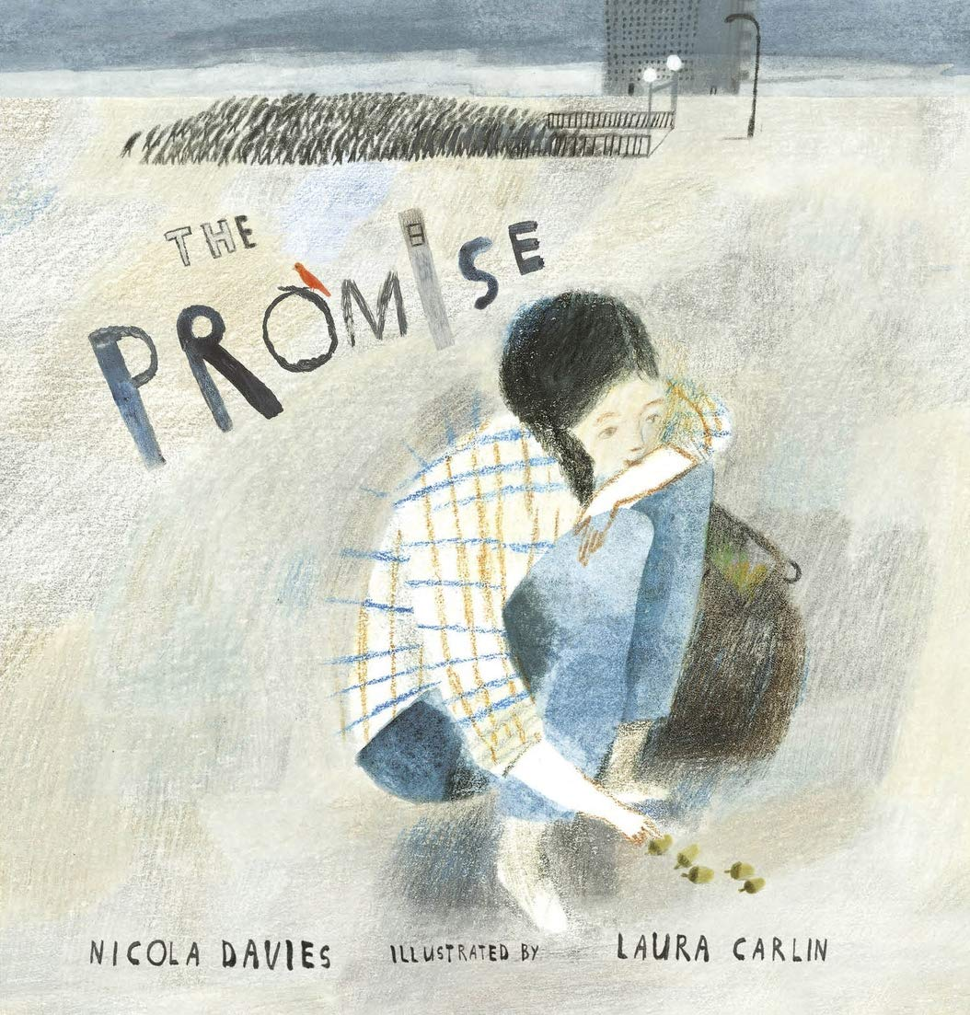

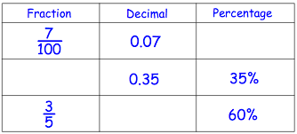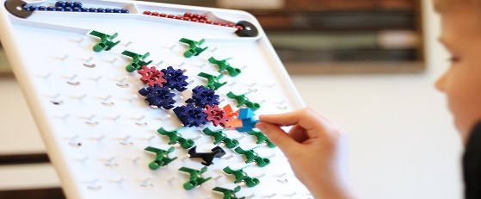

**Computing**

This unit looks at how a flat-file database can be used to organise data in records. Pupils use tools within a database to order and answer questions about data. They create graphs and charts from their data to help solve problems.

**Music**

In this unit, children will investigate musical notation. They will begin to understand what each symbol means in sheet music and begin to work on reading those notes and applying them into fun activities.

**Humanities (Geography)**

Year 5 will be learning about Biomes. Within this unit, we will look at the world’s different biomes, where they are located and what features distinguish them. As well as this, we will delve into climate change and look at how it is changing our biomes and what we can do to help reduce its impact.

**P.E.**

In our Tuesday sessions, we will be focussing on badminton (net and wall games). The children will continue to go swimming on a Thursday.