Year 5 Creative Home Learning project Summer 1
Please choose one of the following activities to work on WITH your parents.
It is your project, but we would love your parents to take this opportunity to make some time to help, guide and support you with it!

- Create a colourful poster to explain one of the following campaigns to remove discrimination in British society: Race, Gender, Sexuality ad disability.
- Research and present information about a significant person or persons who has campaigned against the discrimination of others.
- Write a poem about in a style of your choice about equality.

Alternatively your project can be based on the Solar system as this our science topic:
- Planets with Playdough.
- Create a constellation chart using art materials.
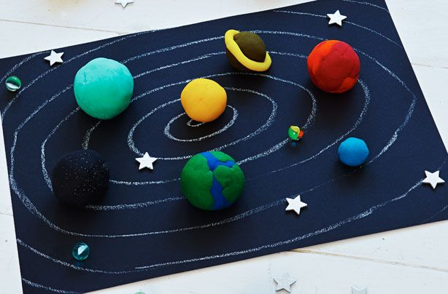
- Create a 3D Solar System Model
- Design a space craft/
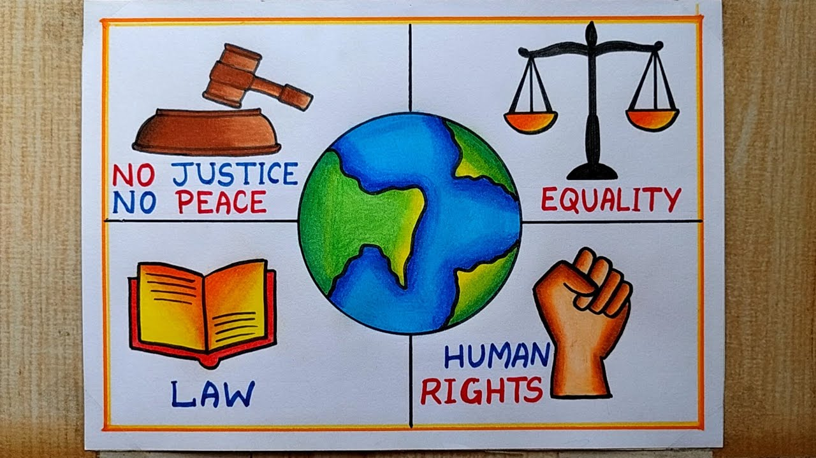
- Write a song or wrap about the solar system.

