**Summer 1 Term Newsletter Year 5**

**R.E.**

This term we will be answering the question who should get to be in charge? Children will explore what makes a religious leader, where else do religious and non-religious people seek leadership and why is it important to have leadership.

**Science**

We will be learning about the solar system children will identify the order of planets and ensure they understand the Earth's position within the solar system

**English**

This term we shall be looking at the book King Kong and they will generate ideas to write a balanced argument and also a short narrative.

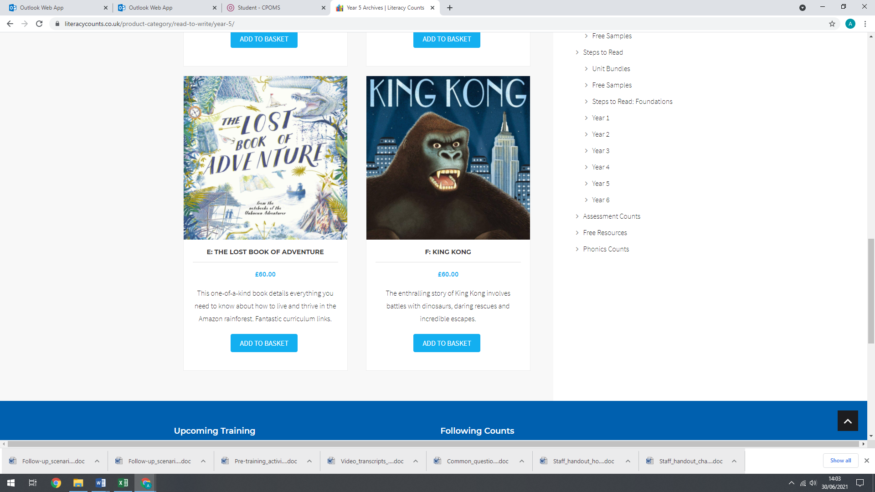

**P.E.**

Our focus will be taking part in Athletics this term (Tuesday) and on a Thursday the children will be having swimming lessons at our local swimming pool.

**Maths**

We will consolidate our learning of Fractions, Decimals and Percentages. We will also be focusing on properties of shape, different angles and delve into some statistics.

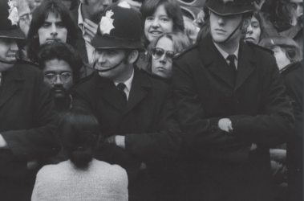

**Humanities**

Year 5 will be learning about the Changing Britain explores civil rights stories from Britain’s recent past, which are still live issues for many today. Whether it is exploring disability, ethnicity/race, gender/sexuality, or workers’ rights.

**Music**

**EXPLORING MUSICAL NOTATION -** This unit builds upon the musicianship skills developed so far, to create class ensemble performances of two pieces of

popular music, using the glockenspiel, un-tuned percussion and the singing voice. Children will discover two pieces of popular music from contrasting eras: one by S Club 7 and one by The Beatles. Through songs and musical games, children will discover some of the elements used in the songs and will apply this to their group ensemble activities.

**PSHE**

Year 5 will be investigation ‘Relationships’, where they will learn about self-esteem, friendships and how to solve problems.

**Computing**

We will be exploring how to create flat-file database can be used to organise data in records. Pupils use tools within a database to order and answer questions about data. They create graphs and charts from their data to help solve problems. They use a real-life database to answer a question, and present their work to others.