Summer 1 Curriculum Map - Nursery

Communication Language & Literacy

Listen to stories and respond appropriately to related questions. Become increasingly confident to speak to others and say what is happening. Extend vocabulary related to current topic.

Develop awareness of tenses and use it when speaking.

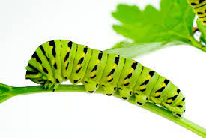

**Minibeasts**

Mathematics

Sort and count minibeasts by specific features.

Look at shapes in the environment and begin to name simple shapes and properties.

Recognise numerals (1-5) and match to appropriate amounts.

Understanding the World

Observe minibeasts outdoors and in the classroom. Learn how to take care of living things.

Discuss and compare minibeasts and talk about their unique features.

Physical Development

Use one handed tools with increasing confidence.

Become independent in dressing and undressing.

Use bike, trikes, scooters and other equipment to develop fine and gross motor skills.

PSED

Adapt behaviour to events and change.

Talk confidently to peers and adults in small groups.

Share experiences with others and find solutions to conflicts, with support.

Expressive Arts and Design

Use a range of materials to create minibeasts i.e.: play dough, painting, recycled materials, etc.

Join in singing a variety of familiar and new songs and create own songs.

Listen and respond to what they see and hear and express their thoughts and feelings.