Year 1 Summer 1- Home Learning
This term, our topic is Travel and Transport so the home learning will reflect this. Ideas you may want to present include:
- A drawing of transports found in London (bus, black taxi, underground tube, cycling, e.c.t.)
- Design a futuristic vehicle.
- Make a hot air/balloon-powered car or boat out of recycled materials.
- Create a 2-D-shaped picture of your favourite mode of transport. Can you label the shape names?
- Create a timeline of your favourite mode of transport. How has it changed over time?
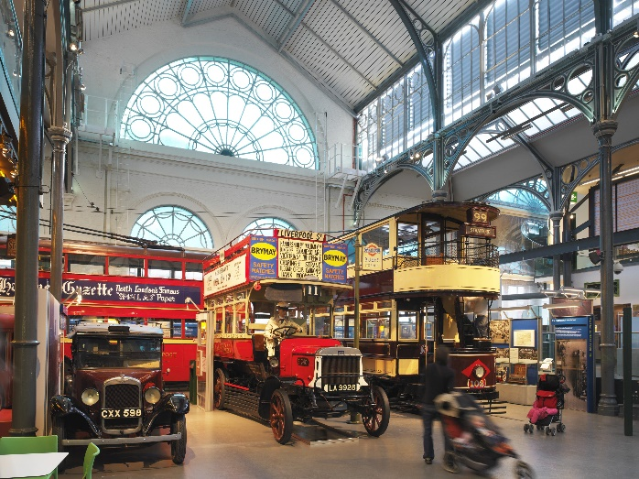
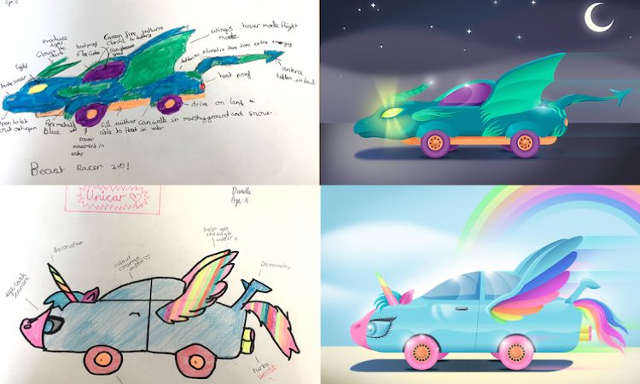
- Spot and talk about different types of vehicles while you are out and about with your family.
