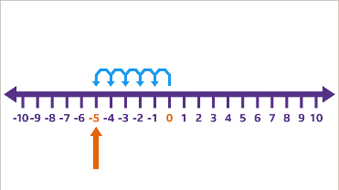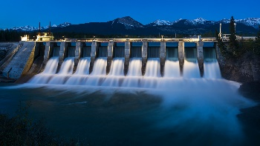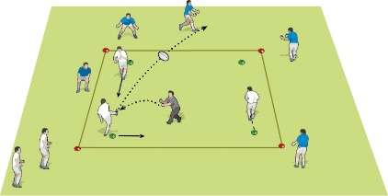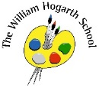**Summer 2 Term Newsletter Year 5**

**English**

This term we shall explore the book “The Lost Book of Adventures A story described as a one off adventure book We will be writing a survival narrative as well as a non-fiction piece too. Within English sessions, we will be looking at the key vocabulary, grammar required in year 5 and also features of the texts we’re writing.

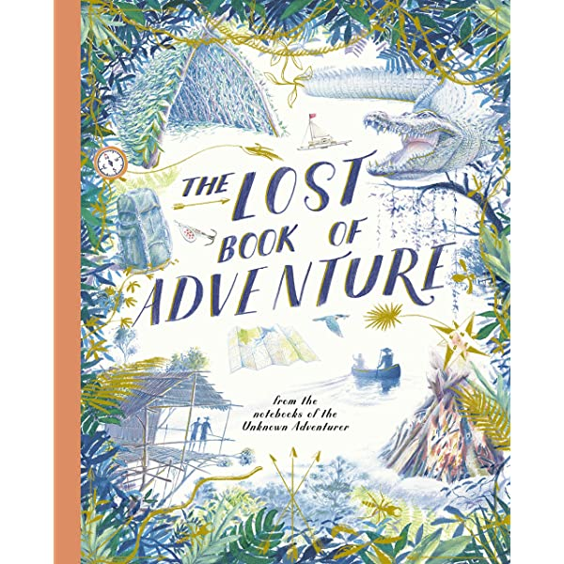

**Maths**

In maths this term, we will be focussing on decimals, negative numbers, converting units and volume. Within each of these units, we will be building the children’s understanding through fluency, reasoning and problem solving.

**Science**

We will be learning about evolution. We will be looking at how animals and humans have changed over time.

**R.E.**

This term children will use images, maps and texts to find out why certain places are significant for different purposes.

**PSHE**

Year 5 will be focusing on a unit called ‘changing me’. We will be focussing on the changes experienced during puberty for both boys and girls etc.

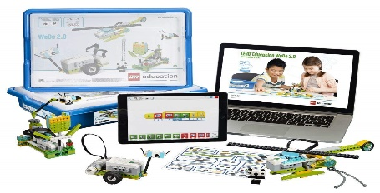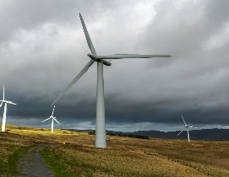

**Humanities (Geography)**

Year 5 will be learning about renewable energy and sustainability. We will be looking at what it means to be sustainable, how countries around the world have become more sustainable and also how we can help. This will lead us into our essay for English titled ‘Humans can’t live sustainably’ How much do you agree with this statement?

**P.E.**

This term we will be focusing on circuits and the children will develop their team working skills and attempt to create their own circuits.

**Computing**

In computing, we will be using the Lego resources to build different functional mechanisms for different purposes.

**Music**

In this unit, children will investigate musical notation. They will begin to understand what each symbol means in sheet music and begin to work on reading those notes and applying them into fun activities.