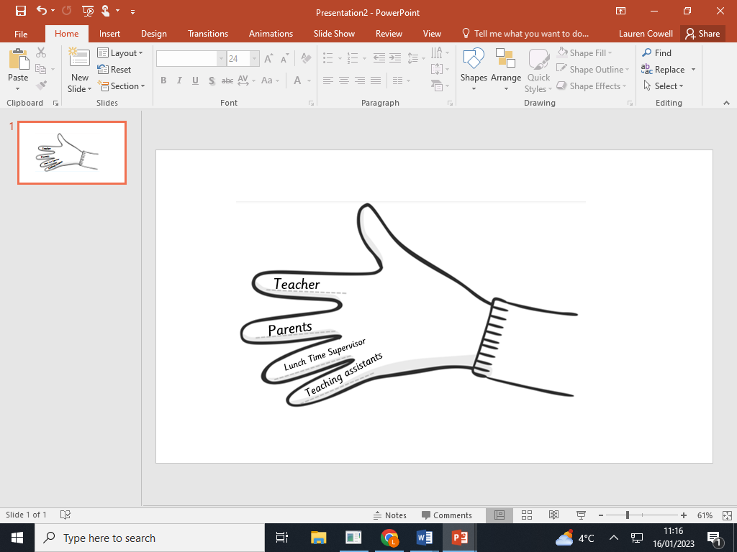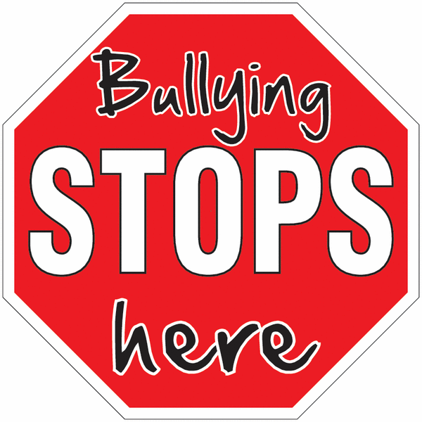

**Tell an adult straight away.**

**Tell the bully to stop!**

**Comfort the person who has been bullied and tell them to speak to someone.**

**Do not argue and fight with the bully.**

**Be an upstander!**

**What if someone you know is being bullied?**

Our helping hand

**STOP**

Start

Telling

Other

People

**Do:**

Ask the bully to stop

Ignore them

Talk to a friend

Use your class worry box

Tell a trusted adult

**Do not:**

Fight back

Hide it

**What should you do if you are being bullied?**

Bullying can take place in a range of places:

* In school
* Outside school
* Online

Verbal and Physical bullying often take place in hidden areas, where no one will see.

**Where could bullying happen?**

**V - Verbal**

**I - Indirect**

**P- Physical**

**Verbal bullying includes**: swearing, name-calling, criticising, threatening

**Indirect bullying includes:** cyber bullying, leaving people out, talking about people behind their backs

**Physical bullying includes**: hitting, punching, tripping over, kicking, pushing, shoving

**What are the types of bullying?**

**What is bullying?**

Bullying is where someone does something hurtful to someone repeatedly.

It is meant to hurt someone’s feelings or physically hurt them.

Bullying is not:

An accident

Falling out with a friend

Something that happens only one time

What should you do if you are being 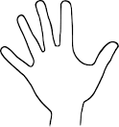bullied