Home Learning Project
Task: Create a timeline of a significant individual.
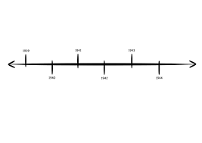
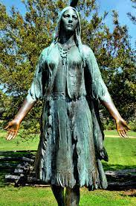

Our history learning this half term is about ‘How should we remember Pocahontas?’
As part of our learning we have been looking at how to create timelines.

Your task is to choose one significant person from history and create a timeline of their lives.

There are loads of people you could choose, here are just some ideas:
- Michelle Obama
- Nelson Mandela
- Mary Anning
- Charles Darwin
- Rosa Parks
- Alan Turing
- Megan Rapinoe
- Captain Tom Moore
- Simone Biles
- Muhammad Ali
- Albert Einstein
- Queen Elizabeth II

