* 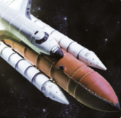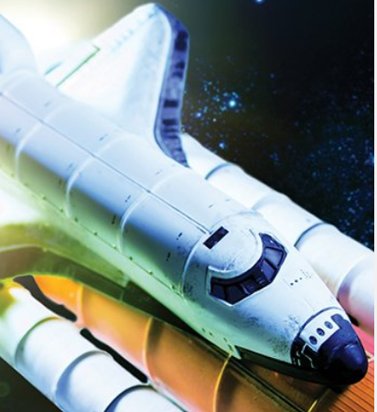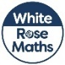

**Music**

We have music lessons with a specialist music teacher every Thursday morning.

These lessons cover rhythm and pulse, pitch, singing games and instrumental activities.

**Computing**

We will develop our understanding of the various aspects of using a computer to create and manipulate text, becoming more familiar with using a keyboard and mouse to enter and remove text. Finally, we will consider the differences between using a computer to create text, and writing text on paper. We will explain which method we prefer and explain the reasoning for choosing this.

**RE**  
In RE this half term we will learn about Christianity. We will reflect on the Christmas story and discuss what we can learn from religious traditions and symbols.

**Art**

This half terms brings with it some fantastic opportunities to celebrate art. We will focus on themes such as bonfire night, Diwali and the poppies of Remembrance Day as well as making some fabulous Christmas crafts.

**Topic**  
CRASH! What was that? It looks like a UFO has crash landed!

Our topic this term is ‘Moon Zoom’. This imaginative project will develop children’s knowledge of technology, space and materials. We will be designing and making model spaceships, and discussing the properties of the materials we use. This topic also links nicely with our Science focus this half term.

**Maths**  
As we move into the second half of the Autumn term, we are focusing on addition and subtraction. Towards the end of the term, we will explore geometry and shape and finally consolidate our knowledge in number and place value. Throughout our lessons, we have an element of problem solving and reasoning. Children will apply their mathematical knowledge and use manipulatives and resources to demonstrate their understanding, deepen thinking and develop mastery.

**Moon Zoom**

**P.E.**  
This half term we will be continue or multi-skills approach to learning in PE. We will focus on developing our ability to share space and be aware of others sharing it with us. To demonstrate agility, balance and coordination and apply these basic skills competently in a range of physical activities.

**PSHE**  
Our PSHE this half term will focus on celebrating differences. We will discuss how to celebrate others as well as ourselves. We will think about how we can include others when we are working or playing and also how we can try to solve problems and use kind words.

**English**  
We will be learning about a range of text types this term. These include:

* Narratives – through traditional tales like Rapunzel
* Instructions – how to catch a witch!

These text types will be used in a cross curricular manner across all subjects. We will also be following the **Read Write Inc. Scheme in Phonics.**

**Science**  
Our everyday materials topic will continue until the end of the Autumn term. We have already learnt a lot about the properties of materials and have enjoyed bending, squashing and stretching things and making material collages! We are now moving on to find out more about absorbent and waterproof materials, which materials are magnetic, and what happens when we heat different materials.